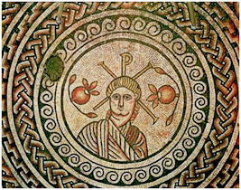
THE MOSAIC
HINTON ST MARY
JULY 2026

MARY ANDREWS 1931 - 2026
It is with sadness to report that a great Village Stalwart died in June.
Mary & Chris Andrews married in 1969 and moved into Hinton St Mary in 1979. Mary has been in a care home for the past 4 years. Mary has achieved and contributed more to our wonderful Hinton St Mary community than anyone else I can think of.
Mary taught Home Economics in Weymouth, Sturminster Newton High School & Yewstock School.
After retiring, Mary devoted her time and energy to support Hinton St Mary, where she was Chairman of the Parish Council and Chairman of the Village Hall. It was felt a modern fully equipped village hall would benefit the village and Mary raised funding of several grants to enable the village hall to become more sustainable for the future of villagers and the cricket club. In 2003, over a 7 month period, Chris Hardiman and Mary Andrews led a team of DIY villagers to improve the village hall resulting in an increase of area, provision of modern toilets, creation of a kitchen area, new hot water and electrical systems and total redecoration.
Mary did so much for our Hinton St Mary community, including helping to organise the village show and for many years doing the church flowers each week. As Chairman of the Parish Council she was very highly regarded and led the change of speed limit on the B3092 from 40mph to 30mph. She also managed the creation of a Parish Appraisal in 2002. Possibly, her greatest achievement, was that she was the driving force behind the creation of a pavement to make walking from Hinton St Mary to Stur safe. Anyone who regularly walks to Stur and has lived in Hinton less than 20 years will find it hard to comprehend that the pavement did not exist prior to Mary being the driving force behind its creation.
Mary & Chris Andrews ran and developed Cub Scout packs in North Dorset including Marnhull, Sturminster Newton and Okeford Fitzpaine.
Mary, thank you for all the time, devotion and support you have given our wonderful community. You were highly respected by all.
We send our condolences to Chris your husband of 57 years.
Thanks to Chris Hardiman for his input.
Celia Wright (current Chairman HSM Parish Council

Hinton St Mary - Gardens Open Weekend; 20th - 21st June 2026
We had a very busy, warm weekend, attendance was good given the hot weather. Visitors clearly enjoyed the experience, being both generous and extremely complementary and a large number of those attending on Saturday returned on Sunday!
The wonderful, combined efforts of village bakers, curators, engineers and active volunteers were invaluable contributions to the event’s success. Smiling faces and willing hands were everywhere whenever they were needed! We know who you all are, but I dare not attempt to name each one here for fear of inadvertently leaving someone out; sincere thanks to all of you!
We are, as ever, grateful to Mr and Mrs Pitt-Rivers for their hospitality in the Tithe Barn and Manor Garden access and the very welcome support from “The Estate”.
We raised over £5,000 towards the upkeep of St Peter’s church, a very welcome ‘gift’ given recent restoration work and the inevitability of more yet to be done.
St Peter’s has for around 800 years offered sanctuary to the community, a place of quiet peace, love and worship so let’s hope that our collective stewardship will help ensure that it remains so for many more years (centuries!). It is open daily from dawn to dusk so, when you next walk by, why not drop in and ‘feel the peace’; a rare gift in current times.
RG 24/06/2026

Charity Fundraiser

Full marks to members of our 'old village' for making a substantial contribution to our tea, coffee and cake fundraising event (Monday 22nd June). We raised just over £600 for the Robin White Centre, Dorchester, where Tony received his immunotherapy treatment last year (raffle £225, refreshments £120, donations £260).

Our thanks go to those who donated raffle prizes and cakes, and to the eleven villagers who braved the sizzling heat to visit us in Sturminster. Special thanks go to Anthea for an outstanding effort with the highly successful raffle and to her very able assistant, John.

Well done to Hinton!
Tony and Michael (formally Michaelmas Cottage)

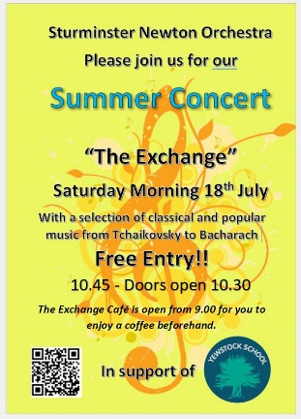
Summer Concert at “The Exchange”
It is hard to believe that, at the time of publication,
we are already half-way through 2026 !!
However, the sun will still be shining (we hope) so why not join us
for our concert on Saturday Morning 18th July?
As usual, our offering will be an eclectic mix of musical genres. This includes a specially commissioned medley from “The Merry Widow”, a rousing piece of Tchaikovsky, some swing – “Strike up the Band” , a selection of well-know Burt Bacharach songs and more.
Our concerts are always in support of a local good cause, which this time is Yewstock School.

If you have never heard us before, you may be pleasantly surprised! We have been described as one of Sturminster Newton’s best kept secrets ….
John Harding
(for Sturminster Newton Orchestra)

______________________________________________________________________________________________
Hinton St Mary Cricket Team Schedule
(Green Games – Home Matches)
Spectators are always very welcome!

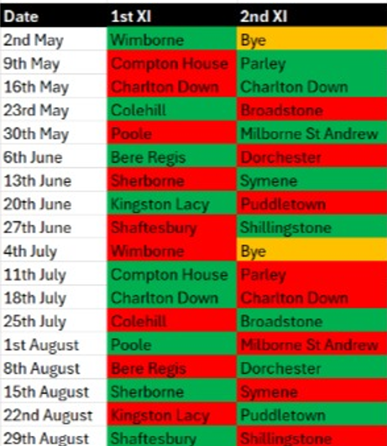
Hello Hinton
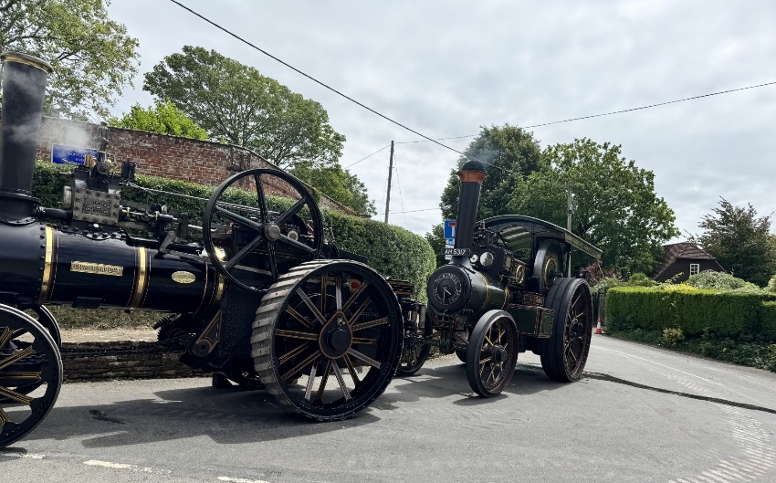
What a fantastic start to the summer we have had. The first May bank holiday we hosted Mark & Jane’s quiz night which has built up a great local following, thank you to all the villagers who support it. The next quiz is Sunday 5th of July starting at 7pm. Teams up to 6 and £2 per person entry.
On the second bank holiday Malea sung beautifully on a warm evening in the garden which was so well received and luckily for us she has agreed to sing again on the August bank holiday – Sunday August 30th in the evening. She sings a mix of soul & blues, classic & modern. No need to book just come along.
Well done to all that contributed to the Open Gardens in June. It seemed to be a great success – the village looked wonderful and was buzzing with visitors. An especially big thank you to Ellie, Robbie, John & Sam for bringing their incredible steam engines outside the pub.
Sales of our Mosaic lager have been in aid of BASE UK. A charity which helps children displaced by the war in Ukraine. Thank you for your support we have raised £150.
Finally, I would like to take the opportunity to thank the whole team here at The White Horse. Even through the unbearable heat everyone continued to work hard and keep smiling!
Hope to see you all soon
Best Wishes
Mel, Andy & The White Horse Team
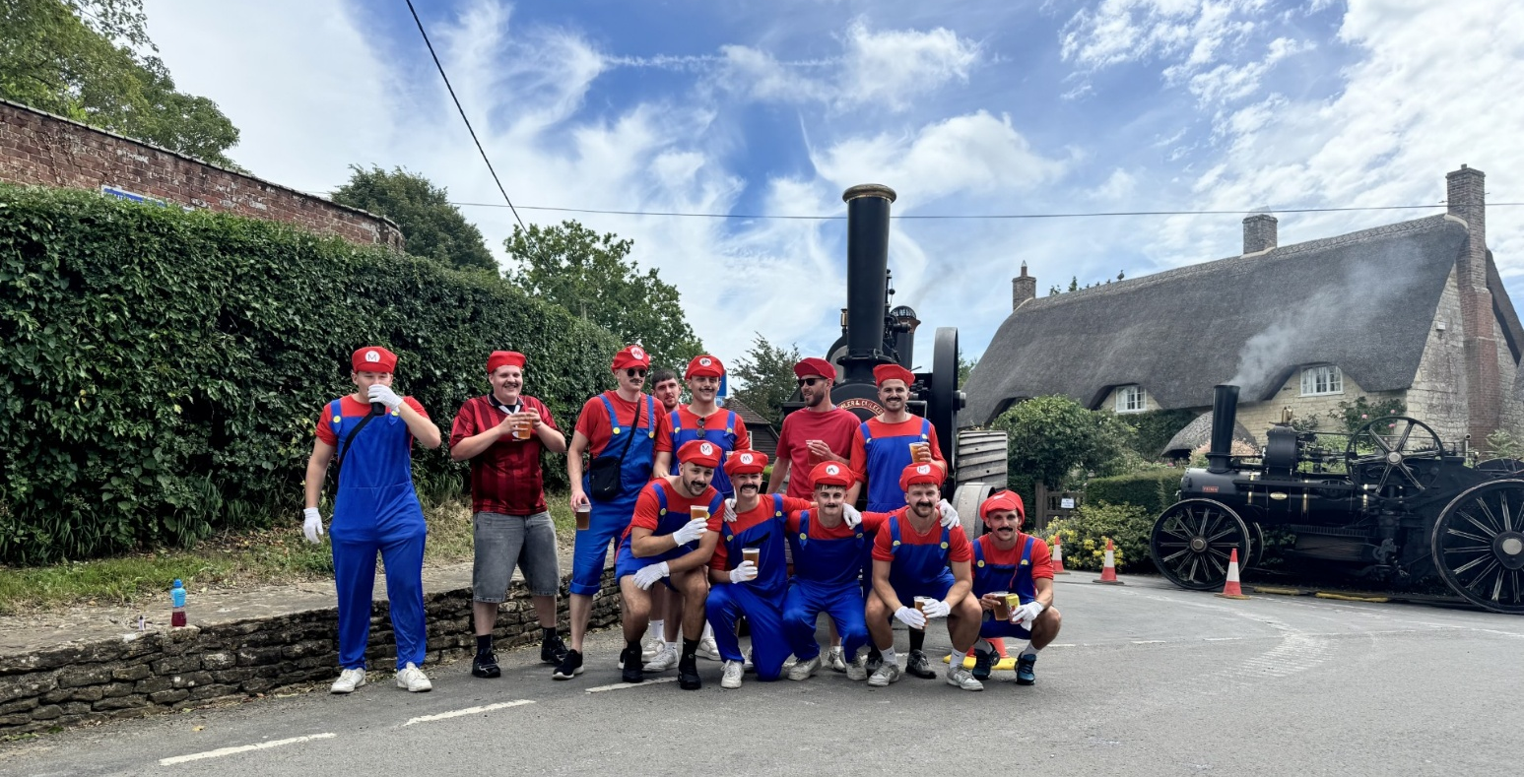

Sturminster Football Club on charity pub run

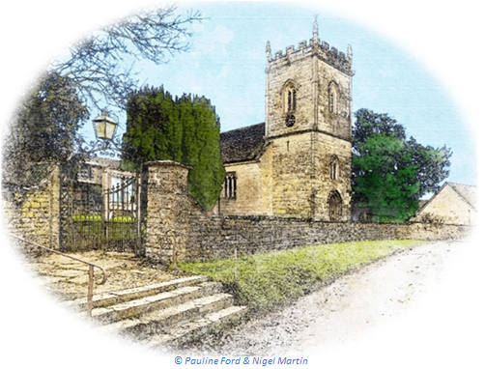
July 2026 Services

St Peter’s Church
- Date & Time | - Service
Sunday 05 July | Holy Communion (BCP)
Sunday 12 July | Morning Prayer (BCP)
Sunday 19 July | Morning Prayer
Sunday 26 July | Morning Prayer
All services at 9:30am unless otherwise noted.

The Church is open daily for sanctuary and prayer
All queries about Church-related support and services should be directed to the Vicar or Churchwardens.
Vicar: The Reverend Mary Gubbins  01258 721 704 | 07440 680 387 | The Vicarage, Sturminster Newton  revd.mary.gubbins@gmail.com
Churchwardens
Robin Gibbs  01258 471 493  robin@aviaconsult.uk | Kevin Peto-Bostick  01258 475 469  kevin.peto.bostick@gmail.com
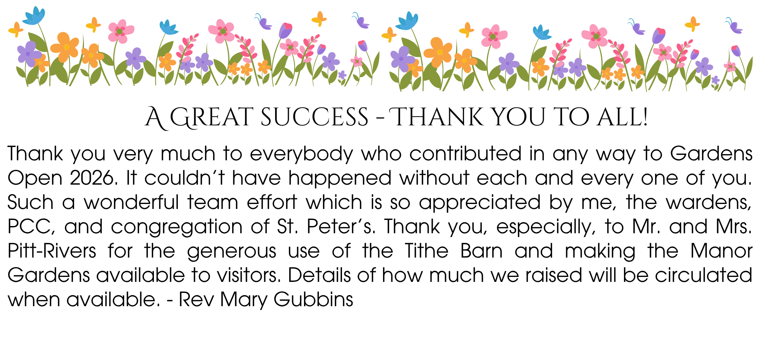
Gardens Open 2026

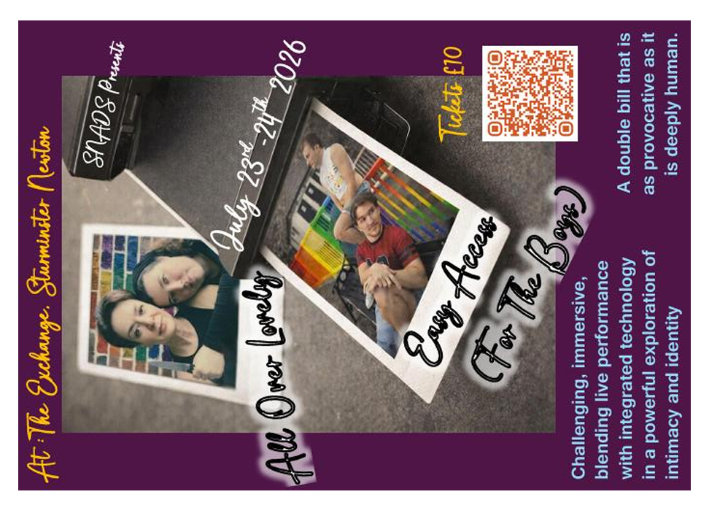
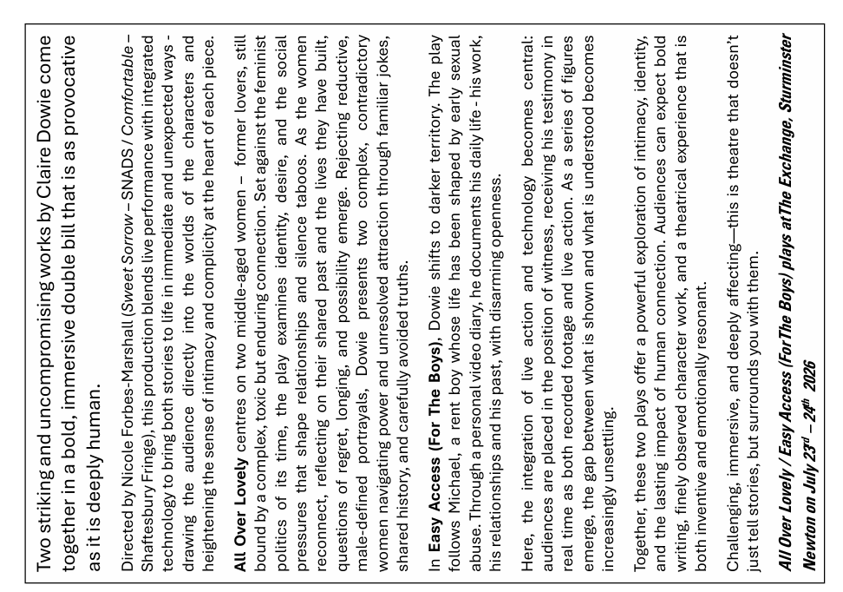

The Mosaic
A big thank you to those of you who have offered to help deliver The Mosaic. One villager has shown an interest in taking over the editing. Hopefully this will be confirmed in the next edition – and the new editor will contact you all to have a chat about vacant delivery rounds.


THE MONTHLY VILLAGE COFFEE MORNING
TUESDAY 7th JULY
10.30 – 12.00
The cost is £1.50– for as much coffee or tea as you can drink
and as many biscuits as you can eat.

BLANDFORD HOSPITAL SHOP WAREHOUSE.
Is open to receive donations at its warehouse in The Building Yard HSM on
Saturday 4th July
10 - 12 midday
Old Poisedale Building, Hinton St. Mary

IF YOU LIVE IN HINTON ST MARY AND DO NOT RECEIVE A COPY OF THE MOSAIC EVERY MONTH – PLEASE LET NIGEL KNOW ON 07710 088322 OR EMAIL DJNMARTIN@BTINTERNET.COM

Please let us have any articles, notices, celebrations, information, items for sale, trusted traders etc you would like to have included in next month’s Mosaic. Deadline 24th of the Month. Thank you, Nigel & Jo. jo.martin99@btinternet.com

VILLAGE HALL to enquire about or book please contact Jane Filbey on 07513 632550 or janefilbey1964@gmail.com

Keep abreast of all things ‘HSM’ on the village facebook page: Hinton St Mary Village Group and the Hinton St Mary Website:
http://www.hintonstmary.com where all previous copies of The Mosaic are also available.

Thank you to our Advertisers and our sponsors:
Mr & Mrs Pitt Rivers, Hinton St Mary Parish Council, St Peter’s Church, HSM Village Hall Committee.

CONTACT THE ESTATE:
If you are out and about on the estate and need to contact us for any reason whatsoever, please call
07511 209705 or email us on info@hintonstmaryestate.com and we will do our best to respond as quickly and possible.
Trusted Traders

These are tradesman/workers who have been personally recommended by villagers. Please let us have details of anybody who has done a great job for you. Thank you.

COMPUTER HELP | TIM WEST | 01258 817537 sturcomputers@hotmail.co.uk
CURTAINS, BLINDS, TRACKS, FABRICS &  FITTING (Marnull) | THE CURTAIN MAN  (Anna & Tony) | 01258 821117 thecurtainmanshop@gmail.com
CARPENTRY/JOINERY | NIGEL BASTABLE | 01258 860459 www.nigelbastable.co.uk
CARPENTRY (& WOODEN FLOORS) | GARY CORCORAN | 07920557651 gccarpentry@hotmail.co.uk
APPLIANCE REPAIRS | ANDY BLANDFORD | 07484 861797 andyblandford1@gmail.com
PEST CONTROL | MARK GOULD  (Rats, Wasps, Moles & Fleas) | 07999 957694 mark_gould2@btconnect.com
BUILDERS | ANDREW TRIM | 07939 541128
FENCING & REPAIRS | DAVID WHITEHAND | 07549 151 799
BOILER MAINTENANCE | BOB JONES & SON | 01963 362 502
PRIVATE CARER | TINA BROWN | 0777 5430457
BUILDING & RENOVATION | MARK GORDGE | 07941 443 306
ROOFING | BEN GIBBS ROOFING | 07912 655095 Bengibbs.roof@gmail.com
SCAFFOLDING | EDW SCAFFOLDING | 07474 552259 elwin1965@icloud.com
HEDGE/TREE CUTTING | HAMBLEDONS 0783347833 | 01258 721552 info@hambeldons.co
PLASTERER | ROBBY PROCTOR | 07872 634677 robbyproctor29@gmail.com
CHIMNEY SWEEP | CHRIS PERRINS 07824 698109 | 01258 837499 cfperrins@gmail.com
PLUMBER | GARY WATKINS | 07887 605112 sales@tradetanks.com

Martin Bennett – Local Mechanic
(based in Hinton St Mary)

I repair and service modern and everyday cars as well as specialising in repairing and restoring classic cars.
I have diagnostics equipment available.
Phone 07746817072
Email martin@mbclassiccars.co.uk



NIGEL BASTABLE LTD
CARPENTRY & JOINERY
The Building Yard – Hinton St Mary
Doors, Windows, Wardrobes, Stairs, Kitchens, Cupboards, Bookcases Etc.
Renovations and Repairs
01258 860459
nigelbastable@btinternet.com www.nigelbastable.co.uk


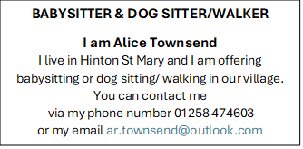
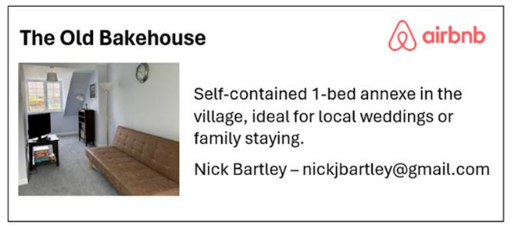
Rose’s Yard
Hinton St Mary
Air B and B
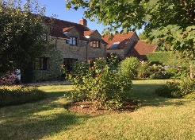

Self-Contained first floor annex
in the centre of the village

sleeping 4

Contact Jo:

jo.martin99@btinternet.com
07860 612412
Or Book Via Air B & B

