
THE MOSAIC
HINTON ST MARY
JUNE 2026

New Editor/s Needed For The Mosaic
In September 2020, together with our dear friend Janet Bolton, Nigel and I took over the baton of producing the Hinton St Mary Mosaic each month from John Harding and Pauline Sherwood.
We are so pleased that we did. As ‘newbies’ in the village it proved to be a fantastic way to get to know our neighbours and other villagers, many of whom are now great friends. We have had a lot of enjoyment producing the magazine each month and haven’t been close to throwing the computer out of the window on too many occasions!
However after 6 years we feel that The Mosaic now needs some original ideas and fresh input. As this coincides with us having more family commitments, we have decided the time has come for us to pass the baton on again. Anybody who is interested or would like to have a chat about what is involved, please contact one of us. We would be very happy to work alongside you for a couple of months to help smooth the transition.
Jo 07860 612412 jo.martin99@btinternet.com Nigel 07710 088322 djnmartin@btinternet.com
Could you help deliver The Mosaic each month?
As many of you know, there are a hardy band of kind people in the village who deliver The Mosaic each month, come rain or shine to all addresses in Hinton St Mary. After delivering the news letter every month for the last 14 years Anthea Harding has decided it is time for a change. We would like to thank Anthea very much for all the deliveries she has made whilst we have been publishing The Mosaic.
If anybody would be willing to take over her round (from September) please could you contact either Jo or Nigel on the above numbers.
Many thanks.

GARDENS OPEN WEEKEND
We are very grateful to everyone who has offered to help in various ways over the Gardens Open weekend. They have all been logged and passed on to those in charge of different areas and you should hear from them directly in the next couple of weeks.

We could still do with more plants or garden related items for the plant stall as we need to cover both days. If you are digging anything out of your garden (or garden shed!) in the next week or two, please don’t bin or compost it but offer it to us first - we can always pot it up or collect for you!
Contact Liz Collins (07377389453 or lizcollins50@gmail.com) if you any questions.
Emergency Action Plan

Dear Hinton St Mary Residents,

Dorset Council has asked the Parish Council if we have an Emergency Action Plan in the event of a major incident (e.g. power outage/ fire/ extreme weather/ terrorist attack).

The view of the Parish Council is that we are a small community and the Parish Council would work together with the Village Hall Committee, Church and the Estate to support residents as required in an emergency so we feel it is a waste of resources preparing a formal plan.
Celia Wright
Hinton St Mary PC

Travel on Public Transport from Hinton St Mary
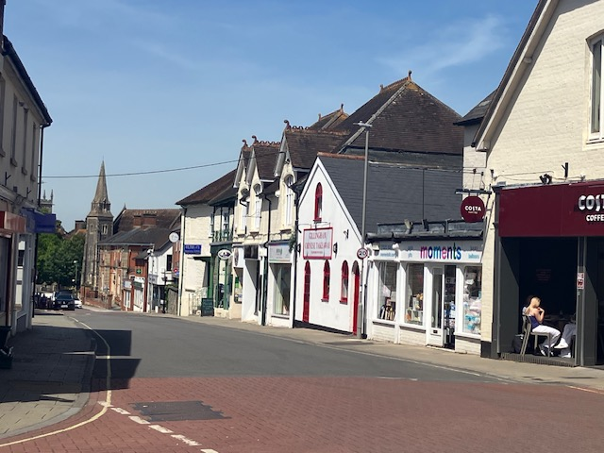
Chapter 3 - the “big Town) (Gillingham)

I caught the CR3 from HSM Bus shelter towards Gillingham at 10.49 and alighted at Gillingham station at 11.15. I had 1 hour 25 minutes to shop in Gillingham with numerous options such as Gillingham High street or Waitrose, Asda or Iceland before I caught the CR3 bus back from the station at 12.40 arriving back in HSM perfectly on time at 13.06.
The return trip is free to those of State pension age with a Dorset Bus Pass or £5 for other adults.

Celia Wright

Temporary Traffic Regulation Order for Ridgeway Lane, Hinton St Mary

Please find the stakeholder information for planned Highways Maintenance works at Ridgeway Lane, Hinton St Mary attached.

Whilst these works are being completed, access to properties and businesses will be maintained as appropriate.

We may ask the public to wait for a short time whilst we move machinery or carry out a task.

Many thanks
Jason Loibl
Construction Delivery Manager

Dorset Highways
Tel; 01305 228100

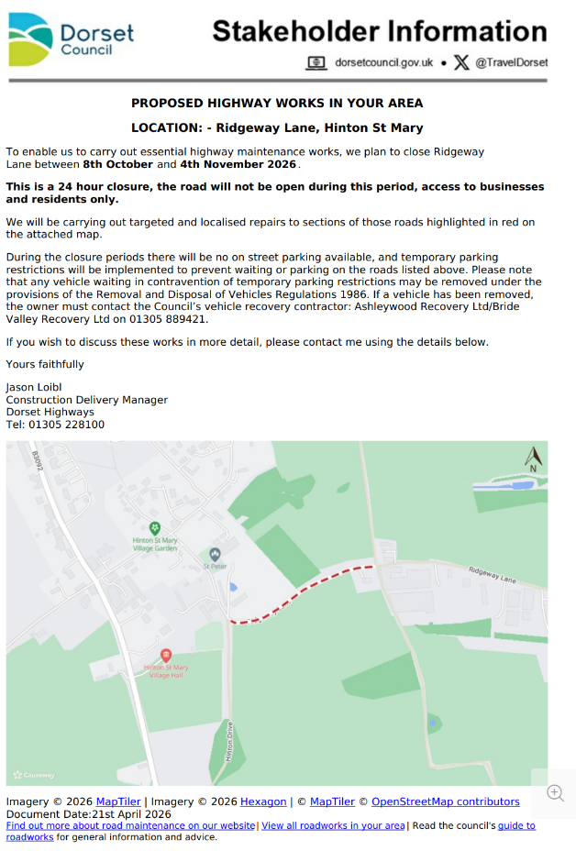

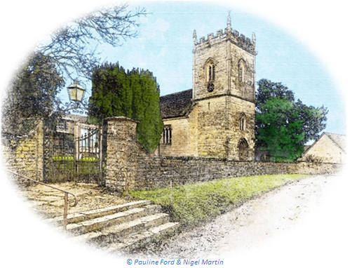
June 2026 Services

St Peter’s Church
- Date & Time | - Service
Sunday 07 June | Holy Communion (BCP)
Sunday 14 June | Morning Prayer (BCP)
Sunday 21 June | Morning Prayer
Sunday 28 June | Holy Communion (CW)
All services at 9:30am unless otherwise noted.

The Church is open daily for sanctuary and prayer
All queries about Church-related support and services should be directed to the Vicar or Churchwardens.
Vicar: The Reverend Mary Gubbins  01258 721 704 | 07440 680 387 | The Vicarage, Sturminster Newton  revd.mary.gubbins@gmail.com
Churchwardens
Robin Gibbs  01258 471 493  robin@aviaconsult.uk | Kevin Peto-Bostick  01258 475 469  kevin.peto.bostick@gmail.com
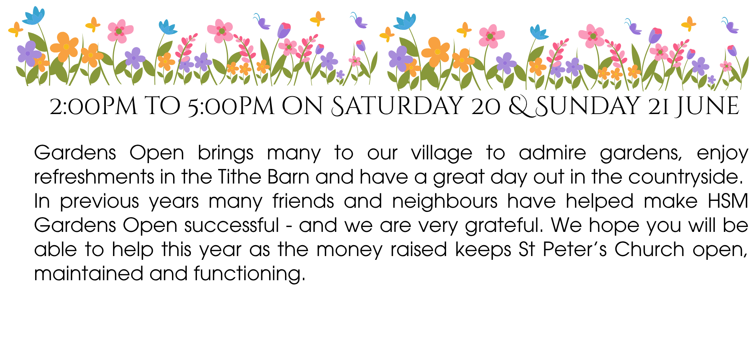
Gardens Open 2026
Parish and Town Council magazine article

If British Summer Time and warmer days mean you will be visiting one of Dorset and Wiltshire’s local heathlands or outdoors spaces to enjoy the wildlife and wilderness, please take a picnic.
Dorset & Wiltshire Fire and Rescue Service (DWFRS) is encouraging residents and visitors to bring a picnic and not a barbecue when out and about. Warmer and breezy weather increases the risk of accidental or deliberate fires in our open spaces.
A wildfire can escalate quickly, so we are asking everyone to follow some simple steps:
• If you are enjoying our open spaces stay alert for signs of fire—smoke, heat, or unusual smells. If you spot anything worrying, call 999 immediately. Consider downloading and using What3Words to identify your exact location.
• Avoid having open fires or using barbecues in the countryside. Disposable barbecues and campfires are banned in many parts of Dorset.
• Extinguish smoking materials properly, and don’t throw cigarette ends on the ground or out of car windows – take your litter home.
• If you’re at the beach, don’t set off flares, have campfires or light barbecues as these can easily lead to gorse and foliage on the cliffs catching fire.
• You can also help by reporting any anti-social behaviour on our heaths to CrimeStoppers by calling 0800 555 111 (100% Anonymous).
Landowners and land managers are also advised, where possible, to be prepared for fires and ensure that fire breaks are cut and well maintained with any cut grasses and vegetation removed from the site.
For more information on heath fires and countryside safety, please visit our website Dorset & Wiltshire Fire Service | Heath fires and countryside safety.



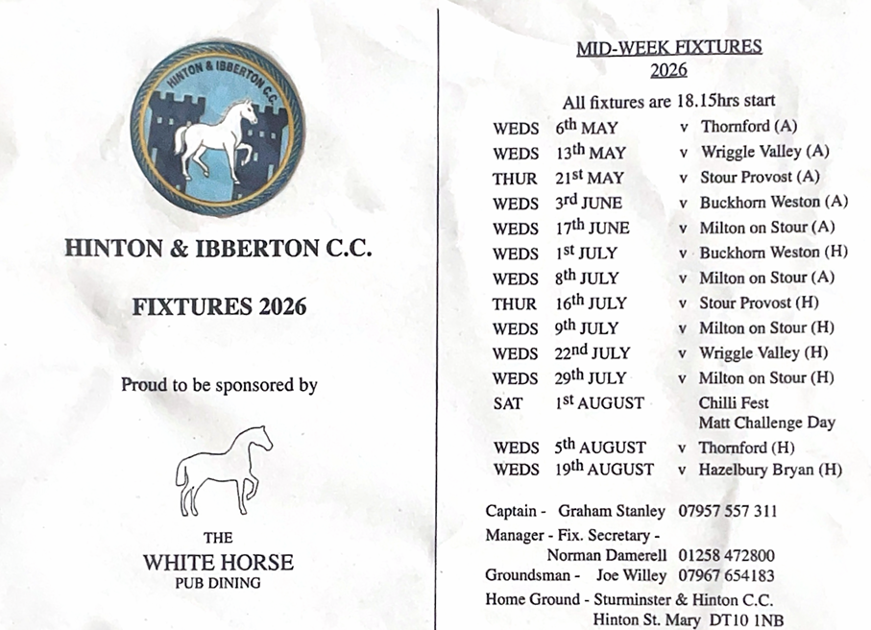


THE MONTHLY VILLAGE COFFEE MORNING
TUESDAY 2ND JUNE
10.30 – 12.00
The cost is £1.50– for as much coffee or tea as you can drink
and as many biscuits as you can eat.

BLANDFORD HOSPITAL SHOP WAREHOUSE.
Is open to receive donations at its warehouse in The Building Yard HSM on
Saturday 6TH June
10 - 12 midday
Old Poisedale Building, Hinton St. Mary

IF YOU LIVE IN HINTON ST MARY AND DO NOT RECEIVE A COPY OF THE MOSAIC EVERY MONTH – PLEASE LET NIGEL KNOW ON 07710 088322 OR EMAIL DJNMARTIN@BTINTERNET.COM

Please let us have any articles, notices, celebrations, information, items for sale, trusted traders etc you would like to have included in next month’s Mosaic. Deadline 24th of the Month. Thank you, Nigel & Jo. jo.martin99@btinternet.com

VILLAGE HALL to enquire about or book please contact Jane Filbey on 07513 632550 or janefilbey1964@gmail.com

Keep abreast of all things ‘HSM’ on the village facebook page: Hinton St Mary Village Group and the Hinton St Mary Website:
http://www.hintonstmary.com where all previous copies of The Mosaic are also available.

Thank you to our Advertisers and our sponsors:
Mr & Mrs Pitt Rivers, Hinton St Mary Parish Council, St Peter’s Church, HSM Village Hall Committee.

CONTACT THE ESTATE:
If you are out and about on the estate and need to contact us for any reason whatsoever, please call
07511 209705 or email us on info@hintonstmaryestate.com and we will do our best to respond as quickly and possible.
Trusted Traders

These are tradesman/workers who have been personally recommended by villagers. Please let us have details of anybody who has done a great job for you. Thank you.

COMPUTER HELP | TIM WEST | 01258 817537 sturcomputers@hotmail.co.uk
CURTAINS, BLINDS, TRACKS, FABRICS &  FITTING (Marnull) | THE CURTAIN MAN  (Anna & Tony) | 01258 821117 thecurtainmanshop@gmail.com
CARPENTRY/JOINERY | NIGEL BASTABLE | 01258 860459 www.nigelbastable.co.uk
CARPENTRY (& WOODEN FLOORS) | GARY CORCORAN | 07920557651 gccarpentry@hotmail.co.uk
APPLIANCE REPAIRS | ANDY BLANDFORD | 07484 861797 andyblandford1@gmail.com
PEST CONTROL | MARK GOULD  (Rats, Wasps, Moles & Fleas) | 07999 957694 mark_gould2@btconnect.com
BUILDERS | ANDREW TRIM | 07939 541128
FENCING & REPAIRS | DAVID WHITEHAND | 07549 151 799
BOILER MAINTENANCE | BOB JONES & SON | 01963 362 502
PRIVATE CARER | TINA BROWN | 0777 5430457
BUILDING & RENOVATION | MARK GORDGE | 07941 443 306
ROOFING | BEN GIBBS ROOFING | 07912 655095 Bengibbs.roof@gmail.com
SCAFFOLDING | EDW SCAFFOLDING | 07474 552259 elwin1965@icloud.com
HEDGE/TREE CUTTING | HAMBLEDONS 0783347833 | 01258 721552 info@hambeldons.co
PLASTERER | ROBBY PROCTOR | 07872 634677 robbyproctor29@gmail.com
CHIMNEY SWEEP | CHRIS PERRINS 07824 698109 | 01258 837499 cfperrins@gmail.com
PLUMBER | GARY WATKINS | 07887 605112 sales@tradetanks.com

Martin Bennett – Local Mechanic
(based in Hinton St Mary)

I repair and service modern and everyday cars as well as specialising in repairing and restoring classic cars.
I have diagnostics equipment available.
Phone 07746817072
Email martin@mbclassiccars.co.uk



NIGEL BASTABLE LTD
CARPENTRY & JOINERY
The Building Yard – Hinton St Mary
Doors, Windows, Wardrobes, Stairs, Kitchens, Cupboards, Bookcases Etc.
Renovations and Repairs
01258 860459
nigelbastable@btinternet.com www.nigelbastable.co.uk


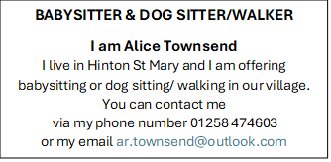
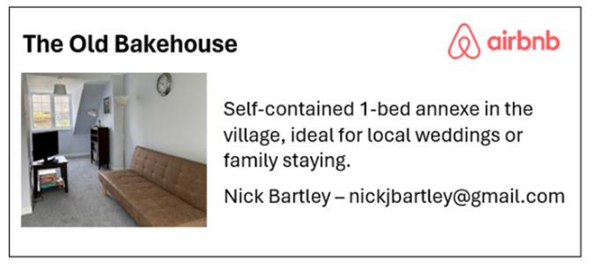
Rose’s Yard
Hinton St Mary
Air B and B
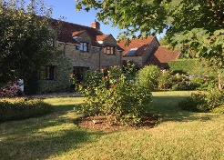

Self-Contained first floor annex
in the centre of the village

sleeping 4

Contact Jo:

jo.martin99@btinternet.com
07860 612412
Or Book Via Air B & B

