
THE MOSAIC
HINTON ST MARY
MAY 2026

 | Fri 19th | Sat 20th | Sun 21st | Comment?
Open your garden

Help serve teas in the Tithe Barn, or help with clearing of tables and washing up.
Help manning contactless payments and cash.
Making cakes/scones:
We always need more than we think as the teas are very popular.
Favourites include brownies, lemon drizzle, carrot cake, scones and gluten free options
Donate plants and other garden items such as good quality pots, tools or ornaments.
Help on Plant Stall
Help set up in Tithe Barn (Friday 19/6 pm and Saturday 20/6 am)
Help with setting up and marshalling car parking.
Help with taking down and clearing the site, Sunday 21^{st,} after 6pm.
I/we are unable to help but enclose a donation.

Please send or make contact as soon as possible by email /phone/text Liz Collins:
lizcollins50@gmail.com or 07377389453

Name ………………………………………..………………………………………………………

Address ………………………………………………………………………………………………..

Tel no ………………………………………………………………………………………….…….

Email ……………………………………………………………………………………………

Gardens Open Teas

I know that Liz has already put out a form for those willing to help in some way over the weekend. However, this is a specific request for help with the teas which are served in the Tithe Barn.
Whether it is serving, clearing tables or washing up, please volunteer even if only for a couple of hours on one of the days. If you have never been to a village event before it is a great way to get to know people and we are a friendly lot.
Friday afternoon/Saturday morning for setting up, filling jam and cream pots, washing cups out. Saturday and Sunday afternoon from 1.30 until just after 6pm. Just let Liz know what time you can offer
If anyone is willing to make a cake for either day that would be marvellous, I have some offers already but we will need quite a few as it gets very busy indeed. I have been told that the most popular are Lemon Drizzle, Carrot, Chocolate, Coffee, Brownies and Scones. A couple of Gluten Free cakes would be most welcome also.
Caroline Dyer- Tea Organiser!
Yew Tree Cottage

Village Hall Vibes
Hello sunshine! It’s that wonderful time of year again as we swap football boots for cricket bats, and the Village Hall fills up with summer gatherings, barbecues, and bouncy castle parties.
The kitchen has recently had a thorough deep clean and is now looking fresher, less cluttered, and much easier to maintain—ready for all your upcoming events.
Internal redecoration of the hall has been slightly delayed due to the poor weather. However, with brighter days ahead and the ability to open windows and doors, we’re hoping to complete this work very soon. Please note there may be some temporary disruption to regular bookings while this takes place. Anyone affected will be contacted well in advance, and we apologise for any inconvenience caused.

Hall Hire Information
The committee is currently exploring the possibility of introducing a new online booking system. If you have any experience with such systems, we would greatly appreciate your feedback and advice.
Please contact:
Lucy Johnson
📞 07715 332611
📧 lucyjohnson2009.lj@gmail.com

The Village Hall is available to hire both during the day and in the evenings at an hourly rate, with a small additional charge via a coin meter for electricity use.
To make a booking, please contact:
Jane Filbey
📞 07513 632550
📧 janefilbey1964@gmail.com

Hire Prices:
• Per Hour: £5 (Village Residents) / £10 (Non-Residents)
• Half Day: £20 (Village Residents) / £40 (Non-Residents)
• Full Day: £40 (Village Residents) / £80 (Non-Residents)
A £10 deposit is required for all bookings.

Village Hall Quarterly Meeting
Our next meeting will take place on Thursday 21st May at 7:00pm. Everyone is warmly invited to attend—it would be lovely to see some new faces! We welcome your ideas, suggestions, and any offers of help.

— The Village Hall Trustees

Travels from Hinton St Mary using Public Transport
Chapter 2 – BLANDFORD FORUM

I got on the CR3 bus in Hinton St Mary at 10.36 in the direction of Stur and was confused where the stop was; was it the lay-by with the post box and bus stop sign or the cut off area before the cross roads where the timetable is?
On asking the driver he was equally confused and assured me he would stop for anyone who put out their hand!

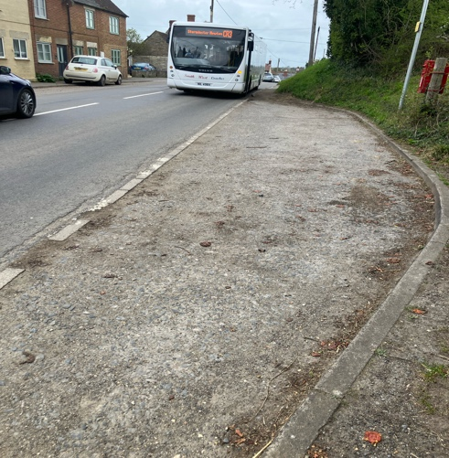
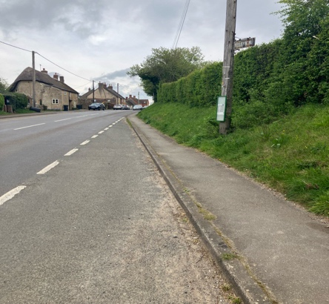

I asked for a return to Blandford but as the CR3 is run by South West Coaches and the CR4 from Stur to Blandford is run by First Bus,this wasn’t possible. A single from HSM to Stur was £2.
The CR4 departed Stur at 10.50 and took the scenic route via Manston, Child Okeford and Okeford Fitzpaine before arriving in Blandford Forum centre at 11.32 leaving me 2.5 hours to shop before I caught the return bus from outside the Crown hotel at 13.55 and arriving back at Stur at 14.37.
The one negative was that if I needed to catch the CR3 from Stur back to Hinton St Mary I had nearly a two hour wait as it departed at 16.30. Thus I chose to walk back to HSM.
Whilst the CR3 runs from Stur to Gillingham and is great in my opinion it would benefit from an increased frequency. I will ask if this is possible when I next attend the Gillingham & Shaftesbury Transport Forum on behalf of the Parish Council.
Celia Wright


May 2026 Services

St Peter’s Church
- Date & Time | - Service
Sunday 03 May | Holy Communion (BCP)
Sunday 10 May | Morning Prayer (BCP)
Thursday 14 May  Ascension | Benefice Holy Communion at St Mary’s – 7:00pm
Sunday 17 May | Morning Prayer
Sunday 24 May  Pentecost | Holy Communion
Sunday 31 May  Trinity | Benefice Holy Communion at St Thomas’, Lydlinch – 11:00am
All services at 9:30am unless otherwise noted.

The Church is open daily for sanctuary and prayer
Gardens Open 2026

All queries about Church-related support and services should be directed to the Vicar or Churchwardens.
Vicar: The Reverend Mary Gubbins  01258 721 704 | 07440 680 387 | The Vicarage, Sturminster Newton  revd.mary.gubbins@gmail.com
Churchwardens
Robin Gibbs  01258 471 493  robin@aviaconsult.uk | Kevin Peto-Bostick  01258 475 469  kevin.peto.bostick@gmail.com
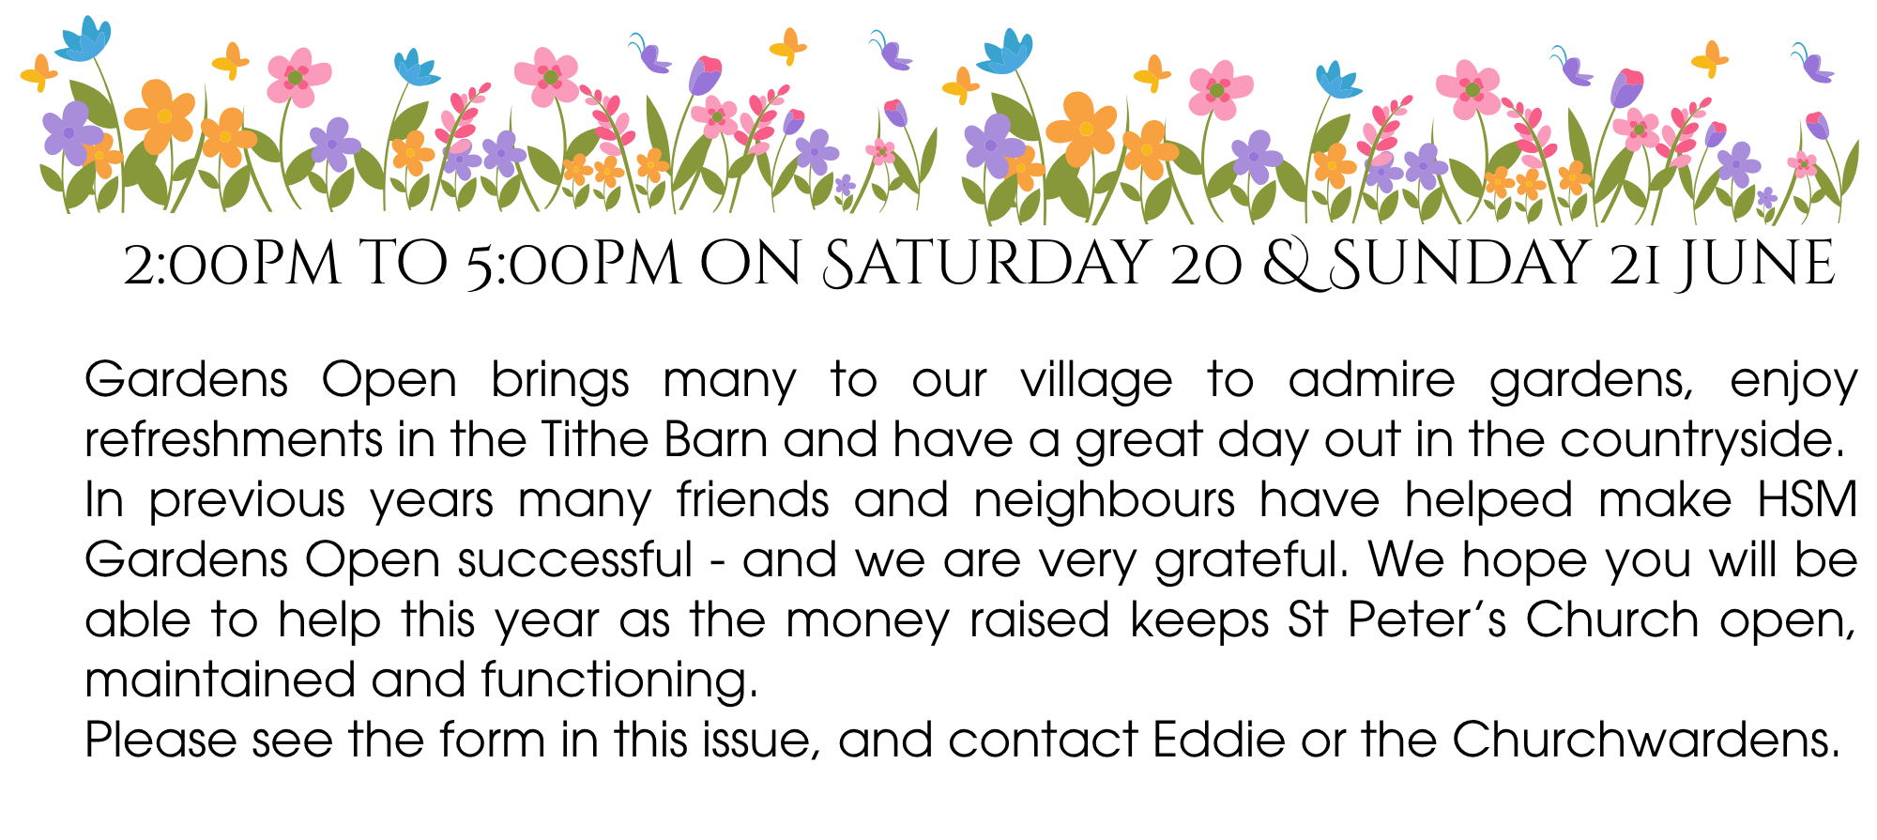

Hello Hinton

It is wonderful to see Hinton coming into bloom in time for the gardens open next month. We have a couple of events coming up in May.
Sunday 3rd of May Quizmasters Jane & Mark are back from their travels. Quiz begins at 7pm. £2 per person teams up to 6.
Sunday 24th of May we have the pleasure of hosting Malea in her debut performance at 6pm. Malea is a soul/jazz singer with a varied set list. Please come and support this upcoming artist.
The chefs have been hard at work making the most of all the beautiful spring ingredients available. Asparagus, wild garlic, Brixham skate and Hinton pork & lamb are featuring heavily on our current menu.
We would also like to thank the estate for their continued support. We couldn’t do this without them.
Look forward to seeing you all soon
Mel, Andy & The White Horse Team


ANSWER TO APRIL QUIZ : AN EYELASH

THE MONTHLY VILLAGE COFFEE MORNING
TUESDAY 5th May
10.30 – 12.00
The cost is £1.50– for as much coffee or tea as you can drink
and as many biscuits as you can eat.

BLANDFORD HOSPITAL SHOP WAREHOUSE.
Is open to receive donations at its warehouse in The Building Yard HSM on
Saturday 2nd May
10 - 12 midday
Old Poisedale Building, Hinton St. Mary

IF YOU LIVE IN HINTON ST MARY AND DO NOT RECEIVE A COPY OF THE MOSAIC EVERY MONTH – PLEASE LET NIGEL KNOW ON 07710 088322 OR EMAIL DJNMARTIN@BTINTERNET.COM

Please let us have any articles, notices, celebrations, information, items for sale, trusted traders etc you would like to have included in next month’s Mosaic. Deadline 24th of the Month. Thank you, Nigel & Jo. jo.martin99@btinternet.com

VILLAGE HALL to enquire about or book please contact Jane Filbey on 07513 632550 or janefilbey1964@gmail.com

Keep abreast of all things ‘HSM’ on the village facebook page: Hinton St Mary Village Group and the Hinton St Mary Website:
http://www.hintonstmary.com where all previous copies of The Mosaic are also available.

Thank you to our Advertisers and our sponsors:
Mr & Mrs Pitt Rivers, Hinton St Mary Parish Council, St Peter’s Church, HSM Village Hall Committee.

CONTACT THE ESTATE:
If you are out and about on the estate and need to contact us for any reason whatsoever, please call
07511 209705 or email us on info@hintonstmaryestate.com and we will do our best to respond as quickly and possible.
Trusted Traders

These are tradesman/workers who have been personally recommended by villagers. Please let us have details of anybody who has done a great job for you. Thank you.

COMPUTER HELP | TIM WEST | 01258 817537 sturcomputers@hotmail.co.uk
CURTAINS, BLINDS, TRACKS, FABRICS &  FITTING (Marnull) | THE CURTAIN MAN  (Anna & Tony) | 01258 821117 thecurtainmanshop@gmail.com
CARPENTRY/JOINERY | NIGEL BASTABLE | 01258 860459 www.nigelbastable.co.uk
CARPENTRY (& WOODEN FLOORS) | GARY CORCORAN | 07920557651 gccarpentry@hotmail.co.uk
APPLIANCE REPAIRS | ANDY BLANDFORD | 07484 861797 andyblandford1@gmail.com
PEST CONTROL | MARK GOULD  (Rats, Wasps, Moles & Fleas) | 07999 957694 mark_gould2@btconnect.com
BUILDERS | ANDREW TRIM | 07939 541128
FENCING & REPAIRS | DAVID WHITEHAND | 07549 151 799
BOILER MAINTENANCE | BOB JONES & SON | 01963 362 502
PRIVATE CARER | TINA BROWN | 0777 5430457
BUILDING & RENOVATION | MARK GORDGE | 07941 443 306
ROOFING | BEN GIBBS ROOFING | 07912 655095 Bengibbs.roof@gmail.com
SCAFFOLDING | EDW SCAFFOLDING | 07474 552259 elwin1965@icloud.com
HEDGE/TREE CUTTING | HAMBLEDONS 0783347833 | 01258 721552 info@hambeldons.co
PLASTERER | ROBBY PROCTOR | 07872 634677 robbyproctor29@gmail.com
CHIMNEY SWEEP | CHRIS PERRINS 07824 698109 | 01258 837499 cfperrins@gmail.com
PLUMBER | GARY WATKINS | 07887 605112 sales@tradetanks.com

Martin Bennett – Local Mechanic
(based in Hinton St Mary)

I repair and service modern and everyday cars as well as specialising in repairing and restoring classic cars.
I have diagnostics equipment available.
Phone 07746817072
Email martin@mbclassiccars.co.uk



NIGEL BASTABLE LTD
CARPENTRY & JOINERY
The Building Yard – Hinton St Mary
Doors, Windows, Wardrobes, Stairs, Kitchens, Cupboards, Bookcases Etc.
Renovations and Repairs
01258 860459
nigelbastable@btinternet.com www.nigelbastable.co.uk


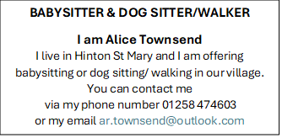
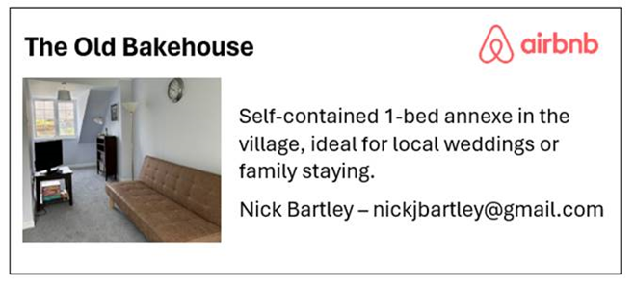
Rose’s Yard
Hinton St Mary
Air B and B
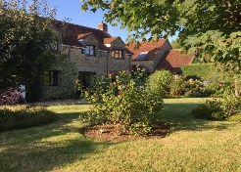

Self-Contained first floor annex
in the centre of the village

sleeping 4

Contact Jo:

jo.martin99@btinternet.com
07860 612412
Or Book Via Air B & B

