
THE MOSAIC
HINTON ST MARY
APRIL 2026

Yes You Can!
Hinton St Mary is a glorious place to live but I am aware we are very dependant on our cars to get around so I have given myself a project to see where I can get using public transport.

Chapter 1: Shopping in Salisbury.
The bus was perfectly on time at HSM bus shelter arriving at 10.49 towards Gillingham where I alighted at 11.15 at Gillingham Railway station. A return fare cost £5 (Dorset only gives free bus passes to those at state pension age).
I purchased a discounted day return rail ticket with my Senior Railcard (available to those aged 60 or more) to Salisbury for a bargain £6.35 and was amazed I could feed a note into the ticket machine and be given change!
The train departed 11.51 and arrived at Salisbury 12.16 leaving me enough time to shop for 2 and a half hours till the train back to Gillingham at 14.47.
The return train arrived on time at Gillingham station at 15.16 allowing plenty of time to jump on the CR3 bus towards Sturminster. The bus left Gillingham station on time at 15.25 with only 2 passengers but after a stop at the school there was standing room only!
The bus went via Marnhull and arrived back in Hinton St Mary just ahead of the scheduled time of 16.03
The CR3 bus runs between Sturminster & Gillingham via Hinton St Mary and is a great asset to our community.
I will place a CR3 timetable in the Parish Council noticeboard. Celia Wright
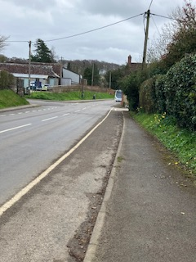

Village Church – Essential Conservation

For some years the chancel (east end of the church) wall plaster has been loose and actually falling off due to potentially serious damp which, if ignored further, risked major structural degradation.
After 5 years of architects and conservation specialists site meetings a well planned, 6-week, conservation programme began on Monday 9th of February.
Completion was planned to meet James and Emily’s wedding on the 21st of March and to be within the then VAT exemption period ending on the 31st.
The first task was to erect scaffolding within and outside the church.

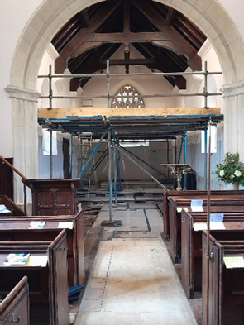

External work included: removal of old, corroded guttering and down pipes, ‘clean / reset’ the roof ‘tiles’, repair gable masonry, repoint the walls, restore rainwater gullies at foot of the walls and fit new guttering and down pipes.

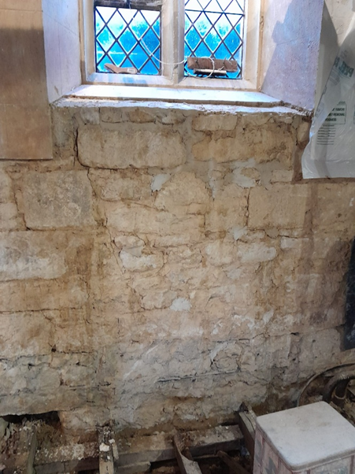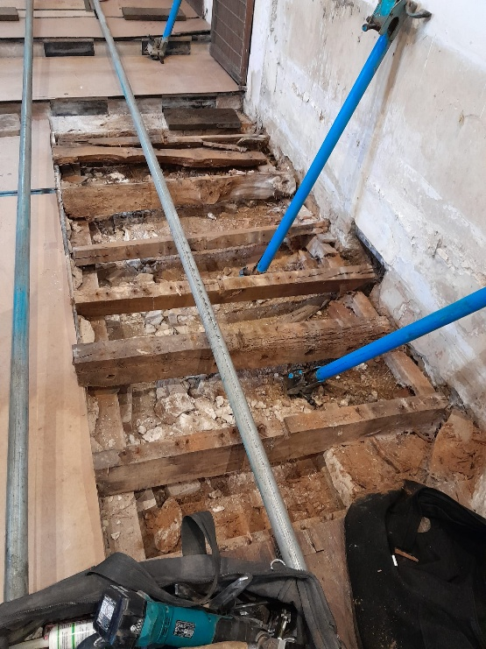
The key interior task was to remove/replace failed plaster up to around 5 feet on all 3 walls.
Village Church – Essential Conservation

However, removal of furnishings and fittings exposed (no surprise!) the need for essential restoration of the choir pews and the wooden floor structure, which had collapsed entirely.

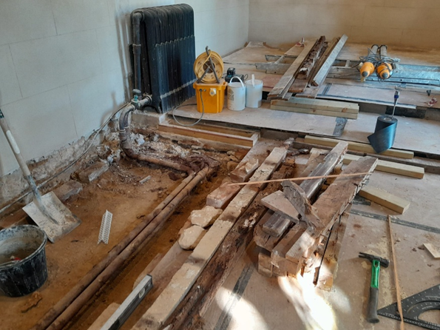

The first 3 weeks were not helped by the cold, wet weather but the conservation team, starting daily at 07:00, soldiered on regardless. Work was finally finished, apart from painting the new plaster, by the 17th of March with 3 working days in hand. The new plaster will be painted after a 4-6 week drying process. February’s weather meant heating 24/7 to stabilise the new plaster, increased heating oil burn and thus an unavoidable oil top-up at massively inflated cost in mid-March!
Regular church services were maintained throughout the process.

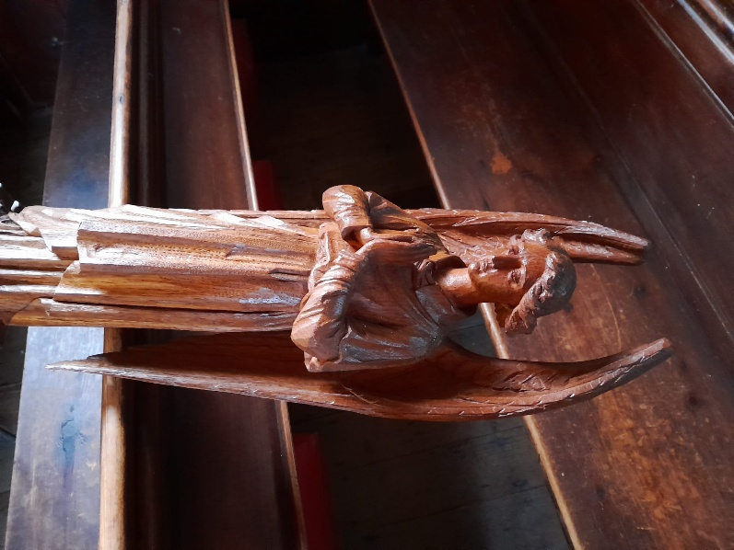
One of two restored ‘Angels’; thanks to the ‘village ladies’
The budgeted conservation cost of around £49,000 (excl. VAT!) will be shared proportionately between the Parish and Church Commissioners.
The last recorded major restoration was completed in 1842, hopefully this conservation work will sustain the church for another 200+ years.

Hinton St Mary Gardens Open Plant Stall
20th and 21st June 2026

Spring has finally arrived – the village is humming with lawnmowers and it is the time when gardeners think about dividing and rethinking their plants, and clearing out old pots etc, especially as the Easter break is early this year. As we have the Village Gardens Open in June, we would welcome any surplus plants or seedlings for sale on the Plant Stall. If you have no room to keep them until then we have arranged two dates when you could share them with others to nurture until June. The first is the Village Coffee morning on April 7th and then on Saturday April 18th we will be holding a Seed and Plant Swap in the Village Garden from 10-12, with coffee and cakes available!
We would also welcome donations of any unwanted ceramic or terracotta pots, garden ornaments or furniture, garden tools such as rakes, trowels, spades etc (but not electric or petrol tools) or unused gardening books. If you are unable to bring them on either of the dates, we can arrange for collection nearer the time.
If you have any queries, want to arrange collection or have surplus plastic pots we could use, please contact Liz Collins: lizcollins50@gmail.com or 07377 389453.

Hinton St Mary Millennium Garden Volunteers

The garden has bloomed beautifully through early spring with violets, primroses, plum blossom and daffodils in succession.
We have managed a fair amount of work on the trees and flower beds ready for the coming year and everything looks prepared for the next phase of flowering with bluebells already appearing.
Our small band of volunteers have made the decision to change our regular meeting to a day which better suits our needs. This will now be a Monday afternoon although, as before you will find people cutting grass or finishing other tasks at other times.
If you are interested in joining us regularly or occasionally, we will be generally found in the Millennium Garden from 2PM on a MONDAY or contact me, Gwyn James on gmjames28@icloud.com.

Hello Hinton

It’s wonderful to see all the daffodils out and to see our little garden full again. This month we had the first of our pigs. A big thank you to Alice who did all the hard work!
Andy and Jack have used every bit, even making pastry with lard brawn fritters and homemade faggots so nothing went to waste.
Later this month we will be hosting a cicchetti evening (Italian small plates.) Details will be on our blackboards soon. Please give us a call to book as you will be unable to do so online or pop in and see us – good excuse for a pint!
Our guest Quiz master this month is Steve on Easter Sunday from 7pm. £2 per entry and teams up to 6 people. We will be open all afternoon and before the quiz we will be drawing the ticket to win the giant Easter egg.
Thank you for your continued support, have a wonderful Easter and hope to see you all soon
Mel, Andy and The White Horse team.

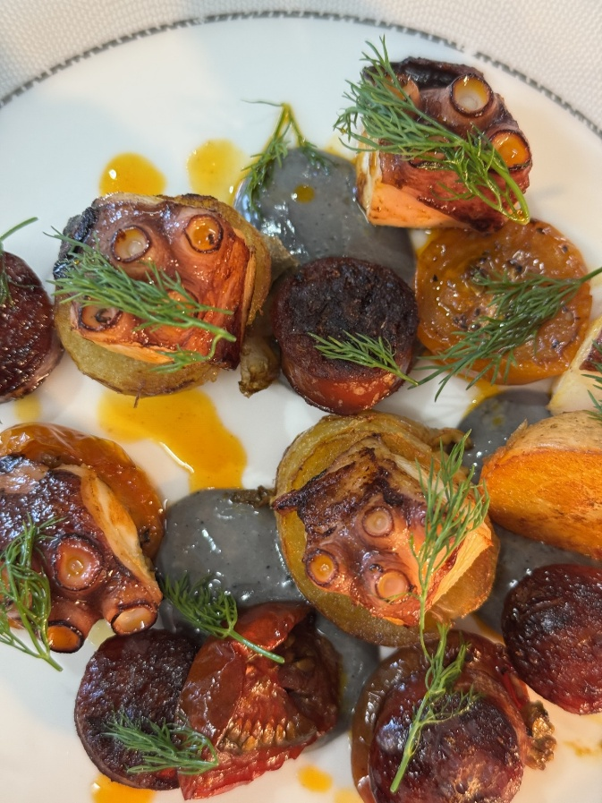


Lemon tart, raspberry sorbet

Octopus with chorizo & squid ink aioli

The Estate. Alice Fox-Pitt
Apologies to the Mosaic team for my hopeless lack of contributions in recent months.
Things have been busy on the estate.

As ever we bask in the reflected glory of Mel and Andy’s incredible hard work in the pub. We could not be prouder of The White Horse Hinton, it’s part in our community and its contribution in so many ways to village life.

We have done up number 18 which was long overdue and now is at a standard we are so proud of. Rupert Webb and his team got it all done in record time ready for James and Emily’s guests for their beautiful wedding in the Barn this weekend.

The Workspace is really building a dynamic community. I am very aware that we haven’t seen many of you from the village. Please let us know what we could do better to support. We have a monthly breakfast, The Hustle which is pulling together such a variety of businesses and individuals.
We launched a monthly Property Networking breakfast this month which was really well received and is now going be rolled out monthly.

We hosted 90 guests for a Cheltenham preview night, I am not sure how many winners we gave but it was a really fun night.

We are trying to develop corporate away days, particularly focussing on encouraging Poole, Bournemouth and Christchurch businesses to come up to North Dorset with their teams to work, eat and enjoy the beautiful area.

We are so excited to have supported Cam at CResults to launch his gym. His is the most brilliant personal trainer and is running classes so do come and check it out.

Gemma Hampton has launched Gemma Hampton Beauty and Well-being just beside the Workspace and as you would expect is totally smashing it. She is expanding her offering all the time and getting busier and busier. You can get vouchers for friends or treat yourself to a very special treatment.

At last it has stopped raining so the farm is coming alive with Fred and the team now able to get in to the land.

The wedding season got underway this weekend with James and Emily’s special day. We have filled our quota of 20 for the season so it will be lovely to see happy faces throughout the summer enjoying our beautiful village, church and barn.

Do come and make the most of the various services that great people are delivering around the village as they need your support.

Over at Gains Cross the Black Cat Cafe is making the most of more people being out and about in the lovely weather. This week they launched their doggie menus!
There are still a couple of office spaces available. The refurb is complete and we are really happy with how it has turned out. Sitting between the road and the trailway it is a great place to work.

The Yard Alice Fox-Pitt

Spring is here and the event season is underway.

Obviously with Williams retirement he now just has a small team of home bred horses to bring on so the yard is focussed on supporting up and coming riders.

Jess Rimmer has a really exciting team of 7 horses. She has been selected for the podium potential squad for under 25s which is an amazing opportunity. This year is the first year of an under 25 world championships and Jess is having a real go at catching the selectors eye.

We have a very strong international contingent with us this year.
Shelby Brost from Canada has three horses in her team.
Guto de Ferrier is with us from Brazil with 2 horses. After 20 years out of the sport back in Brazil he is making a comeback and trying for the next Olympics in LA.
We have a second Brazilian team rider joining us in the next month.
Abigail from Marnhull is working hard to pursue a show jumping career with her lovely horse
Dan, who is now in his 13th season and a core part of the team.
Saskia Hind from Australia is supporting Jackie in the management team.
Yvonne has joined us with her horse from Ireland before she heads to university.
Anna is with us from Ireland whilst in her transition year.
So with a full house of ambitious young riders it is all go for Jackie and William in their training and mentoring of the next generation who are making the most of all that Hinton St Mary and Woodlane Stables has to offer! The weekly team PT sessions with Cam at CResults are going down a storm.
Thank you as ever for your patience with the horses around the village, it is an amazing place to train.

Revised Dates for Highway Works in Veals Lane, Hinton St Mary
To enable Dorset Council to carry out essential highway maintenance, they now plan to close Veals Lane between 26th and 27th May.
The road will be closed daily between 09.30 and 15.30 and will be re-opened at weekends.




ANSWER TO MARCH RIDDLE
The Moon
APRIL RIDDLE
What bats but never hits, is near a ball but never thrown


THE MONTHLY VILLAGE COFFEE MORNING
TUESDAY 7th APRIL
10.30 – 12.00
The cost is £1.50– for as much coffee or tea as you can drink
and as many biscuits as you can eat.

BLANDFORD HOSPITAL SHOP WAREHOUSE.
Is open to receive donations at its warehouse in The Building Yard HSM on
Saturday 4TH April
10 - 12 midday
Old Poisedale Building, Hinton St. Mary

IF YOU LIVE IN HINTON ST MARY AND DO NOT RECEIVE A COPY OF THE MOSAIC EVERY MONTH – PLEASE LET NIGEL KNOW ON 07710 088322 OR EMAIL DJNMARTIN@BTINTERNET.COM

Please let us have any articles, notices, celebrations, information, items for sale, trusted traders etc you would like to have included in next month’s Mosaic. Deadline 24th of the Month. Thank you, Nigel & Jo. jo.martin99@btinternet.com

VILLAGE HALL to enquire about or book please contact Jane Filbey on 07513 632550 or janefilbey1964@gmail.com

Keep abreast of all things ‘HSM’ on the village facebook page: Hinton St Mary Village Group and the Hinton St Mary Website:
http://www.hintonstmary.com where all previous copies of The Mosaic are also available.

Thank you to our Advertisers and our sponsors:
Mr & Mrs Pitt Rivers, Hinton St Mary Parish Council, St Peter’s Church, HSM Village Hall Committee.

CONTACT THE ESTATE:
If you are out and about on the estate and need to contact us for any reason whatsoever, please call
07511 209705 or email us on info@hintonstmaryestate.com and we will do our best to respond as quickly and possible.
Trusted Traders

These are tradesman/workers who have been personally recommended by villagers. Please let us have details of anybody who has done a great job for you. Thank you.

COMPUTER HELP | TIM WEST | 01258 817537 sturcomputers@hotmail.co.uk
CURTAINS, BLINDS, TRACKS, FABRICS &  FITTING (Marnull) | THE CURTAIN MAN  (Anna & Tony) | 01258 821117 thecurtainmanshop@gmail.com
CARPENTRY/JOINERY | NIGEL BASTABLE | 01258 860459 www.nigelbastable.co.uk
CARPENTRY (& WOODEN FLOORS) | GARY CORCORAN | 07920557651 gccarpentry@hotmail.co.uk
APPLIANCE REPAIRS | ANDY BLANDFORD | 07484 861797 andyblandford1@gmail.com
PEST CONTROL | MARK GOULD  (Rats, Wasps, Moles & Fleas) | 07999 957694 mark_gould2@btconnect.com
BUILDERS | ANDREW TRIM | 07939 541128
FENCING & REPAIRS | DAVID WHITEHAND | 07549 151 799
BOILER MAINTENANCE | BOB JONES & SON | 01963 362 502
CARPET & UPHOLSTERY CLEANING | LUCAS BEAVON  WESSEX CLEANING SERVICES | 07419 324238 info@wessexcleaningservices.com
PRIVATE CARER | TINA BROWN | 0777 5430457
BUILDING & RENOVATION | MARK GORDGE | 07941 443 306
ROOFING | BEN GIBBS ROOFING | 07912 655095 Bengibbs.roof@gmail.com
SCAFFOLDING | EDW SCAFFOLDING | 07474 552259 elwin1965@icloud.com
HEDGE/TREE CUTTING | HAMBLEDONS 0783347833 | 01258 721552 info@hambeldons.co
PLASTERER | ROBBY PROCTOR | 07872 634677 robbyproctor29@gmail.com
CHIMNEY SWEEP | CHRIS PERRINS 07824 698109 | 01258 837499 cfperrins@gmail.com
PLUMBER | GARY WATKINS | 07887 605112 sales@tradetanks.com

Martin Bennett – Local Mechanic
(based in Hinton St Mary)

I repair and service modern and everyday cars as well as specialising in repairing and restoring classic cars.
I have diagnostics equipment available.
Phone 07746817072
Email martin@mbclassiccars.co.uk



NIGEL BASTABLE LTD
CARPENTRY & JOINERY
The Building Yard – Hinton St Mary
Doors, Windows, Wardrobes, Stairs, Kitchens, Cupboards, Bookcases Etc.
Renovations and Repairs
01258 860459
nigelbastable@btinternet.com www.nigelbastable.co.uk

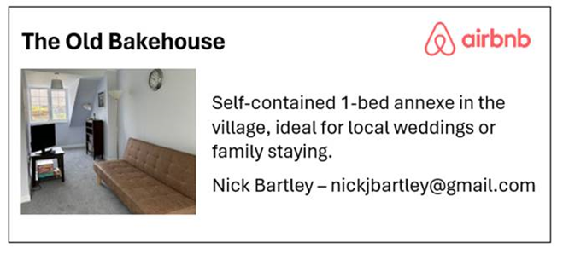
HINTON DECORATING

For competitive rates contact

Ian Black 01258 471453
07842 399910
Or email: ianjamesblack@mail.com


Rose’s Yard
Hinton St Mary
Air B and B
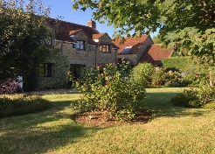

Self-Contained first floor annex
in the centre of the village

sleeping 4

Contact Jo:

jo.martin99@btinternet.com
07860 612412
Or Book Via Air B & B

