
THE MOSAIC
HINTON ST MARY
March 2026


Spring Concert
If you are feeling a bit down and drowned out
by the recent incessant rain, why not try and get
Spring off to a drier and sunnier start by joining
us for our
Spring Concert Saturday 10.45 a.m. 21st March?
Our musical offering comprises, as usual, a very eclectic selection of pieces including
“The Great Gates of Kiev”, “The Man I Love”, a medley from “Oliver” and more.
However, for the very first time we will be joined by some members of the Sturminster Newton Choral Society to lead the singing in a performance of “The Old Hundredth” which many of you may know as Psalm 100.
As ever, the entrance is free and you are cordially welcome to join us in the “Bow Room” afterwards for complimentary drinks and nibbles.
We look forward to seeing you there!
John Harding (for Sturminster Newton Orchestra).

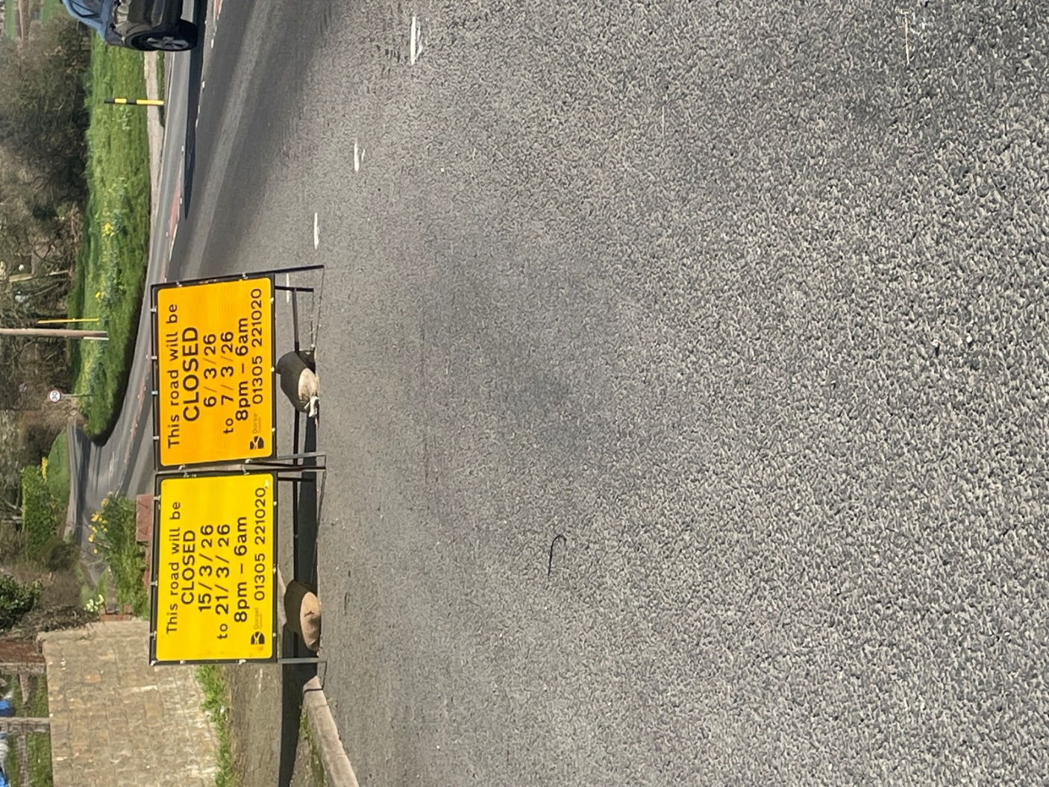
The A30 (Front Street) to East Stour will be closed over night some nights in March. See below:


March 2026 Services

St Peter’s Church
- Date & Time | - Service
Sunday 01 March | Holy Communion (BCP)
Sunday 08 March | Morning Prayer
Sunday 15 March | Morning Prayer
Sunday 22 March | Holy Communion (CW)
Sunday 29 March Palm Sunday | Benefice Holy Communion (CW) 11am
All services at 9:30am unless otherwise noted.

The Church is open daily for sanctuary and prayer

Gardens Open 2026
All queries about Church-related support and services should be directed to the Vicar or Churchwardens.
Vicar: The Reverend Mary Gubbins  01258 721 704 | 07440 680 387 | The Vicarage, Sturminster Newton  revd.mary.gubbins@gmail.com
Churchwardens
Robin Gibbs  01258 471 493  robin@aviaconsult.uk | Kevin Peto-Bostick  01258 475 469  kevin.peto.bostick@gmail.com
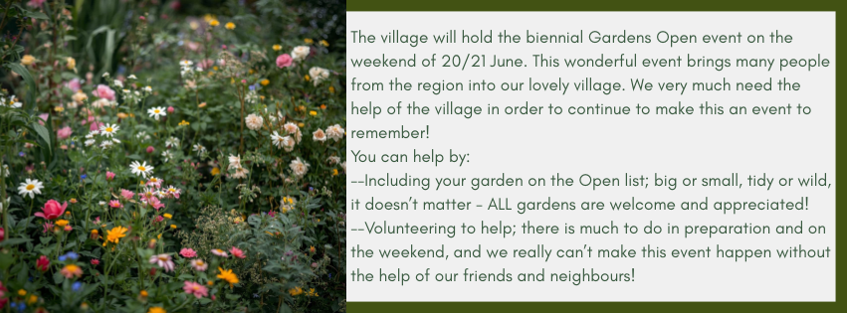
Village Hall Vibes
The VH AGM took place on Thursday 19th February. Thank you to all who attended!
Unfortunately, we have still not appointed a Village Representative to join the committee. If this is something you might be interested in, please make contact to discuss.
The next VH quarterly meeting, is scheduled for Thursday 21st May.
Hall Hire Information
The Village Hall is available to hire during the day and evenings at an hourly rate, plus a coin meter charge for any electricity used.
To arrange a booking, please contact:
Jane Filbey: -
📞 07513 632550
📧 janefilbey1964@gmail.com
Please note: Between 20th February and 10th April, all hall bookings should be directed to:
Lucy Johnson: -
📞 07715 332611
📧 lucyjohnson2009.lj@gmail.com
Hire Prices:
· Per Hour: £5 (Village Residents) / £10 (Non-Village Residents)
· Half Day: £20 (Village Residents) / £40 (Non-Village Residents)
· Full Day: £40 (Village Residents) / £80 (Non-Village Residents)
A £10 deposit is required for all bookings.
Thank you to all the VH hirers for their continued support.
— The Village Hall Trustees

Please let us know what you would like included in your Mosaic

We would be grateful to receive any articles, notices, celebrations, information, quizzes, items for sale etc that villagers would find of interest.

The usual deadline is the 24th of the month.

Thank you
Jo & Nigel
jo.martin99@btinternet.com


Riddle
I am always old, but sometimes new.
While I’m never sad, sometimes I’m blue.
I am never empty, but only sometimes full.
I never push but I always pull.
What am I?

Answer in April Mosaic


THE MONTHLY VILLAGE COFFEE MORNING
TUESDAY 3rd March
10.30 – 12.00
The cost is £1.50– for as much coffee or tea as you can drink
and as many biscuits as you can eat.

BLANDFORD HOSPITAL SHOP WAREHOUSE.
Is open to receive donations at its warehouse in The Building Yard HSM on
Saturday 7th March
10 - 12 midday
Old Poisedale Building, Hinton St. Mary

IF YOU LIVE IN HINTON ST MARY AND DO NOT RECEIVE A COPY OF THE MOSAIC EVERY MONTH – PLEASE LET NIGEL KNOW ON 07710 088322 OR EMAIL DJNMARTIN@BTINTERNET.COM

Please let us have any articles, notices, celebrations, information, items for sale, trusted traders etc you would like to have included in next month’s Mosaic. Deadline 24th of the Month. Thank you, Nigel & Jo. jo.martin99@btinternet.com

VILLAGE HALL to enquire about or book please contact Jane Filbey on 07513 632550 or janefilbey1964@gmail.com

Keep abreast of all things ‘HSM’ on the village facebook page: Hinton St Mary Village Group and the Hinton St Mary Website:
http://www.hintonstmary.com where all previous copies of The Mosaic are also available.

Thank you to our Advertisers and our sponsors:
Mr & Mrs Pitt Rivers, Hinton St Mary Parish Council, St Peter’s Church, HSM Village Hall Committee.

CONTACT THE ESTATE:
If you are out and about on the estate and need to contact us for any reason whatsoever, please call
07511 209705 or email us on info@hintonstmaryestate.com and we will do our best to respond as quickly and possible.
Trusted Traders

These are tradesman/workers who have been personally recommended by villagers. Please let us have details of anybody who has done a great job for you. Thank you.

COMPUTER HELP | TIM WEST | 01258 817537 sturcomputers@hotmail.co.uk
CURTAINS, BLINDS, TRACKS, FABRICS &  FITTING (Marnull) | THE CURTAIN MAN  (Anna & Tony) | 01258 821117 thecurtainmanshop@gmail.com
CARPENTRY/JOINERY | NIGEL BASTABLE | 01258 860459 www.nigelbastable.co.uk
CARPENTRY (& WOODEN FLOORS) | GARY CORCORAN | 07920557651 gccarpentry@hotmail.co.uk
APPLIANCE REPAIRS | ANDY BLANDFORD | 07484 861797 andyblandford1@gmail.com
PEST CONTROL | MARK GOULD  (Rats, Wasps, Moles & Fleas) | 07999 957694 mark_gould2@btconnect.com
BUILDERS | ANDREW TRIM | 07939 541128
FENCING & REPAIRS | DAVID WHITEHAND | 07549 151 799
BOILER MAINTENANCE | BOB JONES & SON | 01963 362 502
CARPET & UPHOLSTERY CLEANING | LUCAS BEAVON  WESSEX CLEANING SERVICES | 07419 324238 info@wessexcleaningservices.com
PRIVATE CARER | TINA BROWN | 0777 5430457
BUILDING & RENOVATION | MARK GORDGE | 07941 443 306
ROOFING | BEN GIBBS ROOFING | 07912 655095 Bengibbs.roof@gmail.com
SCAFFOLDING | EDW SCAFFOLDING | 07474 552259 elwin1965@icloud.com
HEDGE/TREE CUTTING | HAMBLEDONS 0783347833 | 01258 721552 info@hambeldons.co
PLASTERER | ROBBY PROCTOR | 07872 634677 robbyproctor29@gmail.com
CHIMNEY SWEEP | CHRIS PERRINS 07824 698109 | 01258 837499 cfperrins@gmail.com
PLUMBER | GARY WATKINS | 07887 605112 sales@tradetanks.com

Martin Bennett – Local Mechanic
(based in Hinton St Mary)

I repair and service modern and everyday cars as well as specialising in repairing and restoring classic cars.
I have diagnostics equipment available.
Phone 07746817072
Email martin@mbclassiccars.co.uk



NIGEL BASTABLE LTD
CARPENTRY & JOINERY
The Building Yard – Hinton St Mary
Doors, Windows, Wardrobes, Stairs, Kitchens, Cupboards, Bookcases Etc.
Renovations and Repairs
01258 860459
nigelbastable@btinternet.com www.nigelbastable.co.uk

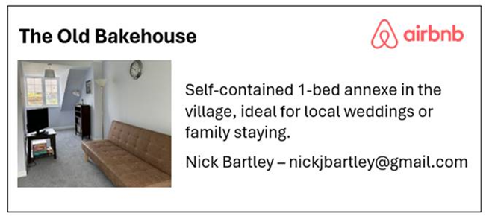
Rose’s Yard
Hinton St Mary
Air B and B
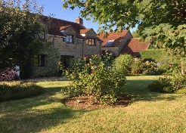

Self-Contained first floor annex
in the centre of the village

sleeping 4

Contact Jo:

jo.martin99@btinternet.com
07860 612412
Or Book Via Air B & B

HINTON DECORATING

For competitive rates contact

Ian Black 01258 471453
07842 399910
Or email: ianjamesblack@mail.com


