
THE MOSAIC
HINTON ST MARY
January 2026

Kids’ Afternoon Tea with Santa

We had an absolutely fantastic turnout for our Kids’ Afternoon Tea with Santa, with 10 families joining us from the village — a total of 46 people. The Tithe Barn was buzzing with festive cheer, excited little faces, and a wonderful sense of community.
Events like this simply wouldn’t be possible without the generosity and support of so many people. A heartfelt thank you to Nigel and Jo for raising funds through their coffee morning, and to Linda for supporting our fundraising event, the Christmas Wreath Workshop, by providing the beautiful greenery. Our thanks also go to Gina and Robin for lending us their delightful snowman, which added the perfect festive touch to the decorations, to Mark for bringing the magic as Santa, and to Liz for kindly donating Millennium Garden apple juice.
A big thank you to Sophie for her help setting up on the day, and to Celia for handmaking the delicious Christmas cakes and treats that were so enjoyed. We’re also very grateful to Mrs Green for bringing the carols to life with her piano playing, creating a wonderfully festive atmosphere. And finally, our thanks to Mr and Mrs Pitt-Rivers for generously allowing us to use the Tithe Barn.
Thank you to everyone who came along — and a special thanks to all who stayed behind to help pack away. We can’t wait to see you at the next event!
From
The Hinton Hub
Gemma & Toni
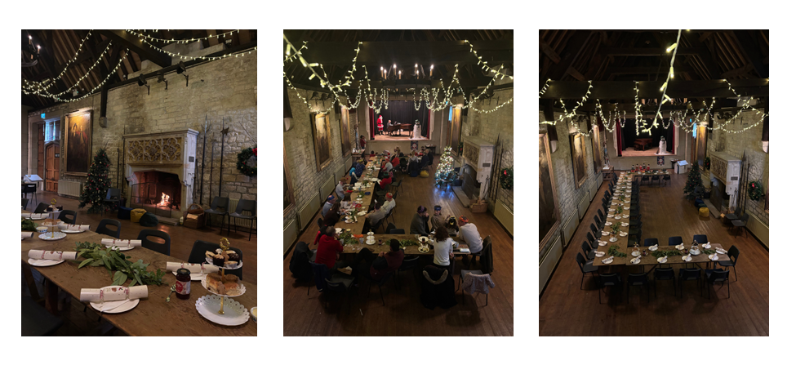

The Village Christmas Party

The village Christmas party was held in the Tithe barn on 12th December where many villagers gathered for an evening of good food, chat and village socialisation. The mulled wine welcome drink went down well and there was some positive feedback on the new food format. The 12 days of Christmas was performed well but perhaps at a reduced decibel level of previous years as the Bartletts were missing due to their staff Christmas party!

Thanks to Mr & Mrs Pitt-Rivers for allowing us to use the wonderful Tithe barn and thanks to the organising committee led by Jane Filbey. Thanks to DJ Wolf (Warren) for the music. Thanks to all villagers who attended; we are lucky to live in such a lovely village with a great community spirit.

Charles Wright
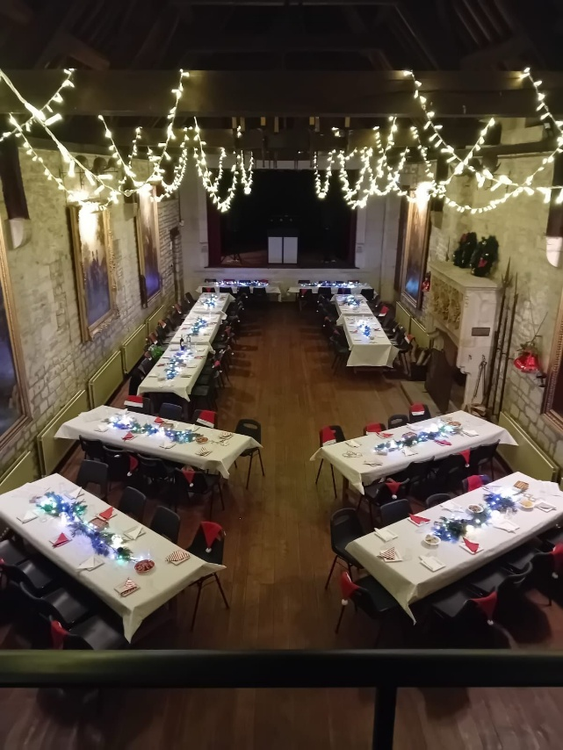
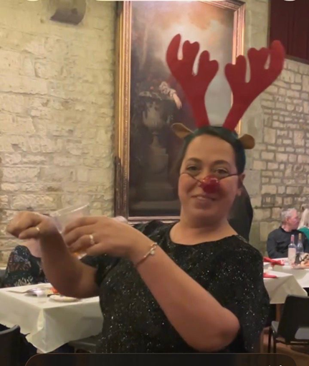

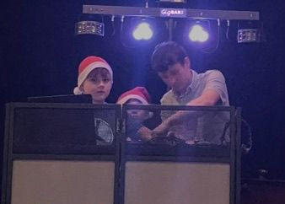

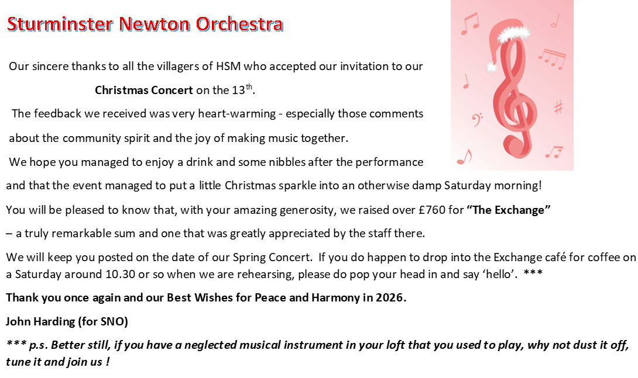

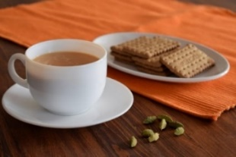
THE MONTHLY VILLAGE COFFEE MORNING
TUESDAY 4TH JANUARY
TUESDAY 3rd FEBRUARY
10.30 – 12.00
The cost is £1.50– for as much coffee or tea as you can drink
and as many biscuits as you can eat.

BLANDFORD HOSPITAL SHOP WAREHOUSE.
Is open to receive donations at its warehouse in The Building Yard HSM on
Saturday 7th February
10 - 12 midday
Old Poisedale Building, Hinton St. Mary

IF YOU LIVE IN HINTON ST MARY AND DO NOT RECEIVE A COPY OF THE MOSAIC EVERY MONTH – PLEASE LET NIGEL KNOW ON 07710 088322 OR EMAIL DJNMARTIN@BTINTERNET.COM

Please let us have any articles, notices, celebrations, information, items for sale, trusted traders etc you would like to have included in next month’s Mosaic. Deadline 24th of the Month. Thank you, Nigel & Jo. jo.martin99@btinternet.com

VILLAGE HALL to enquire about or book please contact Jane Filbey on 07513 632550 or janefilbey1964@gmail.com

Keep abreast of all things ‘HSM’ on the village facebook page: Hinton St Mary Village Group and the Hinton St Mary Website:
http://www.hintonstmary.com where all previous copies of The Mosaic are also available.

Thank you to our Advertisers and our sponsors:
Mr & Mrs Pitt Rivers, Hinton St Mary Parish Council, St Peter’s Church, HSM Village Hall Committee.

CONTACT THE ESTATE:
If you are out and about on the estate and need to contact us for any reason whatsoever, please call
07511 209705 or email us on info@hintonstmaryestate.com and we will do our best to respond as quickly and possible.
Trusted Traders

These are tradesman/workers who have been personally recommended by villagers. Please let us have details of anybody who has done a great job for you. Thank you.

COMPUTER HELP | TIM WEST | 01258 817537 sturcomputers@hotmail.co.uk
CURTAINS, BLINDS, TRACKS, FABRICS &  FITTING (Marnull) | THE CURTAIN MAN  (Anna & Tony) | 01258 821117 thecurtainmanshop@gmail.com
CARPENTRY/JOINERY | NIGEL BASTABLE | 01258 860459 www.nigelbastable.co.uk
CARPENTRY (& WOODEN FLOORS) | GARY CORCORAN | 07920557651 gccarpentry@hotmail.co.uk
APPLIANCE REPAIRS | ANDY BLANDFORD | 07484 861797 andyblandford1@gmail.com
PEST CONTROL | MARK GOULD  (Rats, Wasps, Moles & Fleas) | 07999 957694 mark_gould2@btconnect.com
BUILDERS | ANDREW TRIM | 07939 541128
FENCING & REPAIRS | DAVID WHITEHAND | 07549 151 799
BOILER MAINTENANCE | BOB JONES & SON | 01963 362 502
CARPET & UPHOLSTERY CLEANING | LUCAS BEAVON  WESSEX CLEANING SERVICES | 07419 324238 info@wessexcleaningservices.com
PRIVATE CARER | TINA BROWN | 0777 5430457
BUILDING & RENOVATION | MARK GORDGE | 07941 443 306
ROOFING | BEN GIBBS ROOFING | 07912 655095 Bengibbs.roof@gmail.com
SCAFFOLDING | EDW SCAFFOLDING | 07474 552259 elwin1965@icloud.com
HEDGE/TREE CUTTING | HAMBLEDONS 0783347833 | 01258 721552 info@hambeldons.co
PLASTERER | ROBBY PROCTOR | 07872 634677 robbyproctor29@gmail.com
CHIMNEY SWEEP | CHRIS PERRINS 07824 698109 | 01258 837499 cfperrins@gmail.com

NIGEL BASTABLE LTD
CARPENTRY & JOINERY
The Building Yard – Hinton St Mary
Doors, Windows, Wardrobes, Stairs, Kitchens, Cupboards, Bookcases Etc.
Renovations and Repairs
01258 860459
nigelbastable@btinternet.com www.nigelbastable.co.uk

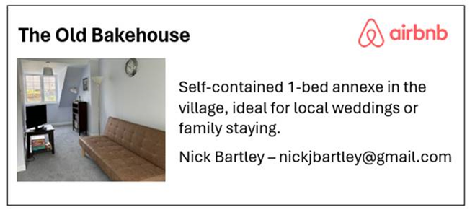
Rose’s Yard
Hinton St Mary
Air B and B
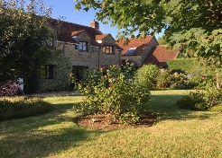

Self-Contained first floor annex
in the centre of the village

sleeping 4

Contact Jo:

jo.martin99@btinternet.com
07860 612412
Or Book Via Air B & B


HINTON DECORATING

For competitive rates contact

Ian Black 01258 471453
07842 399910
Or email: ianjamesblack@mail.com


