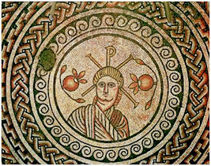
_{THE MOSAIC}
HINTON ST MARY
December 2025


We would like to take this oppportunity to thank everybody who delivers the Mosaic each month and to wish all of our contributors and readers a very
Happy Christmas and a peaceful and healthy 2026.
Due to the Christmas and New Year break the January Mosaic will not be out until the 2nd week of January.

Millennium Garden Update
After facing the challenges and work needed to restore the garden after a particularly difficult dry summer, it has been wonderful and often surprising to see the resilience of the plants and a notable return of insects to the area, even so late in the year,
Much of our recent work has focused on tidying up the orchard area, particularly the essential task of clearing fallen fruit and leaves. This has been demanding but necessary to maintain the health of the orchard area. However, through this process concerns have grown regarding the well-being of our fruit trees. The combination of an extended dry spell and the strain of a heavy fruiting season has clearly taken its toll,
And we are increasingly concerned that the trees need work to allow them to continue to thrive and produce.
Ongoing Work and Volunteer Support
We have begun the process of trimming back some of the overgrown boughs that are within easy reach, but there remains a substantial amount of work still to be done. For this reason, we are reaching out to anyone in the community willing to join us in fruit tree pruning. Some experience would be helpful but not essential. If you are able to spare just a couple of hours at your convenience, your assistance would be greatly appreciated. By focusing on the orchard area at this time, we hope that we can preserve the unusual varieties, which we are lucky enough to have as a village for the future.
If you can help:
Please contact me on gmjames28@icloud.com.



Note from the Christmas Party Organising Committee:
Please note the correct start time is 7pm as stated above. (Not 7.30 as previously advised.)
We have listened to feedback from past years and this year:
- Mulled wine and other options including apple juice will be available as a welcome drink.
- To avoid queuing please bring finger buffet food which we ask you to place at the table you sit at.
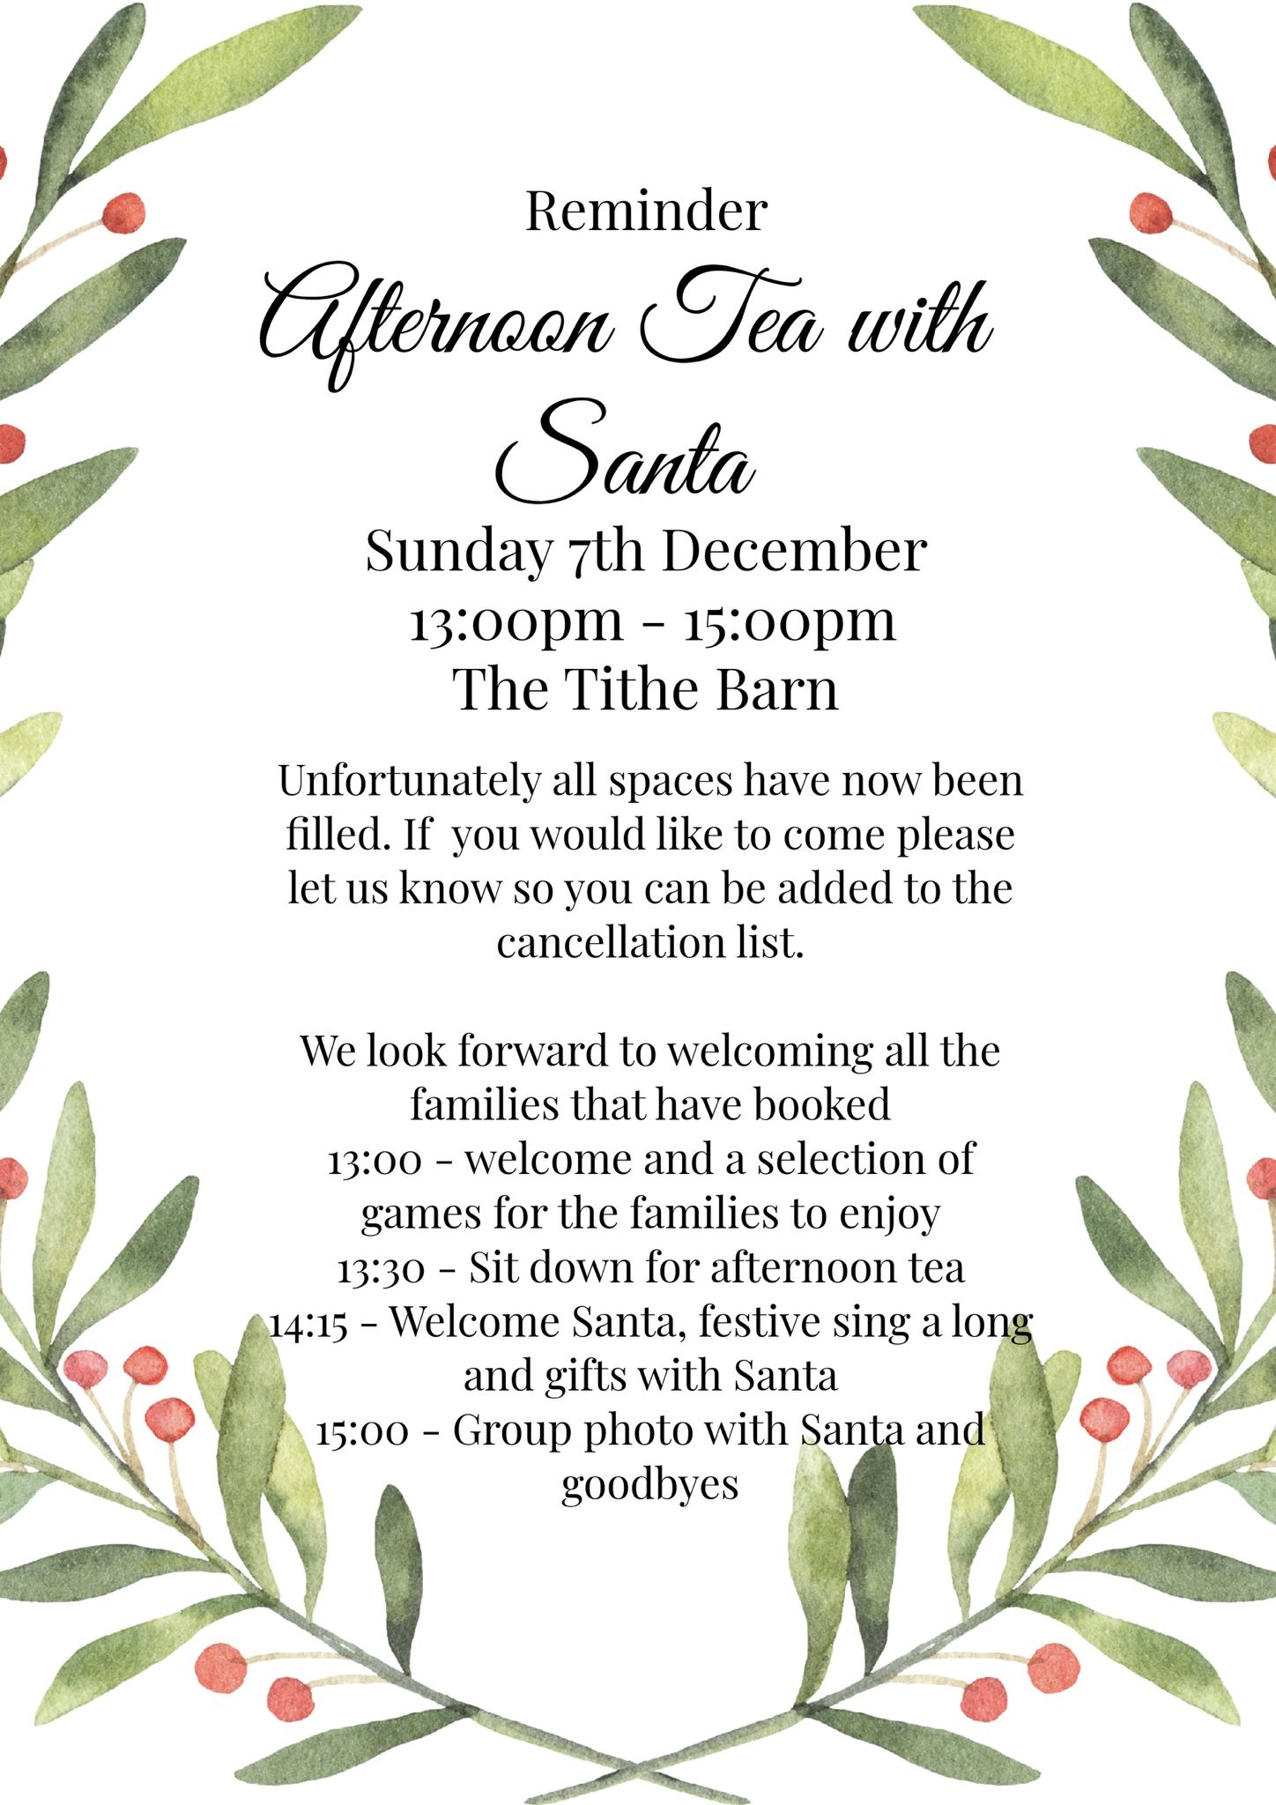

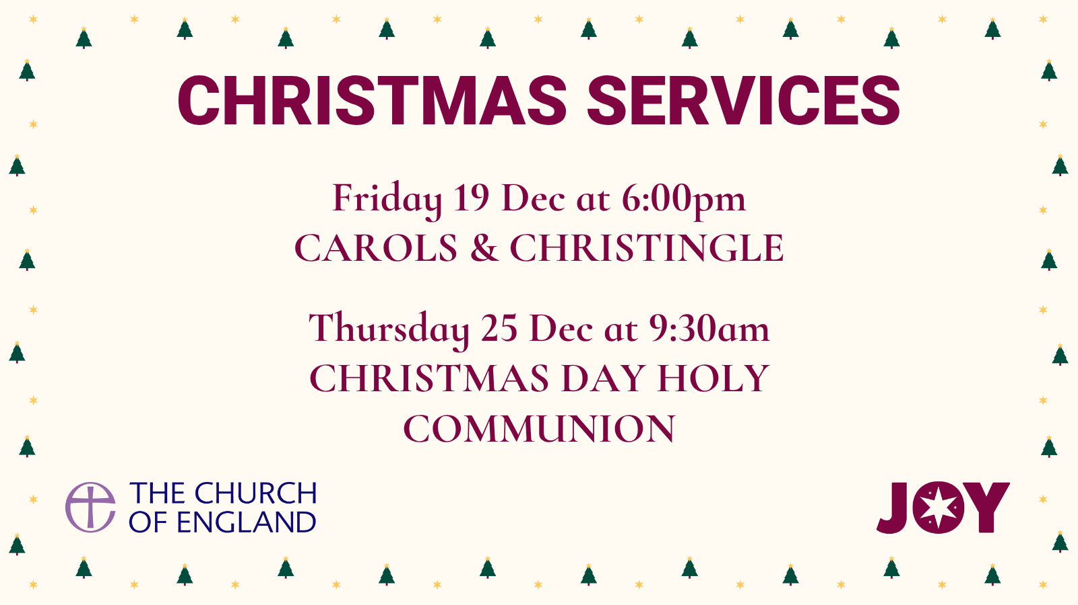
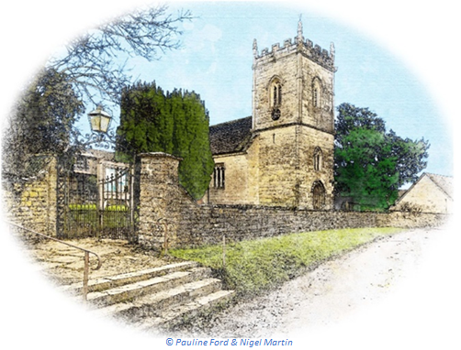
December 2025 Services

The Church is open daily for sanctuary and prayer

St Peter’s Church - Hinton St Mary
Date & Time | Service
Sunday 7 December 9:30am | Holy Communion (BCP)
Sunday 14 December 9:30am | Morning Prayer
Friday 19 December 6:00pm | Carols & Christingle
Sunday 21 December 9:30am | Morning Prayer
Thursday 25 December 9:30am | Christmas Morning Holy Communion
Sunday 28 December 9:30am | Morning Prayer
Sunday 4 January 9:30am | Holy Communion (BCP)
All queries about Church-related support and services should be directed to the Vicar or Churchwardens
Vicar: The Reverend Mary Gubbins
01258 721 704 | 07440 680 387
The Vicarage, Sturminster Newton
revd.mary.gubbins@gmail.com
Churchwardens
Robin Gibbs  01258 471 493  robin@aviaconsult.uk | Kevin Peto-Bostick  01258 475 469  kevin.peto.bostick@gmail.com
Hello Hinton
We had a fantastic Halloween party at the end of October. A great turnout from some very spooky villagers. Thank you to DJ Wolf and Lucy Johnson for her great decorations. We had some amazing contenders for best costume. We must give special mention to Robbie, Sophie, Ray & Jenna as The Incredibles, Lucy as a very creepy scarecrow (she is to blame if amazon won’t deliver to Hinton anymore!) Emily and Jack as the duo from Breaking Bad but you can’t beat a man in drag! Congratulations to Ed Townsend (Harley Quinn) and Mark Steggs (Wednesday Adams.) Ian Black had the best pumpkin with his self-portrait. All three won a £15 drinks voucher for The White Horse .
Last Sunday evening we hosted a Beaujolais evening with a 3 course dinner accompanied by 3 Beaujolais wines, talks by wine experts Pierre & Dan and a performance from The Belle St Duo. It was a sold out event & a great success- thank you for all your support.
We are now gearing up for Christmas and New Year. Please see our Opening Hours and book as early as you can to avoid disappointment. We are also open Christmas Day 12 until 2pm for drinks please pop in and see us.
New Year’s Eve we are open until late with DJ Wolf. We will be closed from New Year’s Day until Wednesday the 7th of January when we will return to our usual opening times until we take our annual holiday in February.
From all of us at The White Horse we wish everyone in Hinton a very Merry Christmas and a Happy New Year.
Monday 22nd and Tuesday 23rd December open for Lunch and Dinner
Wednesday 24th Christmas Eve open for Lunch, Dinner and all day for drinks
Thursday 25th Christmas Day open 12pm -2pm for drinks
Friday 26th Boxing Day Closed
Saturday 27th December open for Lunch and Dinner
Sunday 28th December open for Lunch
Monday 29th , Tuesday 30th & Wednesday 31st of December open for Lunch and Dinner
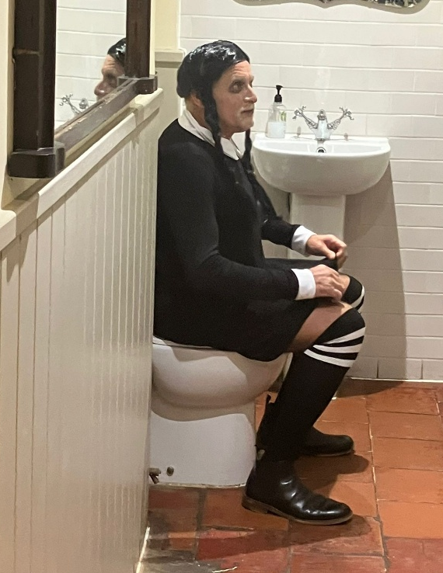
January 1st – January 6th Closed
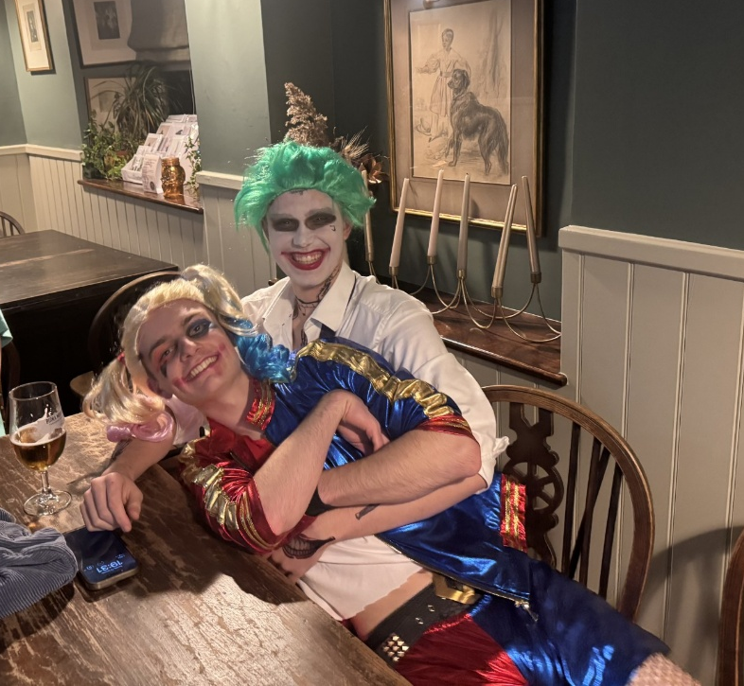
January 7th Back to normal opening times
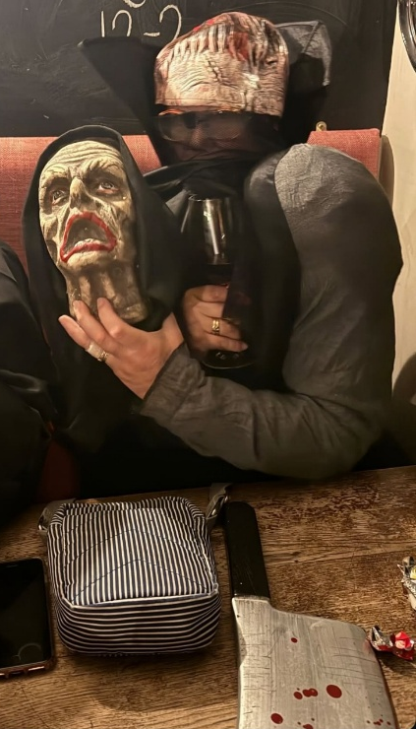
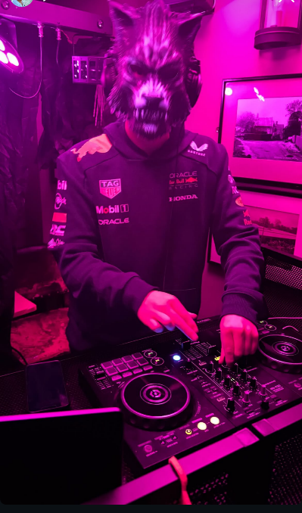
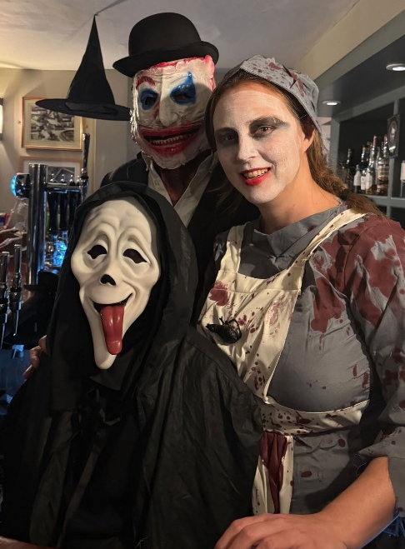

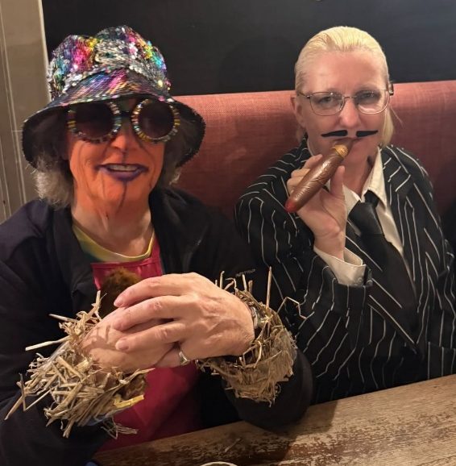
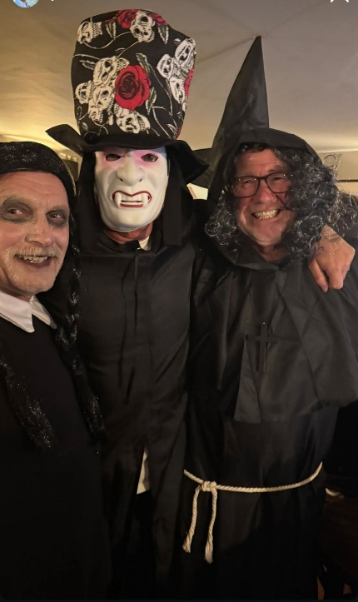



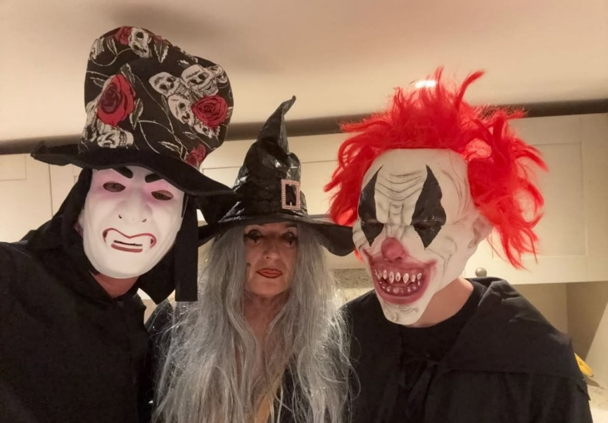


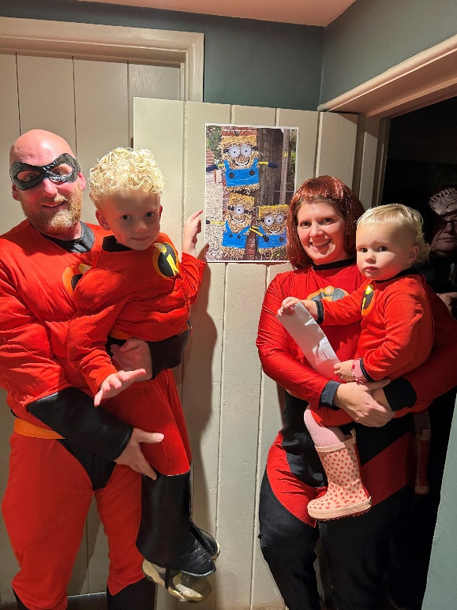

🎄Village Hall Vibes
As we approach the end of 2025, the Village Hall Committee held its final quarterly meeting of the year on Friday, 21st November. We’re pleased to report that hall bookings remain steady, ensuring the hall continues to be financially secure.
Looking ahead to the new year, we have plans for some much-needed maintenance and redecoration. These improvements will help create a brighter, more welcoming space for all our users and community groups.
We would also like to remind residents that we are still seeking a village representative to join the committee. This is a valuable opportunity to support the running of an important community asset. If you’re interested in getting involved, we would be delighted to hear from you.
Thank you for your continued support throughout the year.
— The Village Hall Team

Village Apple Juice
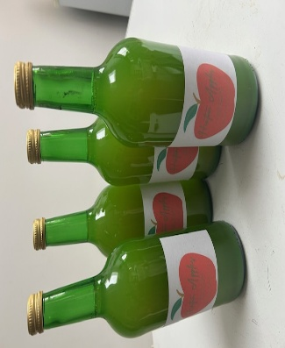
Thanks to those who contributed fruit or helped with picking, we made 134 bottles of juice from Hinton apples this year. The juice was processed, bottled and pasteurised for us by Bridge Farm Cider near Yeovil to last at least a year in the bottle, at a cost of £2 per bottle.
We have now sold the majority of bottles, with contributions above the actual cost going to The Farming Community Network, the charity supported by this year’s Village Harvest Festival and so far have raised £50 for the charity.
There are still a few bottles left if anyone has missed out and Root and Vine have kindly offered to sell any remaining bottles for us. Contact Liz Collins on 07377389453 if you are interested - they might make good gifts for Christmas!
………………………………………………………………………………………………………………………………………………………………………
TACK SALE
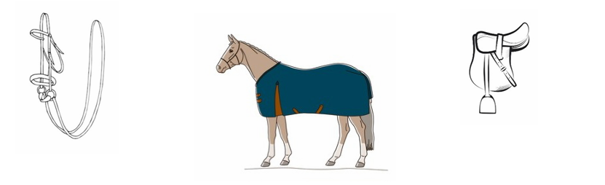

WILLIAM FOX-PITT IS HAVING A YARD CLEAROUT SALE
ON SUNDAY 7TH DECEMBER
FROM 10AM-3PM
AT HINTON WORKSPACE, DT10 1NA
What3Words https://w3w.co////others.evoke.button
Come and buy a Christmas present or
use this opportunity to find a bargain
Saddles, various bridles, bits, rugs
and MUCH MUCH MORE

Cash preferred but card machine also available

Sturminster Newton Orchestra

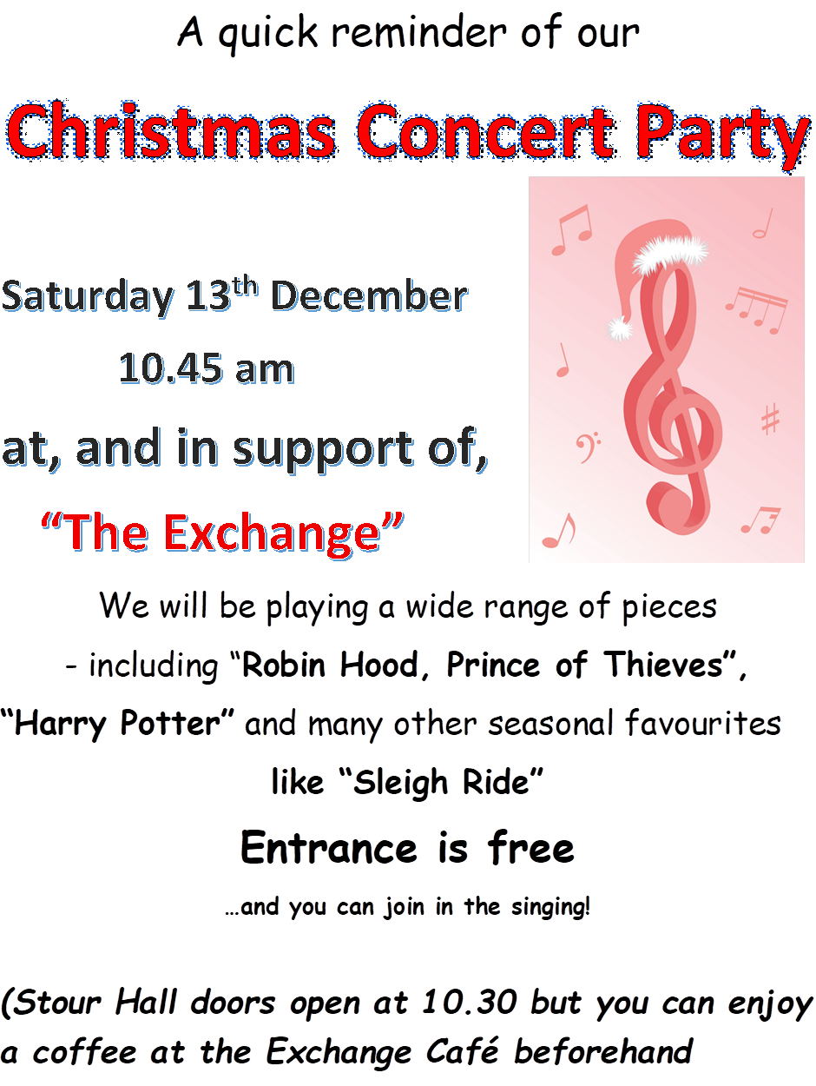

BIG NEWS 🚀FROM THE HINTON WORKSPACE
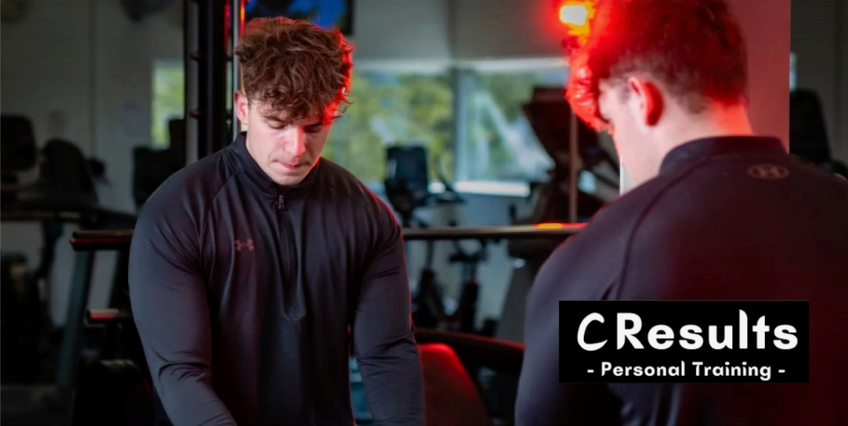
IN THE GARAGE....

We’re excited to share that the garage is set to become a high-impact gym space in collaboration with young fitness entrepreneur Cam Taylor, founder of C-Results.
Cam will be delivering personal training, one-to-one sessions, and small group classes from HIIT, kettlebells, barbell conditioning, and smart, strength-focused training. All designed to build confidence, capability and real results.
If you’re ready to make 2026 your year for building business muscle and real muscle, this could be exactly what you need.
Opening January / February

JUST ACROSS THE COURTYARD....
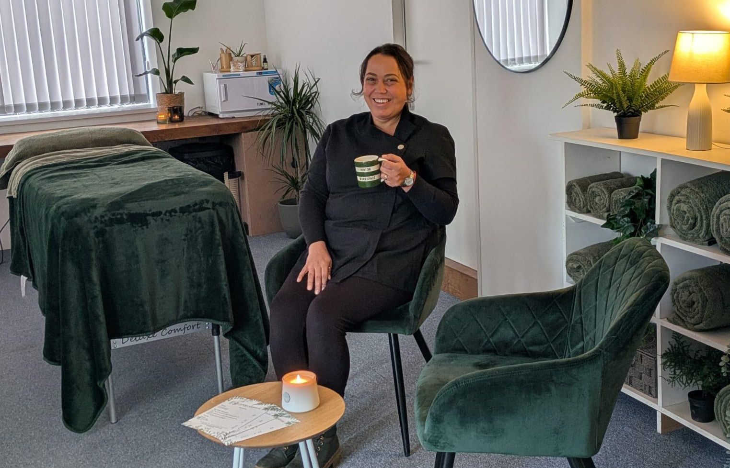

We’re absolutely thrilled to welcome Gemma Hampton, who is bringing her new beauty and wellbeing practice to Hinton Workspace.
Gemma specialises in professional facials, holistic body treatments and expert waxing services.
It’s a brilliant addition to life at Hinton and genuinely means there’s almost no reason to leave Hinton St Mary again!
Opening January

Richard Collins has asked us to publish the following:
“It’s time we thanked Jo and Nigel Martin for their contribution to village life over the past years. Not only do they edit the Mosaic, making it such a good read, but they also serve coffee and biscuits every month in the village hall, giving us all the opportunity to meet, catch up on local gossip and keep up to date with events. Nigel announced recently that the coffee mornings had generated hundreds of pounds of profit which is being given to various village organisations, making a big difference to each of their activities. We are very grateful for your hard work and dedication to the village.”
*****
Thank you very much Richard for you kind words, which are much appreciated. We both really enjoy living in Hinton and being part of village life!
We would like to add our thanks to all the other people in the village who contribute so much of their time to help make Hinton such a lovely place to live – including (but not limited to), everybody who delivers the Mosaic each month, the dedicated people who maintain our lovely Millenium Gardens, Rev. Mary, everybody involved in running and maintaining the church, including cutting the grass and arranging the flowers etc, our Parish Councillors and everyone who gets involved in the juice making, The Village Hall Committee, The Hinton Hubb, The Hinton Work Space, The Christmas Party Committee and the Children’s Party committee. And of course, Mr and Mrs Pitt Rivers for allowing the village to use the Tithe Barn for village events and the fabulous team at the White Horse!
Jo & Nigel

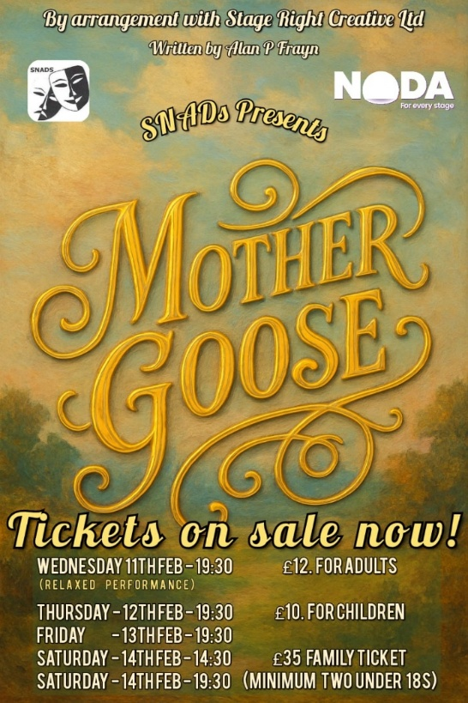

SNADS latest adventure takes us to the pantomime world of Mother Goose! Directed by Craig White and Jess Allen, Produced by John Skinner, our 2026 pantomime is one you won’t want to miss!! Tickets on sale NOW from the Exchange



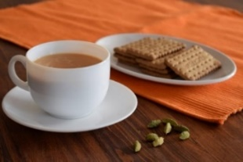
THE MONTHLY VILLAGE COFFEE MORNING
TUESDAY 2ND December
10.30 – 12.00
& TUESDAY 6TH JANUARY
10.30 – 12.00
The cost is £1.50– for as much coffee or tea as you can drink
and as many biscuits as you can eat.

BLANDFORD HOSPITAL SHOP WAREHOUSE.
Is open to receive donations at its warehouse in The Building Yard HSM on
Saturday 6th December
10 - 12 midday
Old Poisedale Building, Hinton St. Mary

IF YOU LIVE IN HINTON ST MARY AND DO NOT RECEIVE A COPY OF THE MOSAIC EVERY MONTH – PLEASE LET NIGEL KNOW ON 07710 088322 OR EMAIL DJNMARTIN@BTINTERNET.COM

Please let us have any articles, notices, celebrations, information, items for sale, trusted traders etc you would like to have included in next month’s Mosaic. Deadline 24th of the Month. Thank you, Nigel & Jo. jo.martin99@btinternet.com

VILLAGE HALL to enquire about or book please contact Jane Filbey on 07513 632550 or janefilbey1964@gmail.com

Keep abreast of all things ‘HSM’ on the village facebook page: Hinton St Mary Village Group and the Hinton St Mary Website:
http://www.hintonstmary.com where all previous copies of The Mosaic are also available.

Thank you to our Advertisers and our sponsors:
Mr & Mrs Pitt Rivers, Hinton St Mary Parish Council, St Peter’s Church, HSM Village Hall Committee.

CONTACT THE ESTATE:
If you are out and about on the estate and need to contact us for any reason whatsoever, please call
07511 209705 or email us on info@hintonstmaryestate.com and we will do our best to respond as quickly and possible.
Trusted Traders

These are tradesman/workers who have been personally recommended by villagers. Please let us have details of anybody who has done a great job for you. Thank you.

COMPUTER HELP | TIM WEST | 01258 817537 sturcomputers@hotmail.co.uk
CURTAINS, BLINDS, TRACKS, FABRICS &  FITTING (Marnull) | THE CURTAIN MAN  (Anna & Tony) | 01258 821117 thecurtainmanshop@gmail.com
CARPENTRY/JOINERY | NIGEL BASTABLE | 01258 860459 www.nigelbastable.co.uk
CARPENTRY (& WOODEN FLOORS) | GARY CORCORAN | 07920557651 gccarpentry@hotmail.co.uk
APPLIANCE REPAIRS | ANDY BLANDFORD | 07484 861797 andyblandford1@gmail.com
PEST CONTROL | MARK GOULD  (Rats, Wasps, Moles & Fleas) | 07999 957694 mark_gould2@btconnect.com
BUILDERS | ANDREW TRIM | 07939 541128
FENCING & REPAIRS | DAVID WHITEHAND | 07549 151 799
BOILER MAINTENANCE | BOB JONES & SON | 01963 362 502
CARPET & UPHOLSTERY CLEANING | LUCAS BEAVON  WESSEX CLEANING SERVICES | 07419 324238 info@wessexcleaningservices.com
PRIVATE CARER | TINA BROWN | 0777 5430457
BUILDING & RENOVATION | MARK GORDGE | 07941 443 306
ROOFING | BEN GIBBS ROOFING | 07912 655095 Bengibbs.roof@gmail.com
SCAFFOLDING | EDW SCAFFOLDING | 07474 552259 elwin1965@icloud.com
HEDGE/TREE CUTTING | HAMBLEDONS 0783347833 | 01258 721552 info@hambeldons.co
PLASTERER | ROBBY PROCTOR | 07872 634677 robbyproctor29@gmail.com
CHIMNEY SWEEP | CHRIS PERRINS 07824 698109 | 01258 837499 cfperrins@gmail.com

NIGEL BASTABLE LTD
CARPENTRY & JOINERY
The Building Yard – Hinton St Mary
Doors, Windows, Wardrobes, Stairs, Kitchens, Cupboards, Bookcases Etc.
Renovations and Repairs
01258 860459
nigelbastable@btinternet.com www.nigelbastable.co.uk

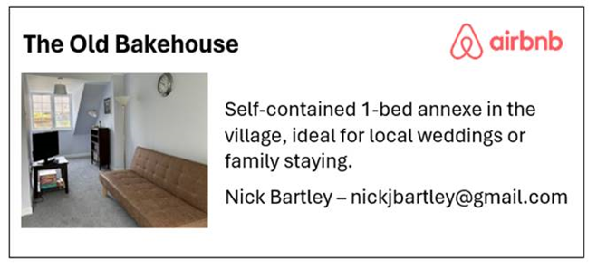
Rose’s Yard
Hinton St Mary
Air B and B
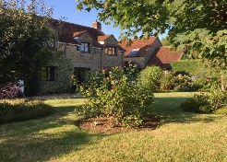

Self-Contained first floor annex
in the centre of the village

sleeping 4

Contact Jo:

jo.martin99@btinternet.com
07860 612412
Or Book Via Air B & B


HINTON DECORATING

For competitive rates contact

Ian Black 01258 471453
07842 399910
Or email: ianjamesblack@mail.com


What’s on at the Hinton Workspace in December:
3rd December 6pm What the Budget means for you
11th December 9-11am The Hustle
8th January 6-8pm Handwrite your way to Health
15th January 6-8pm Making Money from Property

For more information or to book see website or email reception@hintonworkshpce.co.uk

