
THE MOSAIC
HINTON ST MARY
February 2026

Happy New Year Hinton
In the Autumn we launched our new house lager “Mosaic”. From every pint sold we donate 5p to different worthy causes. By Christmas we had raised £65 for dogs 4 rescue. A unique kennel free rescue, which uses dogs to rehabilitate other dogs giving them a better chance of being rehomed successfully and giving dogs that cannot be rehomed a place for life.
We are closing for our annual holiday from the 11th of February and returning on the 25th of February.
Before we go we have a quiz night on the 1st of February with Mark & Jane. 7pm start, teams up to 6 and only £2 entry.
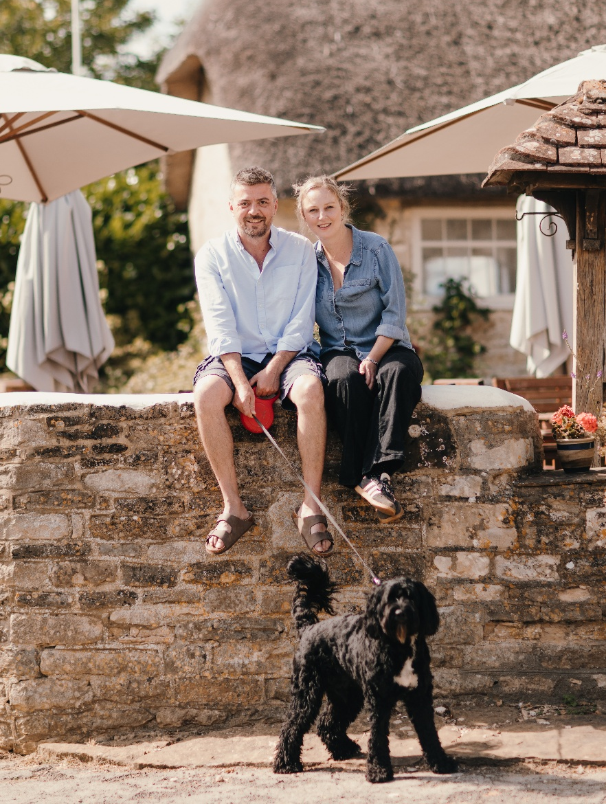
Help us drink the beer on Sunday the 8th of February before we close. Belle St Duo are performing from 6pm. Come and drink and dance the winter blues away.
When we get back- we have another quiz night on Sunday 1st of March with guest quiz masters Kevin and Alex while Mark & Jane have a well-earned holiday. 7pm start and teams up to 6, £2 entry as per usual.
We are also planning an Italian small plates evening “cicchetti” for spring, dates & details to be confirmed.
Thank you all for your support in 2025 and looking forward to 2026!
Best Wishes
Andy, Mel & Team White Horse

Village Hall Vibes
Happy New Year to everyone from the Village Hall Committee!
We would like to let all users know that there may be some disruption to regular bookings in the near future due to internal redecoration. Any bookings affected will be notified in good time, and we apologise in advance for any inconvenience this may cause.
Hall Hire Information
The Village Hall is available to hire during the day and evenings at an hourly rate, plus a coin meter charge for any electricity used.
To arrange a booking, please contact:
Jane Filbey: -
📞 07513 632550
📧 janefilbey1964@gmail.com
Please note: Between 20th February and 10th April, all hall bookings should be directed to:
Lucy Johnson: -
📞 07715 332611
📧 lucyjohnson2009.lj@gmail.com
Hire Prices:
- Per Hour: £5 (Village Residents) / £10 (Non-Village Residents)
- Half Day: £20 (Village Residents) / £40 (Non-Village Residents)
- Full Day: £40 (Village Residents) / £80 (Non-Village Residents)
A £10 deposit is required for all bookings.
We rely on bookings to keep the Village Hall financially viable, as costs continue to rise for utilities, maintenance and other essentials. We are incredibly lucky to have such a wonderful facility in our village and are keen to ensure it continues to thrive.
Please consider the Village Hall if you — or someone you know — are planning a children’s party, family gathering, field sports, BBQ, bouncy castle, charity event, or looking for a quiet space for a meeting, art class or similar activity. The uses are endless! The hall includes a small but functional kitchen for drinks and snacks, a beautiful veranda with amazing views, and plenty of car parking.
Village Hall AGM
The AGM will take place on Thursday 19th February at 7:00pm. Everyone is very welcome to attend, and it would be lovely to see more villagers there. We welcome ideas and offers of help.
We are also seeking a Village Representative to join the committee. If this is something you might be interested in, the AGM would be a great opportunity to have a chat with us.
— The Village Hall Trustees

TEMPORARY ROAD CLOSURE VEALS LANE 20th to 23rd MARCH 09.30 - 15.30

Dear Hinton St Mary Residents,
Please note that following the report of uneven road surface in Veals Lane where Castlemans Lane joins, Dorset Council is proposing to close the road to allow road repairs to be completed.
Hinton St Mary Parish Council
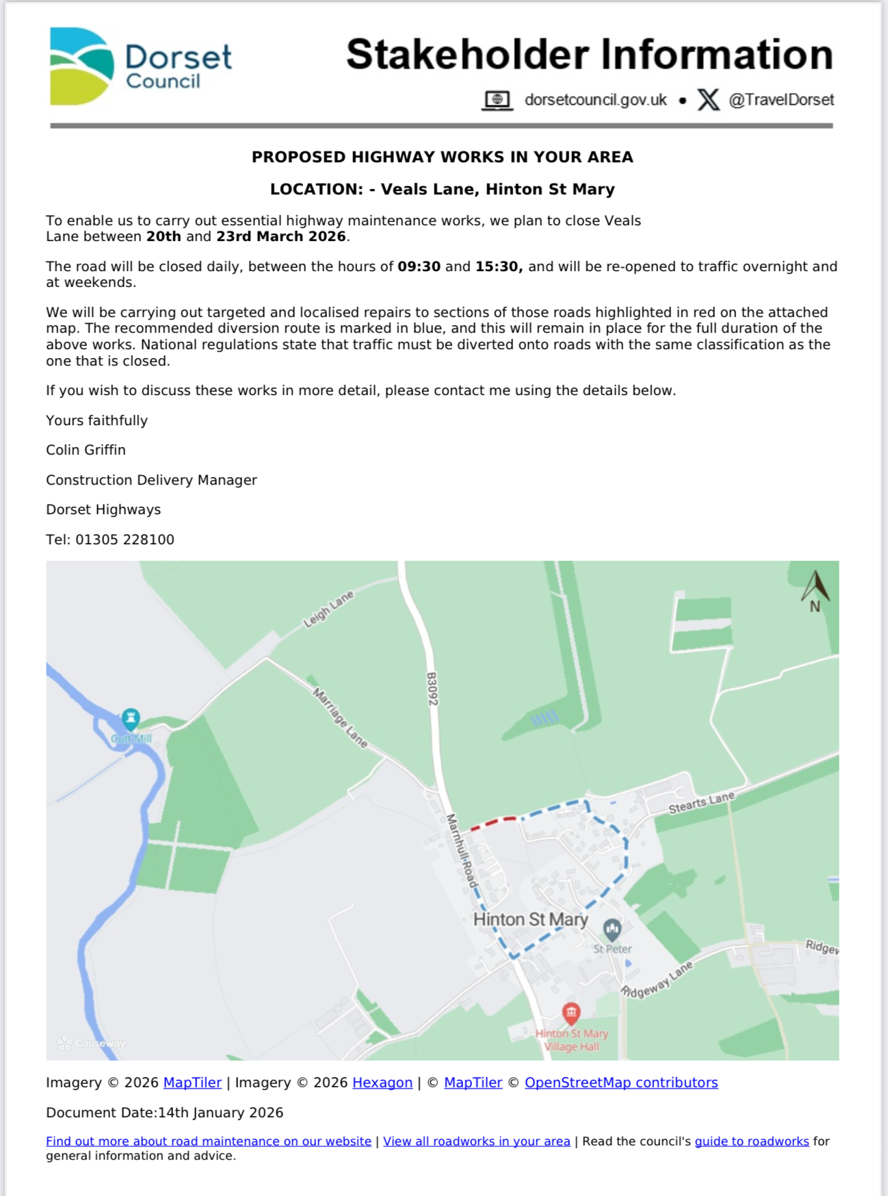

Whilst these works are being completed, access to properties and businesses will be maintained as appropriate. We may ask the public to wait for a short time whilst we move machinery or carry out a task.

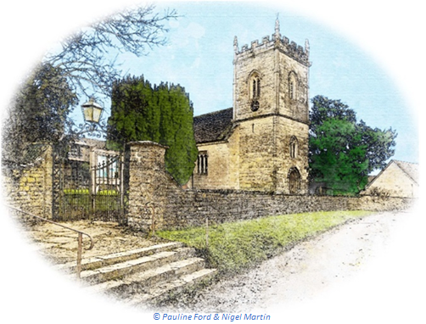
February 2026 Services

St Peter’s Church
- Date & Time | - Service
Sunday 01 Feb | Holy Communion (BCP)
Sunday 08 Feb | Morning Prayer
Sunday 15 Feb | Morning Prayer
Wednesday 18 Feb 7:00pm | Holy Communion  (Ash Wednesday)
Sunday 22 Feb | Holy Communion (CW)
All services at 9:30am unless otherwise noted.

The Church is open daily for sanctuary and prayer

Gardens Open 2026
All queries about Church-related support and services should be directed to the Vicar or Churchwardens.
Vicar: The Reverend Mary Gubbins  01258 721 704 | 07440 680 387 | The Vicarage, Sturminster Newton  revd.mary.gubbins@gmail.com
Churchwardens
Robin Gibbs  01258 471 493  robin@aviaconsult.uk | Kevin Peto-Bostick  01258 475 469  kevin.peto.bostick@gmail.com
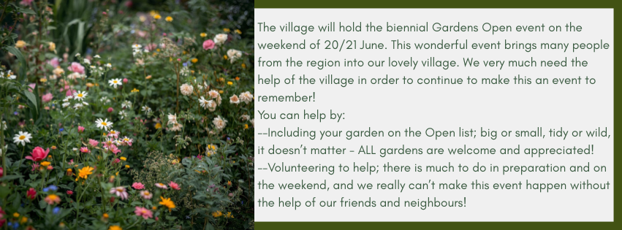

Martin Bennett – Local Mechanic located in Hinton St Mary
Hi All
I thought it was about time I introduced myself. I have had a classic car repair and restoration business in Hinton for over 6 years now. I try to mainly focus on classic cars pre-1990, however I am more than happy to repair or service any modern or every day cars for villagers.
I look after several cars in the village, both classic and modern and I thought I would just put the word out in case this would be helpful to anyone. I’ve been in the trade since 2010 and I have diagnostic equipment to hand.
If you would like to get in contact , my number is 07746 817072. Alternatively you are more than welcome to drop a message, or email me at martin@mbclassiccars.co.uk
Many thanks
Martin

Hinton & Ibberton Cricket Club

Hinton & Ibberton cc recently enjoyed their end of season gathering. Prizes and gifts were handed out and thanks given to all that have been involved. Special thanks went to Mel, Andy and all at The White Horse for the continued support and fantastic food, and Joe Willey for his efforts working on our pitches. A special award went to Norman Damerall, for his incredible devotion to our cricket. After a life time of being involved on the field, he has took the decision to retire and be a lot safer watching from the boundary.
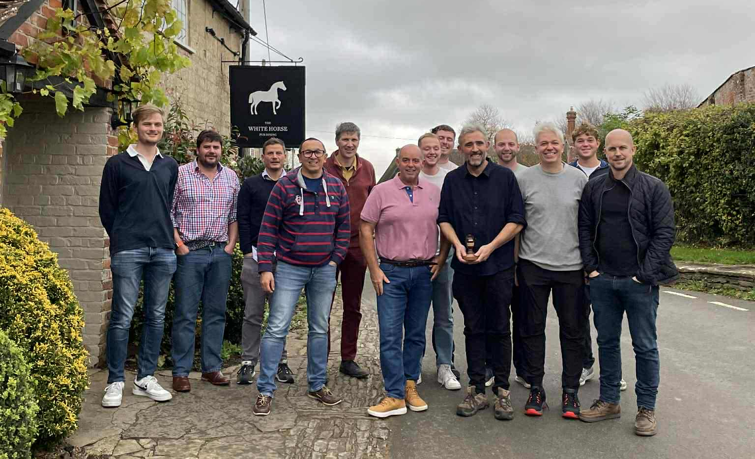
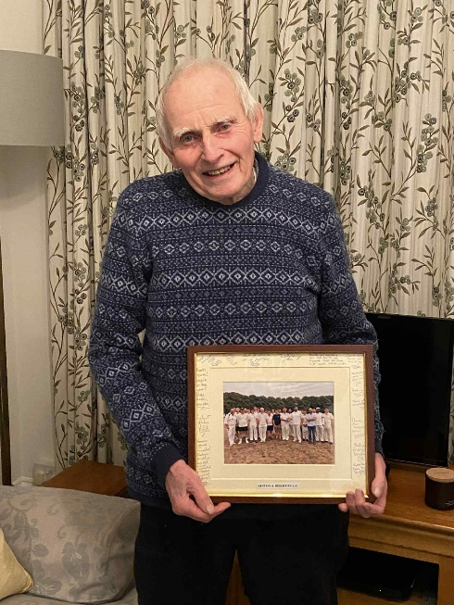

Hinton St Mary Role of Honour 1915 - 1918

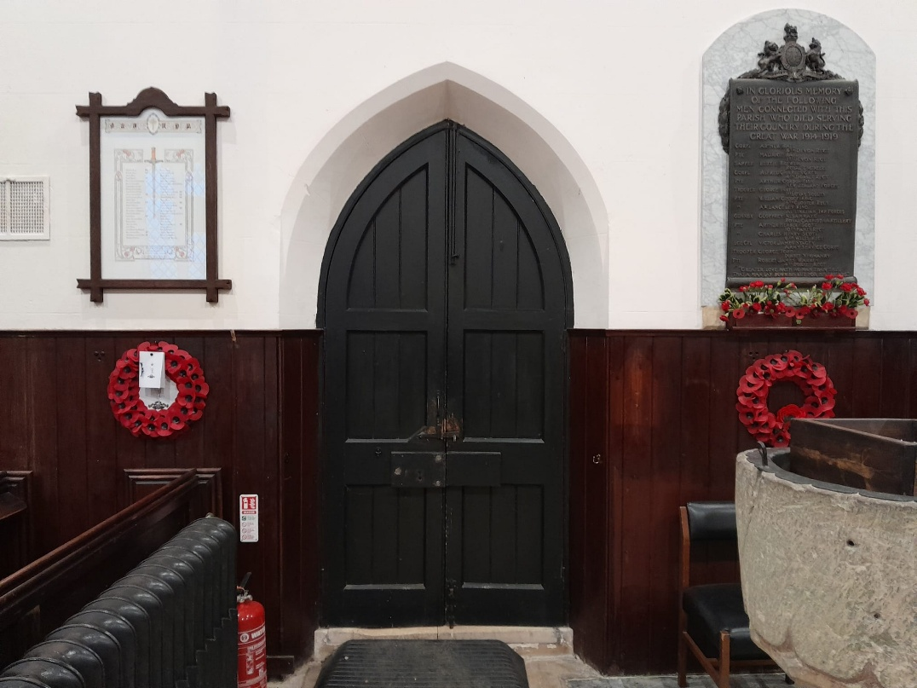
The Role of Honour: a tribute to the courage and sacrifice of all those from this village who served and who we remember with pride.

The original Role of Honour, created on vellum by E T Delt, was hung and dedicated* by the Bishop of Salisbury in St Peter’s Church on the 1st of August 1920.
The framed document was re-discovered, abandoned and seriously dilapidated in the church during work on the heating system. The frame had rotted and the vellum firmly stuck to the glass by an active fungal infestation and likely to disintegrate if disturbed.
After extremely delicate, humidity-controlled, work, Dorset History Centre conservationists separated the remains of the document from the frame. It is now preserved, and may be viewed by appointment, in the Dorset History Museum in Dorchester. High-definition photography of the original document’s remains enabled us to commission the recreation of a full-size facsimile printed on parchment.
Set in a new, traditional glazed oak frame created by Nigel Bastable and his team, the Role of Honour was finally returned to its original place in St Peter’s church on Remembrance Sunday, 2025, 105 years after the dedication of the original. It will be preserved there in perpetuity.
Our sincere thanks go to those generous donors who supported this conservation project. Further contributions are always welcome, anyone wishing to do so, please contact the church wardens or directly to: https://givealittle.co/c/HSM-Roll-of-Honour

Hinton St Mary Role of Honour 1915 - 1918
The Church Clock
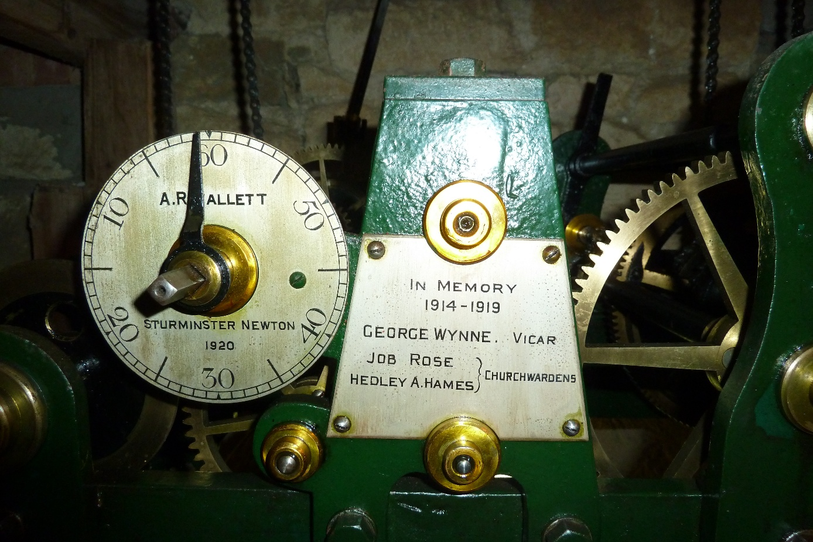
*The flat-bed turret clock, made in Sturminster Newton, was installed in the church and simultaneously dedicated on the 1st of August 1920 as a living memorial to the fallen.
The many enduring connections with those honoured and their families still in and around Hinton St Mary add to the significance of these memorials.

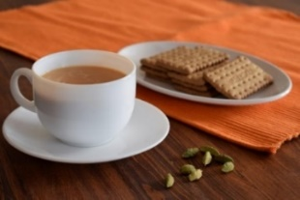
THE MONTHLY VILLAGE COFFEE MORNING
TUESDAY 3rd Febuary
10.30 – 12.00
The cost is £1.50– for as much coffee or tea as you can drink
and as many biscuits as you can eat.

BLANDFORD HOSPITAL SHOP WAREHOUSE.
Is open to receive donations at its warehouse in The Building Yard HSM on
Saturday 7th February
10 - 12 midday
Old Poisedale Building, Hinton St. Mary

IF YOU LIVE IN HINTON ST MARY AND DO NOT RECEIVE A COPY OF THE MOSAIC EVERY MONTH – PLEASE LET NIGEL KNOW ON 07710 088322 OR EMAIL DJNMARTIN@BTINTERNET.COM

Please let us have any articles, notices, celebrations, information, items for sale, trusted traders etc you would like to have included in next month’s Mosaic. Deadline 24th of the Month. Thank you, Nigel & Jo. jo.martin99@btinternet.com

VILLAGE HALL to enquire about or book please contact Jane Filbey on 07513 632550 or janefilbey1964@gmail.com

Keep abreast of all things ‘HSM’ on the village facebook page: Hinton St Mary Village Group and the Hinton St Mary Website:
http://www.hintonstmary.com where all previous copies of The Mosaic are also available.

Thank you to our Advertisers and our sponsors:
Mr & Mrs Pitt Rivers, Hinton St Mary Parish Council, St Peter’s Church, HSM Village Hall Committee.

CONTACT THE ESTATE:
If you are out and about on the estate and need to contact us for any reason whatsoever, please call
07511 209705 or email us on info@hintonstmaryestate.com and we will do our best to respond as quickly and possible.
Trusted Traders

These are tradesman/workers who have been personally recommended by villagers. Please let us have details of anybody who has done a great job for you. Thank you.

COMPUTER HELP | TIM WEST | 01258 817537 sturcomputers@hotmail.co.uk
CURTAINS, BLINDS, TRACKS, FABRICS &  FITTING (Marnull) | THE CURTAIN MAN  (Anna & Tony) | 01258 821117 thecurtainmanshop@gmail.com
CARPENTRY/JOINERY | NIGEL BASTABLE | 01258 860459 www.nigelbastable.co.uk
CARPENTRY (& WOODEN FLOORS) | GARY CORCORAN | 07920557651 gccarpentry@hotmail.co.uk
APPLIANCE REPAIRS | ANDY BLANDFORD | 07484 861797 andyblandford1@gmail.com
PEST CONTROL | MARK GOULD  (Rats, Wasps, Moles & Fleas) | 07999 957694 mark_gould2@btconnect.com
BUILDERS | ANDREW TRIM | 07939 541128
FENCING & REPAIRS | DAVID WHITEHAND | 07549 151 799
BOILER MAINTENANCE | BOB JONES & SON | 01963 362 502
CARPET & UPHOLSTERY CLEANING | LUCAS BEAVON  WESSEX CLEANING SERVICES | 07419 324238 info@wessexcleaningservices.com
PRIVATE CARER | TINA BROWN | 0777 5430457
VEHICLE REPAIRS AND RESTORATION | MARTIN BENNETT | 07746 817072 martin@mbclassiccars.co.uk
ROOFING | BEN GIBBS ROOFING | 07912 655095 Bengibbs.roof@gmail.com
SCAFFOLDING | EDW SCAFFOLDING | 07474 552259 elwin1965@icloud.com
HEDGE/TREE CUTTING | HAMBLEDONS 0783347833 | 01258 721552 info@hambeldons.co
PLASTERER | ROBBY PROCTOR | 07872 634677 robbyproctor29@gmail.com
CHIMNEY SWEEP | CHRIS PERRINS 07824 698109 | 01258 837499 cfperrins@gmail.com
PLUMBER | GARY WATKINS | 07887 605112 sales@tradetanks.com

Martin Bennett – Local Mechanic
(based in Hinton St Mary)

I repair and service modern and everyday cars as well as specialising in repairing and restoring classic cars.
I have diagnostics equipment available.
Phone 07746817072
Email martin@mbclassiccars.co.uk


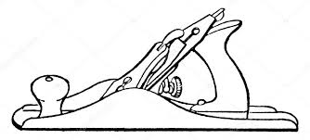
NIGEL BASTABLE LTD
CARPENTRY & JOINERY
The Building Yard – Hinton St Mary
Doors, Windows, Wardrobes, Stairs, Kitchens, Cupboards, Bookcases Etc.
Renovations and Repairs
01258 860459
nigelbastable@btinternet.com www.nigelbastable.co.uk

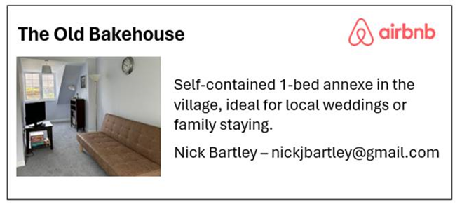
Rose’s Yard
Hinton St Mary
Air B and B
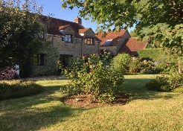

Self-Contained first floor annex
in the centre of the village

sleeping 4

Contact Jo:

jo.martin99@btinternet.com
07860 612412
Or Book Via Air B & B

HINTON DECORATING

For competitive rates contact

Ian Black 01258 471453
07842 399910
Or email: ianjamesblack@mail.com


