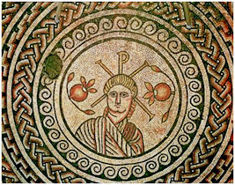
_{THE MOSAIC}
HINTON ST MARY
October 2025
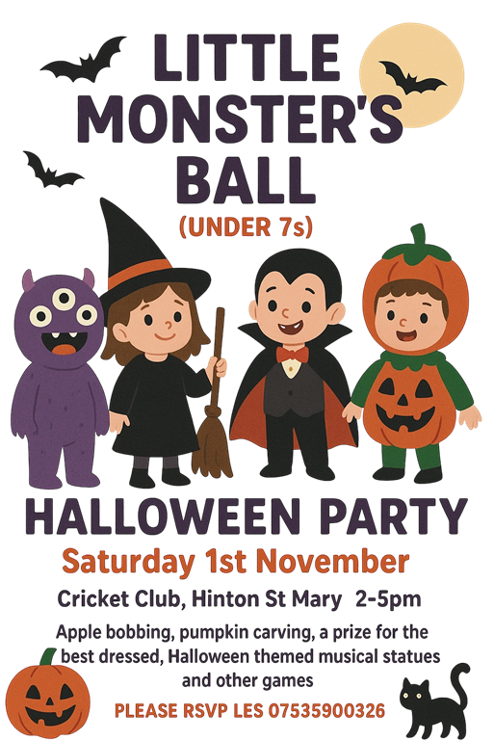

This free event is being hosted by Les James who has recently moved to the village, with Gemma’s sister Toni.
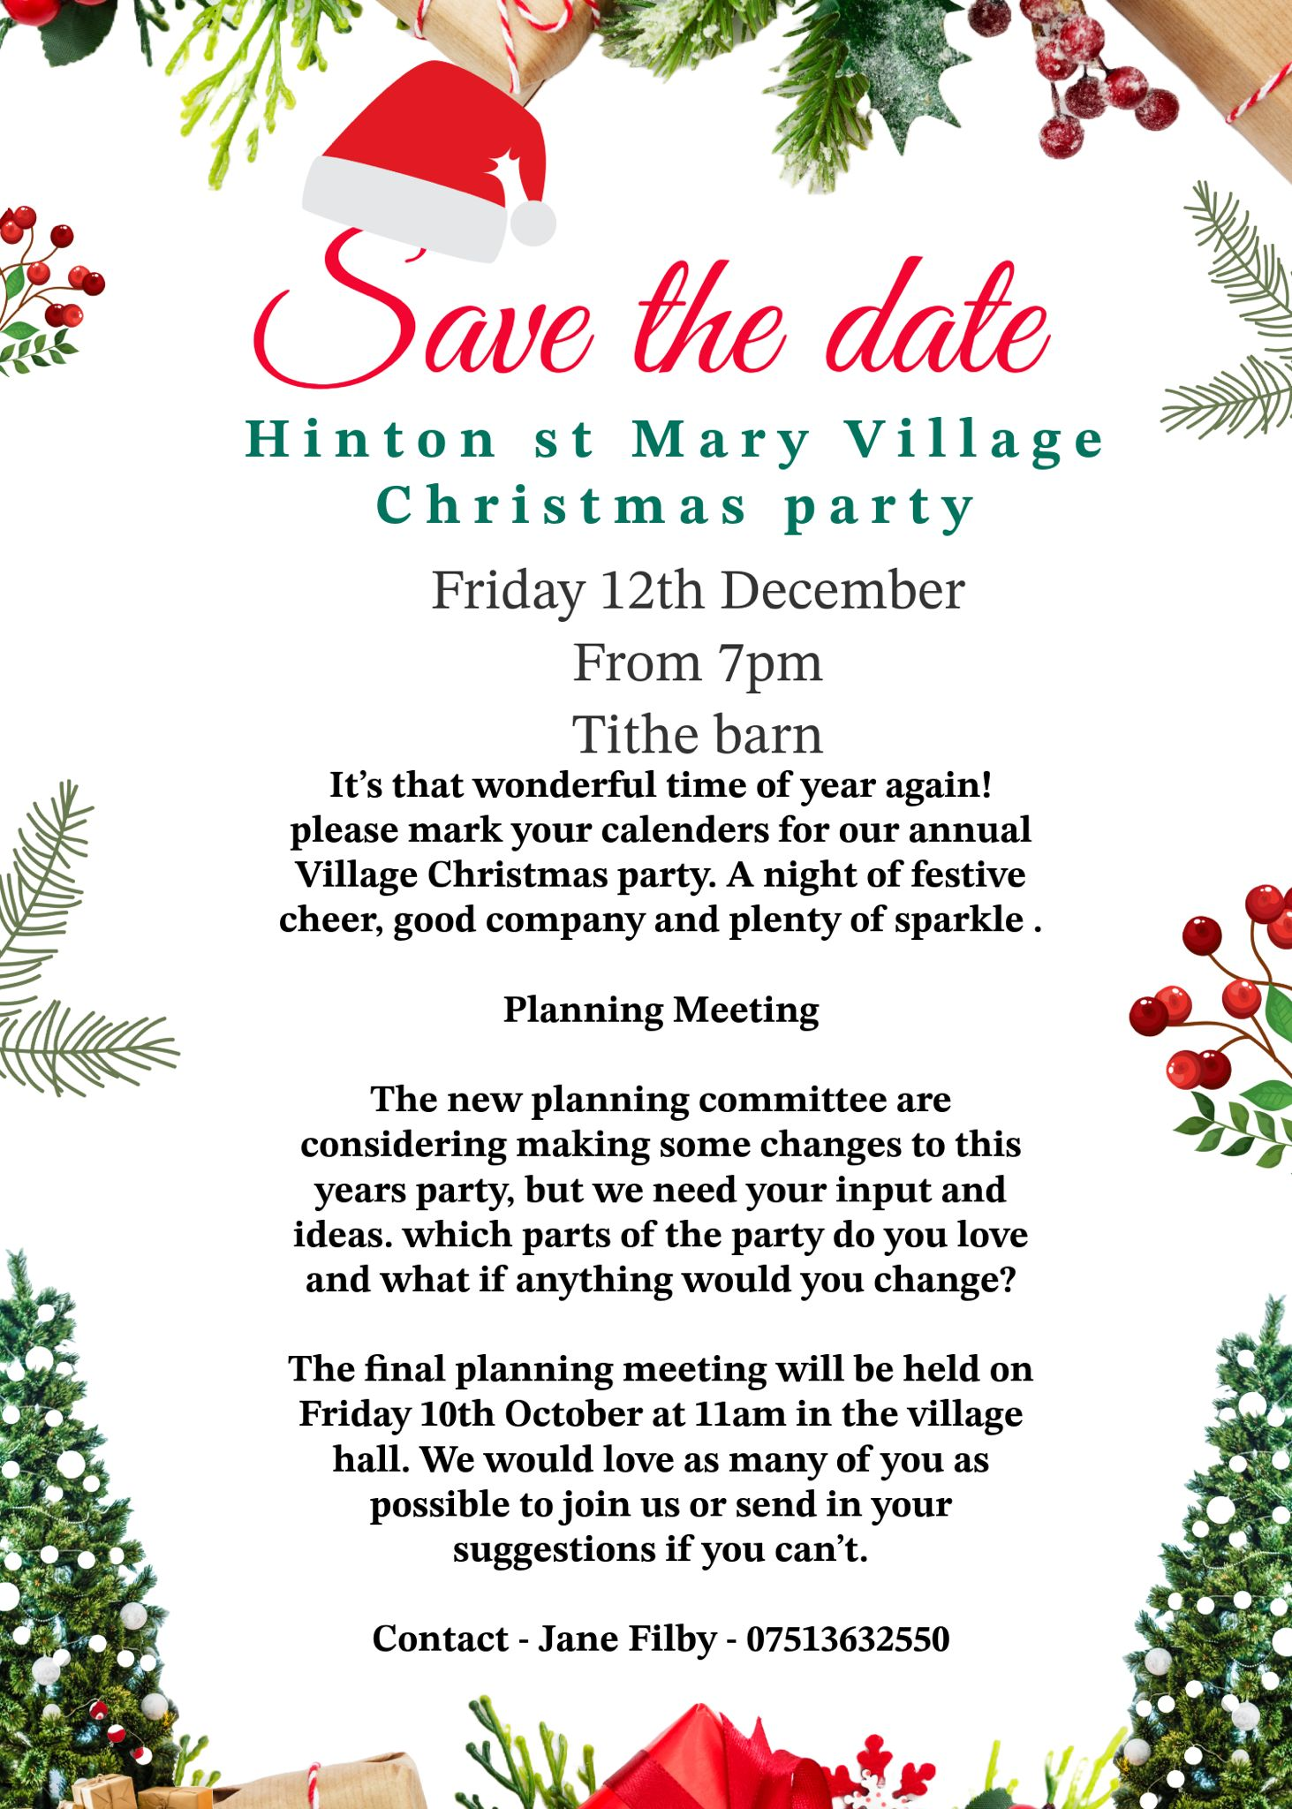

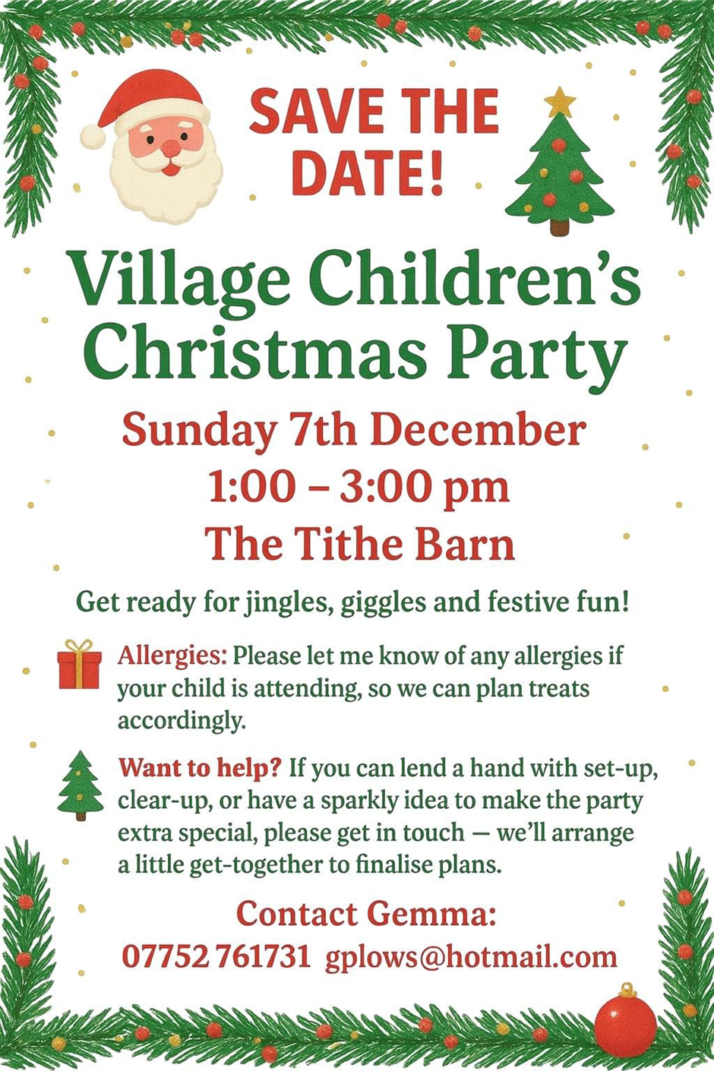



If you are willing to play the piano or keyboard etc for an hour or so at the children’s party – please could you give Gemma a call on the above number. Thank you!

Hello Hinton

We have had a great autumn at The White Horse. Thank you so much to all the villagers and those from further afield who donated their surplus fruit. The boys in the kitchen have been busy making lots of puddings, jams and jellies. Any bruised fruit has been fed to three grateful piggies.

As the weather turns cooler we have a couple of special evenings coming up:

Firstly, Mark & Jane’s quiz on the first Sunday of each month. Teams up to 6 and only £2 per person entry. Autumn quizzes are on Sunday the 5th October and Sunday 2nd of November.

Secondly, we have our Halloween party from 6pm on Sunday 26th of October. We have a prize for best costume; best pumpkin carving and the winner of the scarecrow competition will be announced. We have DJ Wolf playing spooky tunes.

Thirdly, we are planning a French evening to celebrate the release of Beaujolais Nouveau on Sunday the 23rd of November from 6pm. Experience the joy of the new vintage with delicious wines, great live music from the Belle St Duo, and the Chef’s seasonal dishes:
Baguette & Normandy butter
Chicken Liver Parfait, homemade quince jelly
or
Seafood & leek terrine
Served with bro-jolais Chardonnay
*
Confit Duck Cassoulet, Toulouse sausage, pork belly, butter beans
or
Bouillabaisse of Cornish & Devon seafood, saffron potatoes
Served with a la Votre Beaujolais Nouveau
*
Apple tarte Tatin, rum raisin ice cream
or
Pot au Chocolat
Served with Monbazillac Chateau Ramon

£55 per person
Sit down for 6:00pm

Lastly, we are launching our new lager, exclusive to our village pub.

Mosaic Lager (4%) – The White Horse, Hinton St. Mary

The White Horse, at the very heart of Hinton St. Mary, is proud to unveil something truly special – Mosaic Lager, a crisp and refreshing 4% export lager that’s exclusive to our village pub. But this is more than just a pint; it’s a chance to raise a glass while giving back.

For every pint of Mosaic Lager enjoyed, 5p will be donated directly to local charities and community causes. That means every sip goes a little further – not just refreshing you, but also helping support the people, places, and projects that matter most to Hinton St. Mary.

The lager itself carries a story of heritage and collaboration. Its design has been lovingly crafted in partnership with local artist Katie Scorgie and the talented team at the LWC Design Centre. The artwork proudly echoes the village’s renowned 4th-century Roman mosaic, a historic treasure that has inspired this modern-day brew. Just as the ancient mosaic was pieced together to form something lasting and beautiful, Mosaic Lager has been created to bring people together, pint by pint.

So, whether you’re a local regular or a visitor passing through, ordering a Mosaic Lager means joining a tradition of community spirit and generosity. It’s a chance to enjoy a quality beer while knowing you’re playing your part in making a difference.

Raise a glass, share a moment, and help us celebrate the best of village life – Mosaic Lager: a taste of history, a toast to community.

Look forward to seeing you all soon & thank you for continued support
Best wishes
Mel, Andy & The team at The White Horse



Hinton Apples 2025

Last year we took apples from the village to Bridge Farm Cider near Yeovil to be pressed and bottled as juice. Those who contributed, either by helping with picking or providing apples, were offered bottles at cost and the remainder were sold with profits going to Weldmar Hospice.

This year - a bumper year for fruit! - we plan to repeat the process at the beginning of October, with any profits going to the Farming Community Network, the charity supported by this year’s Harvest Celebration.

If you would be able to offer apples - we are ideally looking for a mixture of Bramleys and dessert apples to mix with cider apples from the Community Garden - or to help with picking and collecting fruit, please contact Liz Collins for further details:
lizcollins50@gmail.com or 07377389453

Village Hall Vibes – Autumn Update
As we head into autumn, it’s all change at the Village Hall! With the cricket season wrapped up, Sunday mornings now see the field taken over by youth football matches. Our much-loved midweek clubs and coffee mornings continue to bring people together, offering a warm welcome year-round.
We’re also excited to welcome Dorset Mind, who are now hosting their ‘Mothers in Mind’ sessions at the hall. These sessions are designed to support local mums during early motherhood—it's great to see our hall being used to support mental wellbeing in the community.
Cricket Club Celebrations
The cricket club celebrated the end of their summer season in style over the Bank Holiday with a fantastic Chairman’s Day event. The day featured:
- A small-scale cider festival
- Family fun and games
- Live music from local artists on a temporary outdoor stage
- And some glorious sunshine to top it all off!
A big shoutout to The Vale Family Hub, who joined the day with a cake stall, raising funds for their important local work.
Planning an Event at the Hall?
Just a quick reminder for anyone planning events involving live music or the sale of alcohol:
You’ll need to apply for a Temporary Events Notice (TEN) from the council’s licensing team and provide a copy to the Village Hall committee before your event.
Also, please note: 🕚 All events must finish and the hall be vacated by 11pm to ensure minimal disruption to nearby residents.
Scarecrow Competition – Get Involved!
The annual Scarecrow Competition is now underway, and we’ve already had some brilliant entries! Here’s what you need to know:
- Display your scarecrow before the weekend of 4th/5th October, when judging takes place.
- Winners will be announced at the Halloween Party at The White Horse on Sunday 26th October, and also featured in the November issue of The Mosaic.
📧 Still time to join in! Email your entry to: lucyjohnson2009.lj@gmail.com
Thanks to everyone who continues to support and make use of our Village Hall—it’s wonderful to see it buzzing with activity from such a wide range of groups.
The Village Hall Trustees

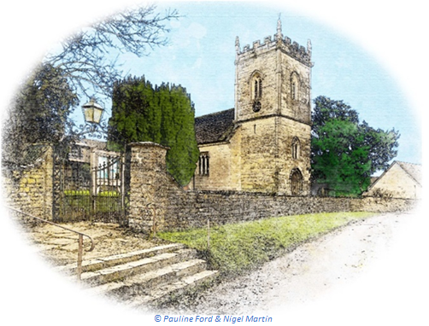
October 2025 Services

The Church is open daily for sanctuary and prayer

St Peter’s Church - Hinton St Mary
Date & Time | Service
Sunday 5 October 9:30am |   Holy Communion (BCP)
Sunday 12 October 9:30am | Blessing of the Animals
Sunday 19 Octobert10:30am | Morning Prayer (CW)
Sunday 26 October 9:30am | Holy Communion (CW)
Upcoming Events
Commemoration of the departed at the 9.30am Holy Communion service on 2 November. Please either put names on the list in the church or tell the Vicar.
Many thanks to all who came to Harvest Lunch in the Tithe Barn, especially those who helped before, during and after the event.

Remembrance Sunday will be marked with a service in the church on Sunday, 9 November at 10:45.
All queries about Church-related support and services should be directed to the Vicar or Churchwardens
Vicar: The Reverend Mary Gubbins
01258 721 704 | 07440 680 387
The Vicarage, Sturminster Newton
revd.mary.gubbins@gmail.com
Churchwardens
Robin Gibbs  01258 471 493  robin@aviaconsult.uk | Kevin Peto-Bostick  01258 475 469  kevin.peto.bostick@gmail.com



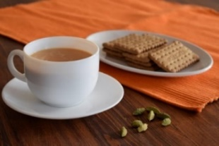
THE MONTHLY VILLAGE COFFEE MORNING
TUESDAY 7th October
10.30 – 12.00

The cost is £1.50– for as much coffee or tea as you can drink and as many biscuits as you can eat.
BLANDFORD HOSPITAL SHOP WAREHOUSE.
Saturday 4th October
10 - 12 midday
Old Poisedale Building, Hinton St. Mary

IF YOU LIVE IN HINTON ST MARY AND DO NOT RECEIVE A COPY OF THE MOSAIC EVERY MONTH – PLEASE LET NIGEL KNOW ON 07710 088322 OR EMAIL DJNMARTIN@BTINTERNET.COM

Please let us have any articles, notices, celebrations, information, items for sale, trusted traders etc you would like to have included in next month’s Mosaic. Deadline 24th of the Month. Thank you, Nigel & Jo. jo.martin99@btinternet.com

VILLAGE HALL to enquire about or book please contact Jane Filbey on 07513 632550 or janefilbey1964@gmail.com

Keep abreast of all things ‘HSM’ on the village facebook page: Hinton St Mary Village Group and the Hinton St Mary Website:
http://www.hintonstmary.com where all previous copies of The Mosaic are also available.

Thank you to our Advertisers and our sponsors:
Mr & Mrs Pitt Rivers, Hinton St Mary Parish Council, St Peter’s Church, HSM Village Hall Committee.

CONTACT THE ESTATE:
If you are out and about on the estate and need to contact us for any reason whatsoever, please call
07511 209705 or email us on info@hintonstmaryestate.com and we will do our best to respond as quickly and possible.

Trusted Traders

These are tradesman/workers who have been personally recommended by villagers. Please let us have details of anybody who has done a great job for you. Thank you.

COMPUTER HELP | TIM WEST | 01258 817537 sturcomputers@hotmail.co.uk
CURTAINS, BLINDS, TRACKS, FABRICS &  FITTING (Marnull) | THE CURTAIN MAN  (Anna & Tony) | 01258 821117 thecurtainmanshop@gmail.com
CARPENTRY/JOINERY | NIGEL BASTABLE | 01258 860459 www.nigelbastable.co.uk
CARPENTRY (& WOODEN FLOORS) | GARY CORCORAN | 07920557651 gccarpentry@hotmail.co.uk
APPLIANCE REPAIRS | ANDY BLANDFORD | 07484 861797 andyblandford1@gmail.com
PEST CONTROL | MARK GOULD  (Rats, Wasps, Moles & Fleas) | 07999 957694 mark_gould2@btconnect.com
BUILDERS | ANDREW TRIM | 07939 541128
FENCING & REPAIRS | DAVID WHITEHAND | 07549 151 799
BOILER MAINTENANCE | BOB JONES & SON | 01963 362 502
CARPET & UPHOLSTERY CLEANING | LUCAS BEAVON  WESSEX CLEANING SERVICES | 07419 324238 info@wessexcleaningservices.com
PRIVATE CARER | TINA BROWN | 0777 5430457
BUILDING & RENOVATION | MARK GORDGE | 07941 443 306
ROOFING | BEN GIBBS ROOFING | 07912 655095 Bengibbs.roof@gmail.com
SCAFFOLDING | EDW SCAFFOLDING | 07474 552259 elwin1965@icloud.com
HEDGE/TREE CUTTING | HAMBLEDONS 0783347833 | 01258 721552 info@hambeldons.co
PLASTERER | ROBBY PROCTOR | 07872 634677 robbyproctor29@gmail.com
CHIMNEY SWEEP | CHRIS PERRINS 07824 698109 | 01258 837499 cfperrins@gmail.com

NIGEL BASTABLE LTD
CARPENTRY & JOINERY
The Building Yard – Hinton St Mary
Doors, Windows, Wardrobes, Stairs, Kitchens, Cupboards, Bookcases Etc.
Renovations and Repairs
01258 860459
nigelbastable@btinternet.com www.nigelbastable.co.uk

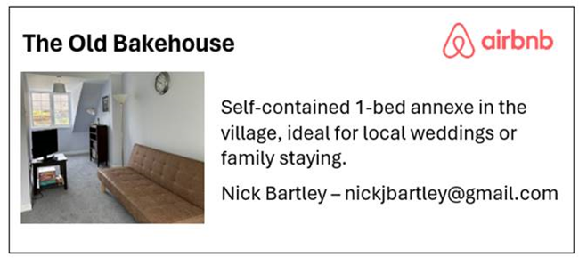
Rose’s Yard
Hinton St Mary
Air B and B
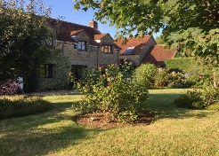

Self-Contained first floor annex
in the centre of the village

sleeping 4

Contact Jo:

jo.martin99@btinternet.com
07860 612412
Or Book Via Air B & B



HINTON DECORATING

For competitive rates contact

Ian Black 01258 471453
07842 399910
Or email: ianjamesblack@mail.com




