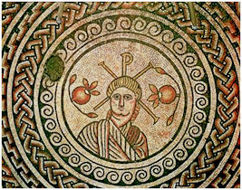
_{THE MOSAIC}
HINTON ST MARY
November 2025

🌾 Village Hall Vibes – Scarecrow Success! 🎃
Only seven scarecrows were displayed this year, but every single one was fantastic! A huge thank you to everyone who took the time to create a display — and to all who wandered the village to view them. The feedback has been wonderful, and we’re delighted that so many people enjoyed taking part.
The Village Hall trustees, along with an independent judge, scored each entry separately, with the combined results announced at the Halloween Party at The White Horse on Sunday.
🏆 The Results:
🥇 1st Place (25 points): The Minions – 4 White Horse Lane
🥈 2nd Place (joint, 22 points): The Workman – Rose’s Yard
: The Scarecrow & His Dog – 11 Veals Lane
🥉 3rd Place (21.5 points): The Giant Sitting on the Wall – Seymour Orchard
We think everyone will agree that this event brought a little extra joy to the village!
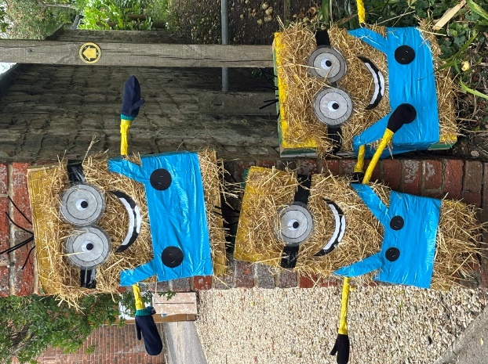
Please share your feedback and ideas for future events and competitions — we’d love to make the next event even better.
— The Village Hall Trustees
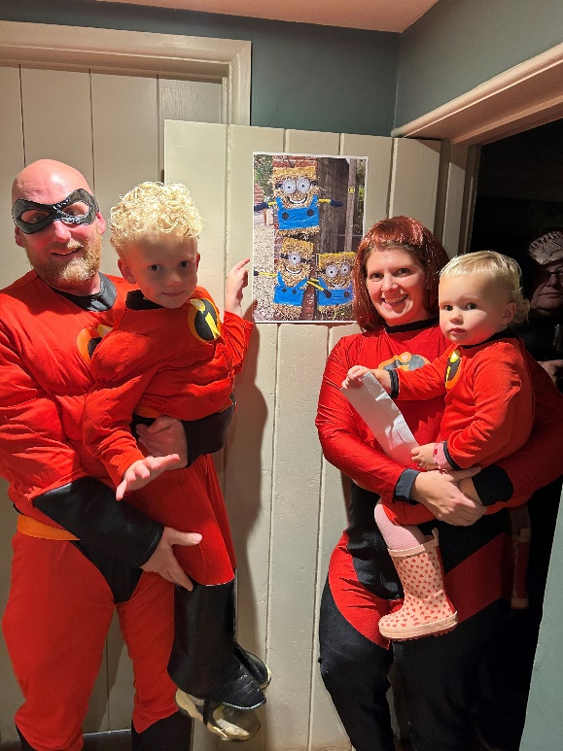

1st Place The Proctor Family
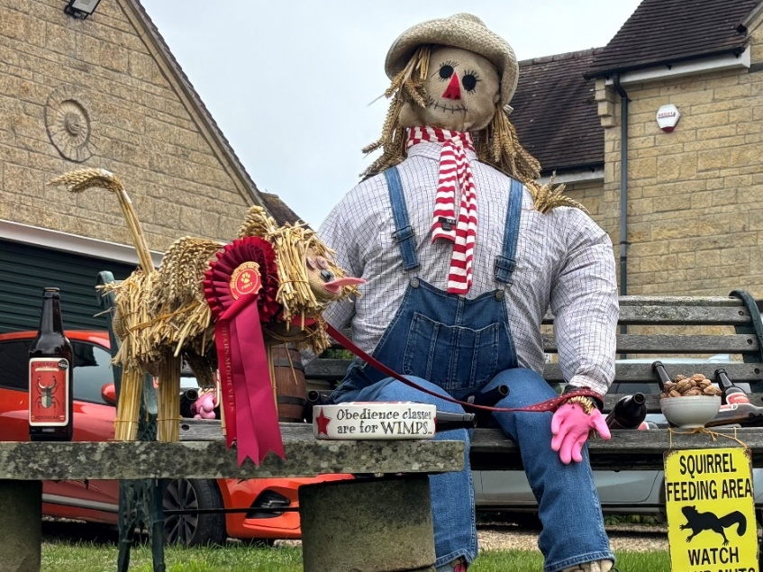
Joint 2nd Place
3rd Place
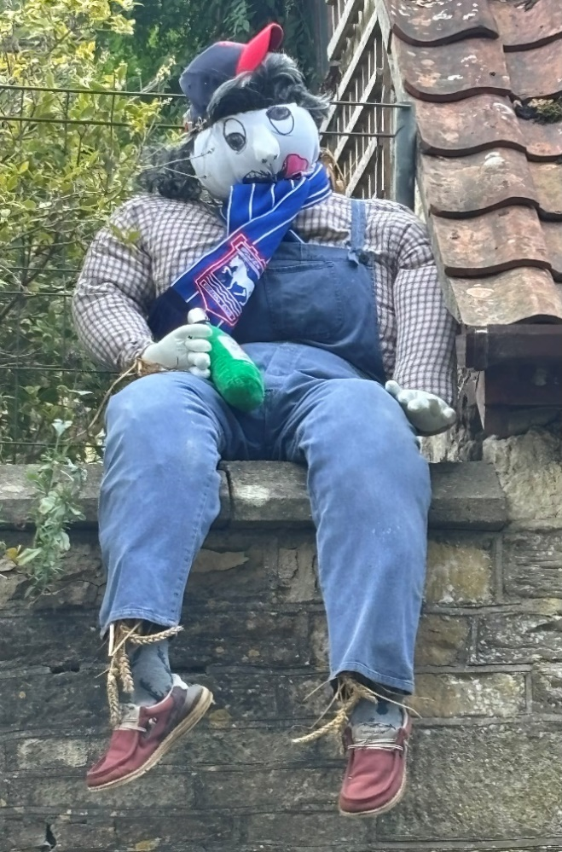

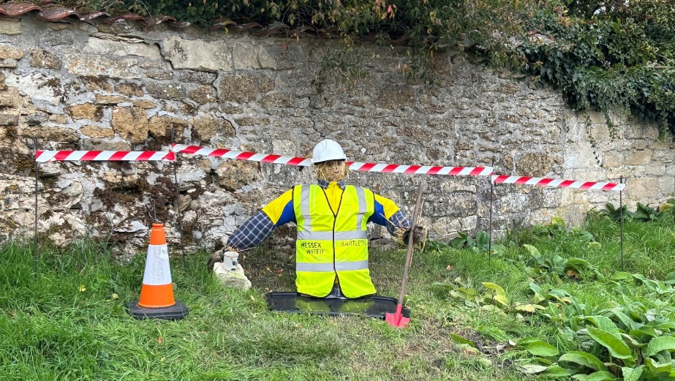
Joint 2nd Place

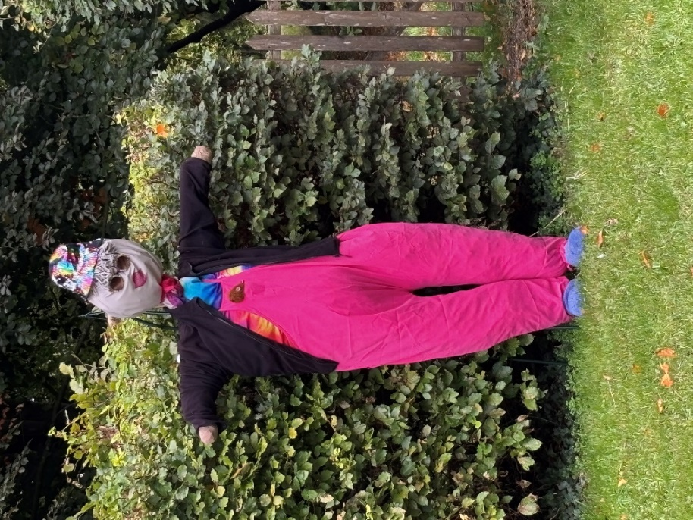
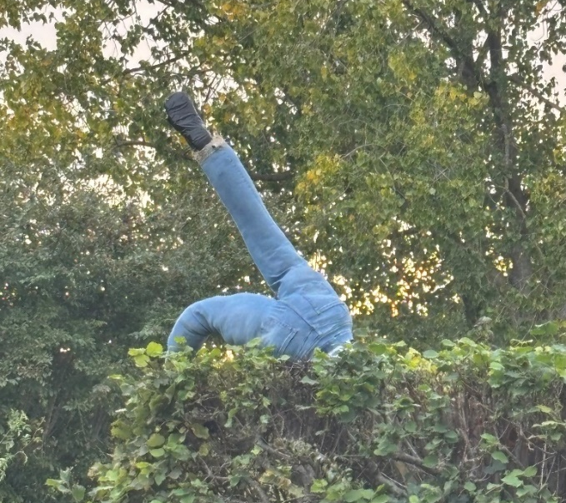

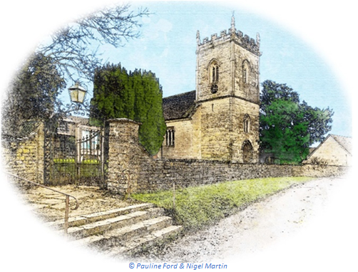
November 2025 Services

The Church is open daily for sanctuary and prayer

St Peter’s Church - Hinton St Mary
- Date & Time | - Service
Sunday 2 November 9:30am | Holy Communion (BCP) with Commemoration of the Departed
  Sunday 9 November 10:45am | Act of Remembrance with Dedication of the Roll of Honour
Sunday 16 November  No Service at St Peter’s | Join us at St Mary’s in Sturminster for a service of Holy Communion with +Karen, Bishop of Sherborne at 11:00am.
Sunday 23 November 9:30am | Holy Communion (CW)
Sunday 30 November 11:00am  No Service at St Peter’s | Join us at St Mary’s in Sturminster for a service of Holy Communion at 11:00am.
  - Upcoming Events
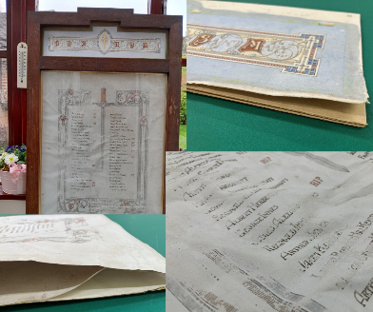
At the service on Remembrance Sunday, we will formally welcome the Hinton St Mary Roll of Honour back for display in the Church. Many thanks are due to those who have supported this effort to preserve and retain this important part of village history. If you would like to support St Peter’s in this effort, please donate at: https://givealittle.co/c/HSM-Roll-of-Honour
Details of Advent and Christmas celebrations will appear in next month’s Mosaic and on our Facebook page.
All queries about Church-related support and services should be directed to the Vicar or Churchwardens
Vicar: The Reverend Mary Gubbins
01258 721 704 | 07440 680 387
The Vicarage, Sturminster Newton
revd.mary.gubbins@gmail.com
Churchwardens
Robin Gibbs  01258 471 493  robin@aviaconsult.uk | Kevin Peto-Bostick  01258 475 469  kevin.peto.bostick@gmail.com

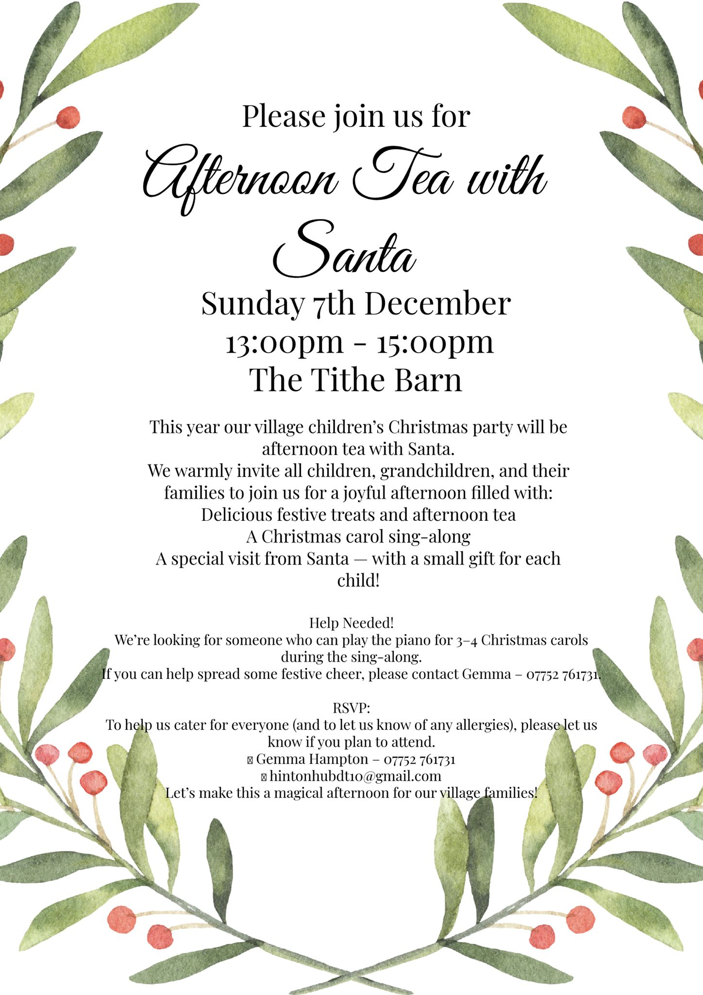


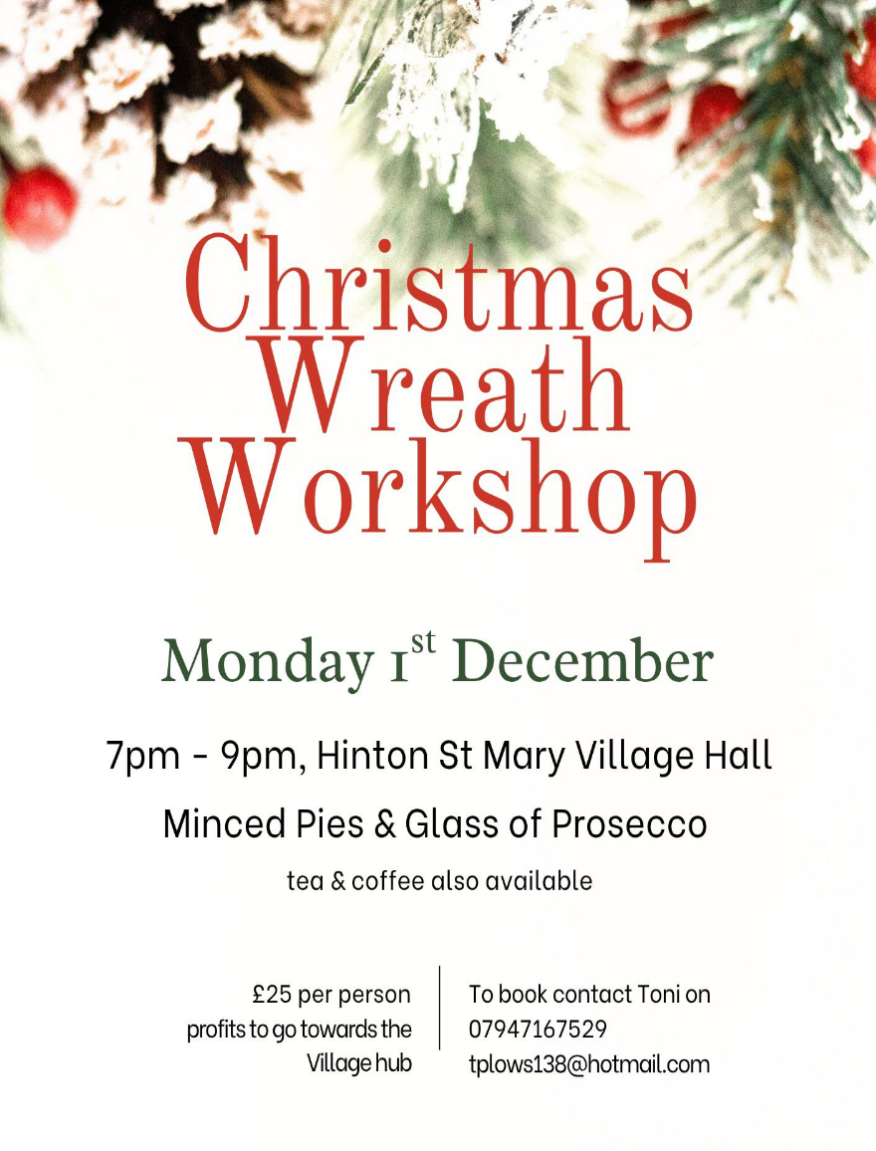
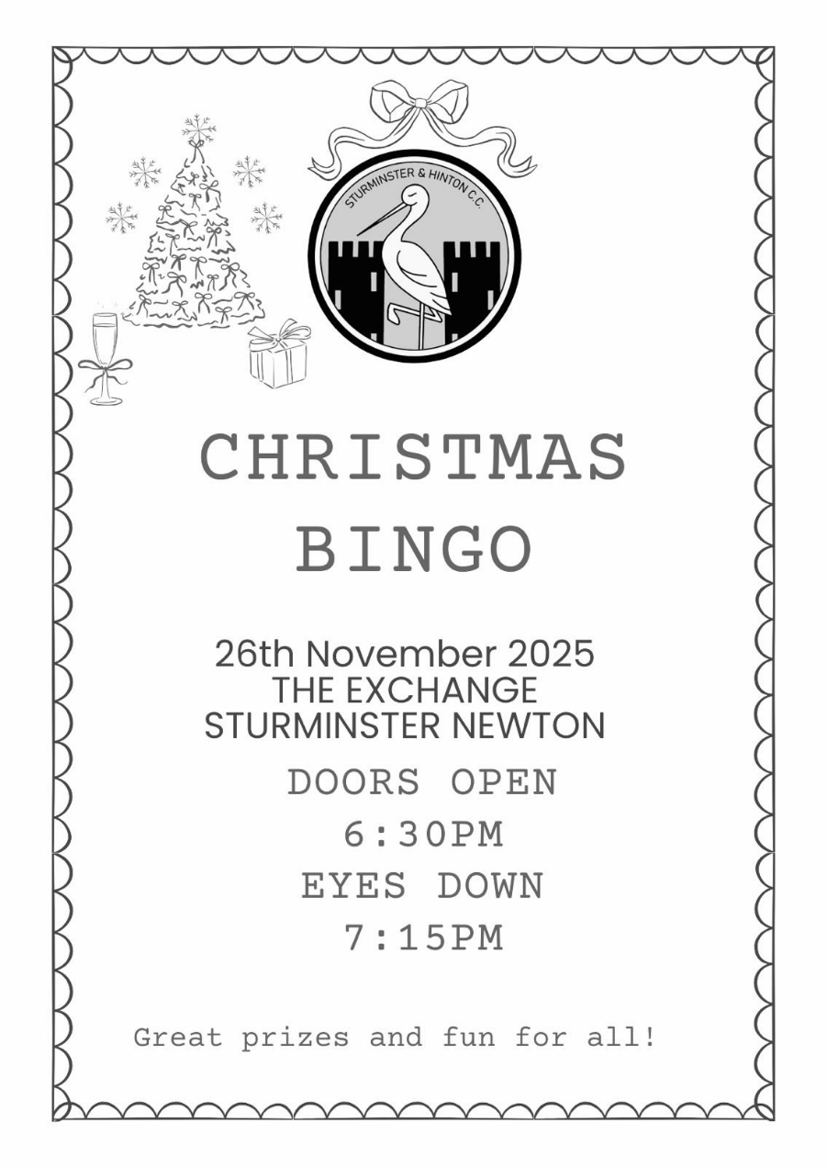


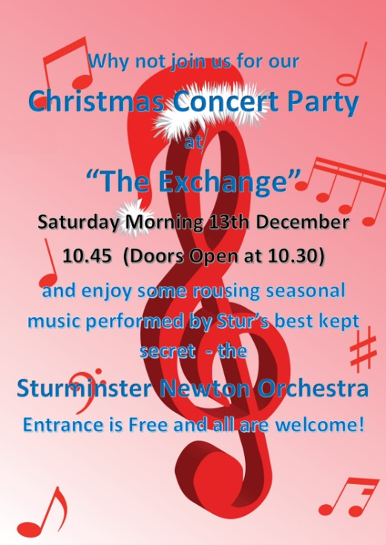
SNO at Christmas?
You can always tell when the Festive Season will soon be upon
us when Sainsbury’s starts selling mince pies in sparkly boxes.
Mind you, that was in September!.
However it might be worth your putting a note in your diary for
our
Christmas Concert at “The Exchange”
on Saturday Morning (10.45) on the 13th December.
(This of course, will be the morning after the night before of
the Village Christmas Party !).

Once again, we will playing an eclectic mix of light classical, film / show and traditional music. This time our offering includes the theme for “Robin Hood – Prince of Thieves”, some foot-tapping Latin numbers and, as you would expect, some sing-along wintry seasonal ones.
As you may know, we always support a good cause at our little concerts and, over the past few years we have raised some £18,000 !! For this one we are supporting “The Exchange” itself.
We would love to see villagers of HSM filling the seats and you are warmly invited to complimentary drinks and nibbles in the “Bow Room” after the performance.
John Harding
(for Sturminster Newton Orchestra)

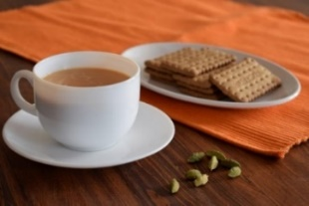
THE MONTHLY VILLAGE COFFEE MORNING
TUESDAY 4th November
10.30 – 12.00

The cost is £1.50– for as much coffee or tea as you can drink and as many biscuits as you can eat.
BLANDFORD HOSPITAL SHOP WAREHOUSE.
Saturday 1st November
10 - 12 midday
Old Poisedale Building, Hinton St. Mary

IF YOU LIVE IN HINTON ST MARY AND DO NOT RECEIVE A COPY OF THE MOSAIC EVERY MONTH – PLEASE LET NIGEL KNOW ON 07710 088322 OR EMAIL DJNMARTIN@BTINTERNET.COM

Please let us have any articles, notices, celebrations, information, items for sale, trusted traders etc you would like to have included in next month’s Mosaic. Deadline 24th of the Month. Thank you, Nigel & Jo. jo.martin99@btinternet.com

VILLAGE HALL to enquire about or book please contact Jane Filbey on 07513 632550 or janefilbey1964@gmail.com

Keep abreast of all things ‘HSM’ on the village facebook page: Hinton St Mary Village Group and the Hinton St Mary Website:
http://www.hintonstmary.com where all previous copies of The Mosaic are also available.

Thank you to our Advertisers and our sponsors:
Mr & Mrs Pitt Rivers, Hinton St Mary Parish Council, St Peter’s Church, HSM Village Hall Committee.

CONTACT THE ESTATE:
If you are out and about on the estate and need to contact us for any reason whatsoever, please call
07511 209705 or email us on info@hintonstmaryestate.com and we will do our best to respond as quickly and possible.

Trusted Traders

These are tradesman/workers who have been personally recommended by villagers. Please let us have details of anybody who has done a great job for you. Thank you.

COMPUTER HELP | TIM WEST | 01258 817537 sturcomputers@hotmail.co.uk
CURTAINS, BLINDS, TRACKS, FABRICS &  FITTING (Marnull) | THE CURTAIN MAN  (Anna & Tony) | 01258 821117 thecurtainmanshop@gmail.com
CARPENTRY/JOINERY | NIGEL BASTABLE | 01258 860459 www.nigelbastable.co.uk
CARPENTRY (& WOODEN FLOORS) | GARY CORCORAN | 07920557651 gccarpentry@hotmail.co.uk
APPLIANCE REPAIRS | ANDY BLANDFORD | 07484 861797 andyblandford1@gmail.com
PEST CONTROL | MARK GOULD  (Rats, Wasps, Moles & Fleas) | 07999 957694 mark_gould2@btconnect.com
BUILDERS | ANDREW TRIM | 07939 541128
FENCING & REPAIRS | DAVID WHITEHAND | 07549 151 799
BOILER MAINTENANCE | BOB JONES & SON | 01963 362 502
CARPET & UPHOLSTERY CLEANING | LUCAS BEAVON  WESSEX CLEANING SERVICES | 07419 324238 info@wessexcleaningservices.com
PRIVATE CARER | TINA BROWN | 0777 5430457
BUILDING & RENOVATION | MARK GORDGE | 07941 443 306
ROOFING | BEN GIBBS ROOFING | 07912 655095 Bengibbs.roof@gmail.com
SCAFFOLDING | EDW SCAFFOLDING | 07474 552259 elwin1965@icloud.com
HEDGE/TREE CUTTING | HAMBLEDONS 0783347833 | 01258 721552 info@hambeldons.co
PLASTERER | ROBBY PROCTOR | 07872 634677 robbyproctor29@gmail.com
CHIMNEY SWEEP | CHRIS PERRINS 07824 698109 | 01258 837499 cfperrins@gmail.com
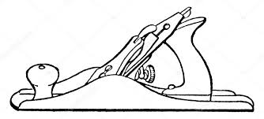
NIGEL BASTABLE LTD
CARPENTRY & JOINERY
The Building Yard – Hinton St Mary
Doors, Windows, Wardrobes, Stairs, Kitchens, Cupboards, Bookcases Etc.
Renovations and Repairs
01258 860459
nigelbastable@btinternet.com www.nigelbastable.co.uk

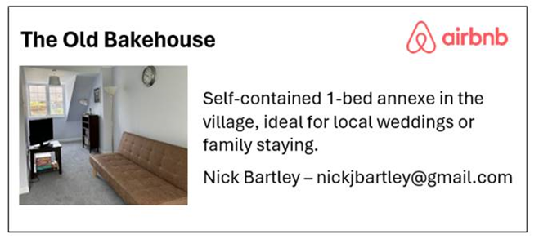
Rose’s Yard
Hinton St Mary
Air B and B
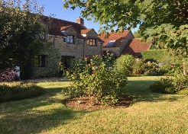

Self-Contained first floor annex
in the centre of the village

sleeping 4

Contact Jo:

jo.martin99@btinternet.com
07860 612412
Or Book Via Air B & B


HINTON DECORATING

For competitive rates contact

Ian Black 01258 471453
07842 399910
Or email: ianjamesblack@mail.com


