ARCHAEOLOGICAL EXCAVATIONS AT HINTON ST MARY

Archaeologists returned to Hinton St Mary for a 3rd and final 4-week season in June and July. This was our last chance to answer important questions about the immediate setting of the famous mosaic discovered in the village in 1963 (currently in the British Museum), and to get as many people involved in the excavation as possible.

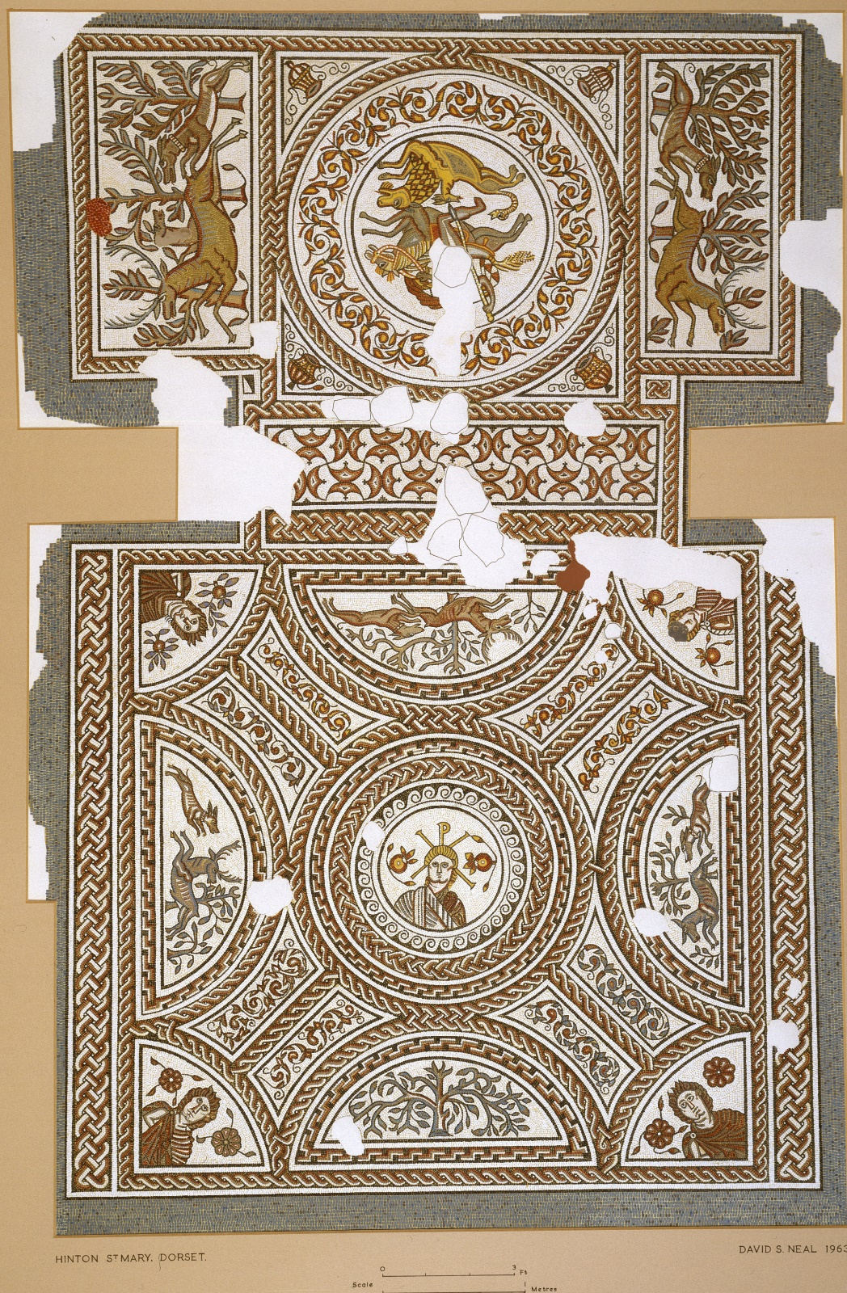
Painting of the Hinton St Mary mosaic by David Neal (© The British Museum)

Looking back over the past 3 years, this has turned out to be an amazing project and everyone is really pleased that we achieved everything we wanted to (and much more) when we first proposed the excavation back in 2019. This is a short summary of some of the many highlights of our time in Hinton St Mary.
We began with an ‘evaluation’ season in 2021, when 6 long narrow trenches were opened in the scheduled area at The Forge where the mosaic was discovered 60 years ago. These were ‘key hole’ trenches that gave us a good idea what lies beneath the ground across the field and which complemented the geophysical surveys undertaken by English Heritage in 1996. Based on new information from these trenches, we devised a plan for 2 further seasons of targeted excavation to answer specific questions about the buried archaeological remains in the scheduled area (all 3 seasons required Scheduled Monument Consent, which was granted by Historic England).
In 2022 and 2023 we opened another 6 large trenches to recover new evidence that would tell us about the layout of the Roman buildings to which the mosaic belonged, as well as when they had been in use. Although it will take a while before we fully understand what we found (the work to clean, identify and catalogue the many finds we recovered has already started), it’s clear that our work will fundamentally change the story of Roman Hinton St Mary and its mosaic.

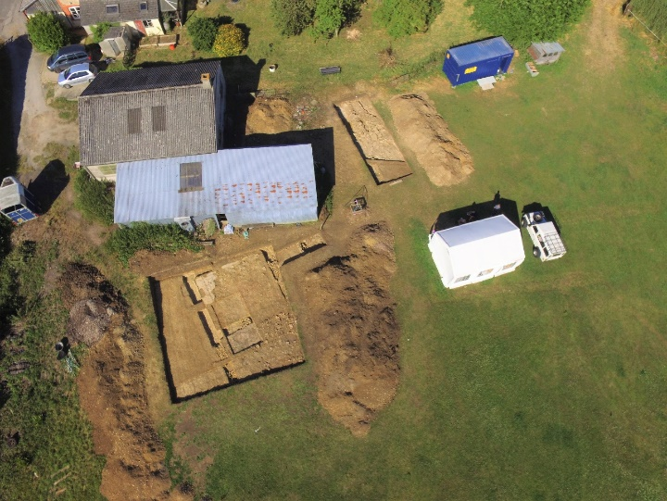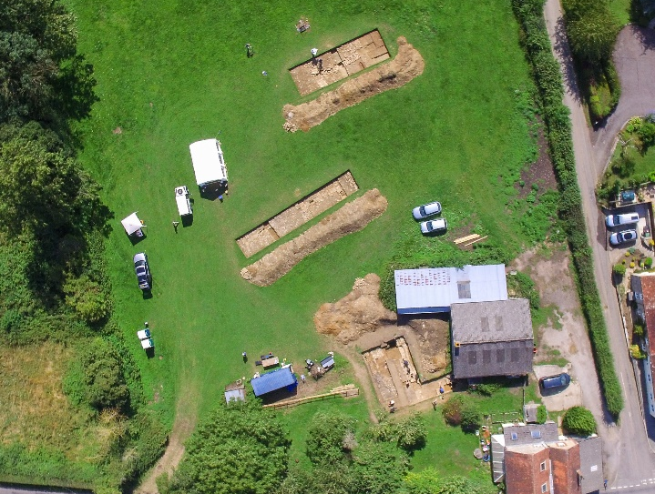
Aerial views of the 2022 and 2023 excavations (photos courtesy of Tom, Poppy and Archie Blake)

For 60 years it was thought that the mosaic decorated the floor of a room in the centre of a large ‘villa’ building, consisting of an imposing main range (the domestic quarters), and 2 ‘wings’ enclosing a large courtyard (not unlike The Manor in Hinton St Mary today). There were many impressive villas like this in southern Roman Britain, thought to have been the homes of wealthy landowners and farmers, and the mosaic suggested that the occupants of the Hinton St Mary example were members of one of the earliest Christian communities in Britain, who were able to express their faith openly and without fear of persecution after the Emperor Constantine’s decision in 313 to decriminalise the Christian religion.
Our excavations have shown that the room with the famous mosaic was definitely not in the centre of a long building, nor were there any ‘wings’ around a courtyard. Instead, the mosaic decorated a room at the end of a longer building aligned at 90° to the plan of the villa building as previously reconstructed. So, rather than the Roman building looking south towards the River Stour and the Blackmore Vale beyond, it was actually built to face westwards in the direction of Marnhull. This changes how we should perceive the building and it also has important implications for understanding how the mosaic room would have been used.
The mosaic was divided into 2 unequal parts and, whereas in the past the smaller part was thought to be an ‘antechamber’ or ‘entrance hall’, we now know that it was at the very far end of the building and, therefore, the room’s focal point. It is likely that there would have been a doorway at the other end of the room, which meant the visitor would have looked at the ‘Christ’ roundel as they entered (and the ‘Christ’ in the roundel would have looked back at the visitor). However, we also showed that the mosaic room had a second doorway too, this time an external entrance from the outside to the east, where several stone plinth-like features might have been for a monumental porch of some kind.
A boundary wall attached to the mosaic building’s end wall separated 2 open spaces – the 1st was to the east of the mosaic (mentioned above), while the 2nd was to the south and had been covered with a hard-wearing stone and cobbled surface, which looks very much like an open yard. The yard’s surface, however, sealed 4 very unusual stone-covered drains that probably originally carried wooden pipes for the movement of water. We think these were drains, but there’s nothing else like them known from Roman Britain and at the moment we’re struggling to understand why they were needed as they must have taken a great effort to build, yet as far as we can tell they don’t seem to go anywhere!

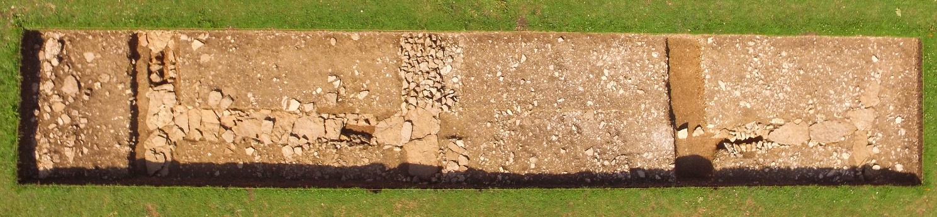
Strange stone-covered drains running underneath the courtyard Trench 5 (photo courtesy of Tom, Poppy and Archie Blake)

Two rectangular buildings flanked the west side of the cobbled yard. The one closest to the mosaic building was divided into square rooms with a corridor or portico along its front facing onto the yard. The northernmost of this building’s rooms had a mosaic floor while the adjacent room was provided with a more modest mortar surface. This 2nd mosaic from Hinton St Mary had been badly damaged by medieval ploughing, but we can see that it originally had an ornate black-and-white border around a central panel that was probably decorated with figurative scenes and fine scrollwork. The second building was built to the south of the first one, but on a slightly different alignment and it did not have a front portico. Two rooms of this building were excavated and we found the remains of a kiln or furnace of some kind, indicating that domestic, craft or industrial activities took place there.

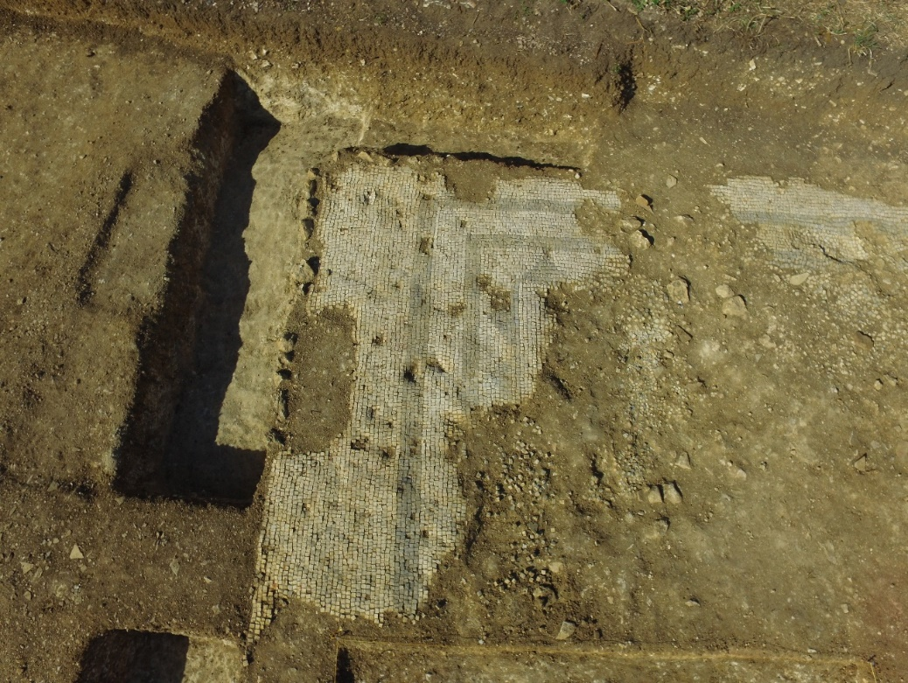
Surviving parts of the damaged mosaic in Trench 2 (© The British Museum).

For an important high-status site in southern Roman Britain, the Hinton St Mary excavations produced a surprisingly small assemblage of finds. We found the usual coins, nails, pot sherds, bricks and tiles, as well as fragments of animal bone, but in very limited quantities. Why this was the case is unclear, but perhaps it reflects how the buildings were used, or the kinds of people that used them? It’s also possible that the modest finds are a result of the fact that the site was not in use for very long and so there was less opportunity for things to become lost or be thrown away. The coins and pottery that we did recover are very clear that the buildings behind The Forge were probably constructed some time in the 330s or 340s and occupied for maybe 70-80 years before the buildings were abandoned and started to fall down around 400-420 (the same time that the Roman occupation of Britain came to an end).
Our archaeological work was not explicitly about the Hinton St Mary mosaic itself, but of course what we have found will influence the on-going debate about who its central roundel depicts. Was it supposed to be Jesus Christ, or an emperor (perhaps Constantine the Great, the 1st Christian emperor of Rome), or maybe the Christian villa owner himself or another important figure in the early Christian community in this part of Roman Britain? There are problems with all of these suggestions and, of course, we might never know the answer to this important question, but what we have done is add several significant new chapters to the story of Roman Hinton St Mary that will stimulate the discussion about the roundel figure’s identity for many years to come.
On the other hand, even though we now know far more about Roman Hinton St Mary, there is still much that remains uncertain about the site. For instance, we don’t know how many buildings stood there, or how far the complex might have extended beyond the scheduled area around The Forge. Nor do we know what all the buildings we found were for or how people might have used them. While it might have been a ‘villa’ – i.e., the home of a wealthy landowner and his family – could it have been built as a religious complex, such as a church, chapel or martyrium perhaps, or possibly a monastic community of some kind? For the time being, these questions will have to remain unanswered, but perhaps another team of archaeologists will decide to return to see if they can finds answers (hopefully not in another 60 years’ time!).
53 people worked on the 3 excavation seasons at Hinton St Mary, which was a partnership between The British Museum, Vianova Archaeology and Albion Archaeology. The excavation was a research, training and engagement project, with much of the work to excavate the trenches being done by student archaeologists from Cardiff University. Thirty-six undergraduates worked on site, while a further 19 volunteers joined the excavation, some for a week or two while several stayed for the duration of multiple seasons. Training for students and volunteers was delivered by professional archaeologists from Albion, focusing on the key skills of digging, recording, surveying and finds work, as well as collective working and public engagement.
Engagement was an integral part of our archaeological project and it’s important that the project benefits the local communities in Hinton St Mary and Sturminster Newton, as well as the wider county. In addition to providing important new information about Hinton St Mary in the Roman period, the excavation delivered additional public benefits, including:
- Webpages describing Roman Hinton St Mary and the results of the recent archaeological work (www.vianovaarchaeology.com/hinton-st-mary/);
- Open afternoons in the 2022 and 2023 seasons, attended by over 450 people. To find out if they had enjoyed the experience, visitors in 2023 were asked to place a small sticker on a Feedback Mosaic. Of the approximately 100 stickers on the mosaic, 95% were directly on the figure’s nose and face (indicating that they ‘Loved It!’);
- Partnership with Yewstock School in Sturminster Newton, a day community school for children with learning difficulties and special educational needs;
- Visits by four classes of Year 8 and Year 9 students from Sturminster High School;
- Public lecture delivered by the excavations three co-directors in the tithe barn in the last week of the 2023 season (venue generously provided by the Hinton St Mary Estate). Approximately 100 people attended the event, which was followed by a drinks reception.

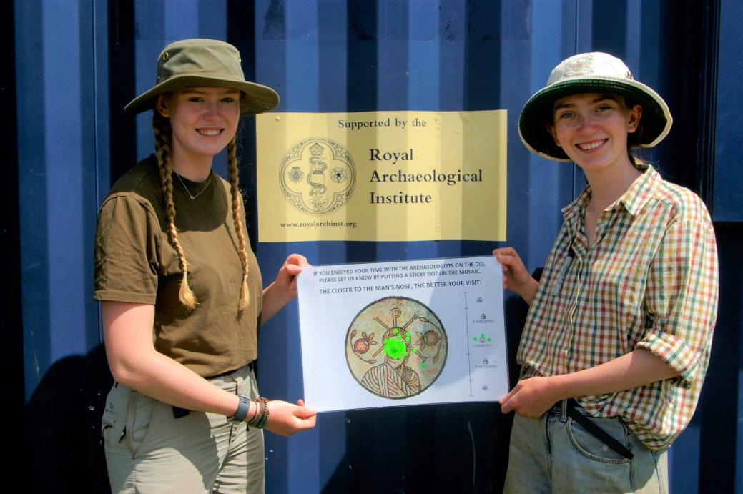
Assistant supervisors Tierney Tudor and Elizabeth Guest with the excavation’s Feedback Mosaic (© The British Museum)
The project welcomed 143 pupils from Yewstock School in Sturminster Newton, who came along for afternoons of trowelling, sieving, metal detecting and finds washing. Our aim was to provide an enriching learning experience for them to understand what archaeology can reveal and how archaeologists uncover the past, as well as to develop an appreciation of this local archaeological site that is unique in Roman Britain. The school children took part in hands-on activities that they could see the archaeologists also doing and everyone enjoyed themselves greatly during their time at the excavation. They learned about what archaeology is, the importance of the past to the places we live in, and how archaeologists can reveal the past.
The impact of the outreach programme with Yewstock School was considerable and this is one of our project’s legacies that we are most proud of. For example, Katherine finds it very difficult to communicate with people that she doesn’t know, particularly adults. After her time at the site, Katherine's teachers described how she'd been inspired to carry out her own excavation in advance of a new path being laid in her grandmother’s garden. Katherine used a trowel to carefully dig the ground and put all the things she found in a tray, which she then brought into school to show her classmates and teachers. Definitely an Archaeologist in the making!
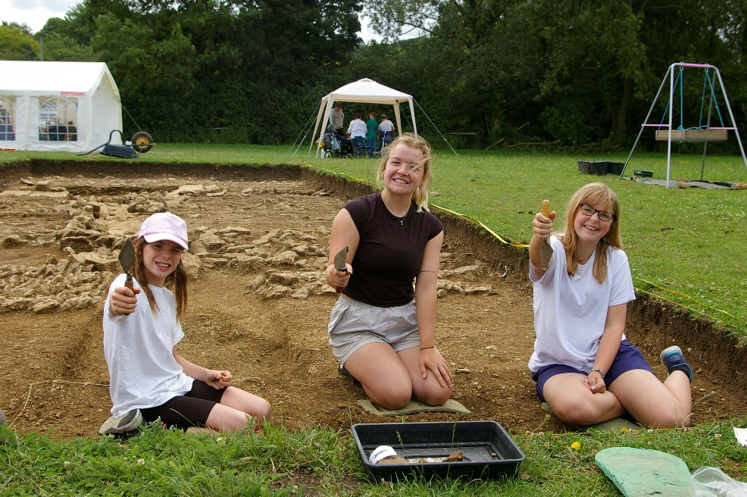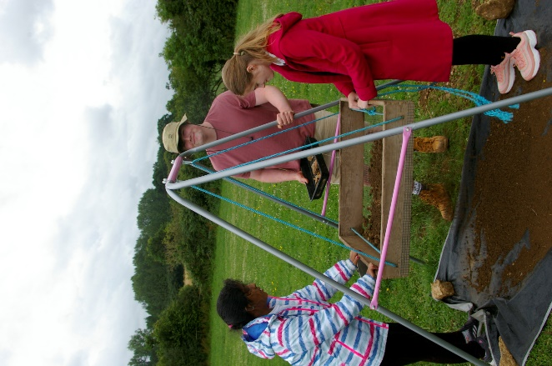
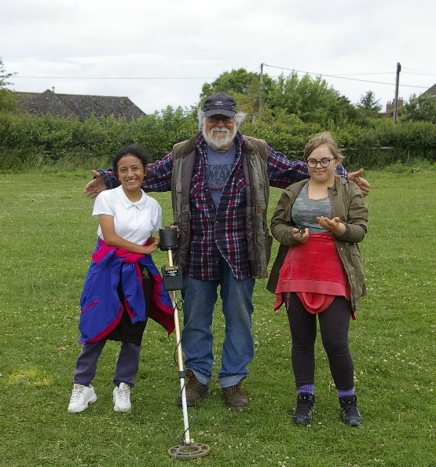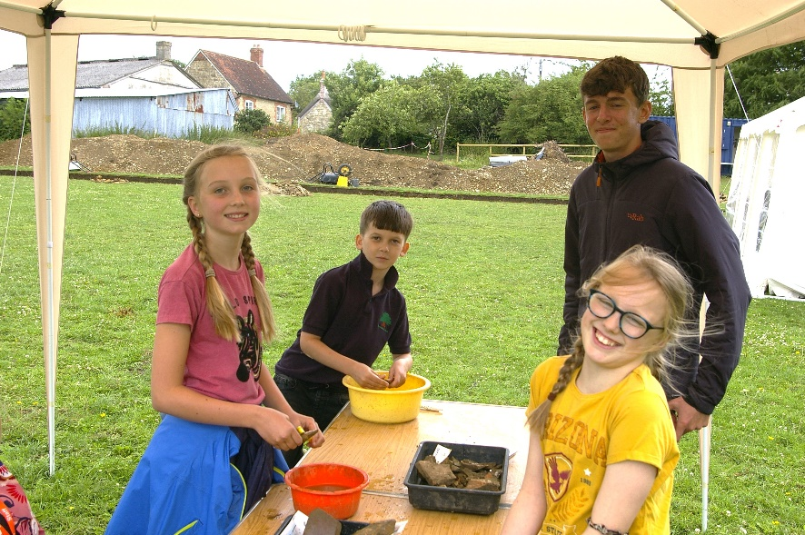
Students from Yewstock School at the excavation, with archaeologists Grace, Ben, Archie and Rory (© The British Museum)

Four classes of 120 students from Sturminster High School also visited for tours of the excavations. They heard about the site’s significance and what we were looking for, before being shown around the trenches. Pupils from Sturminster High School had uncovered the mosaic in 1963 and it was fitting that the school should visit 60 years later.
As I said in this magazine last year (and probably the year before that too), I am very fortunate to have been asked to organise and run an archaeological excavation at such an important and prestigious site as Hinton St Mary. It was a fantastic project to be part of and we did some amazing things in, and out of, the trenches. Special mention has to go to the 3 dig teams for making the month-long seasons such special experiences, particularly the inspirational staff from our commercial partners Albion Archaeology who did such an excellent job in the trenches, as well as the students and volunteers.
As in previous years too, it’s worth emphasising that none of this would have been possible without the help and support of a lot of people and organisations. On behalf of my co-directors Richard Hobbs and Mike Luke, we’d like to thank Katie Scorgie for allowing us to dig up her garden, Mr and Mrs Pitt Rivers and the Hinton St Mary Estate for allowing us to camp and use the facilities in Billy’s Shed, Chris Hardiman and the Village Hall Committee for letting us use the village hall as our base (and the Sturminster and Hinton cricket team), Alice and William Fox-Pitt for their support and advice, and to everyone in Hinton St Mary and Sturminster Newton for making us so welcome!

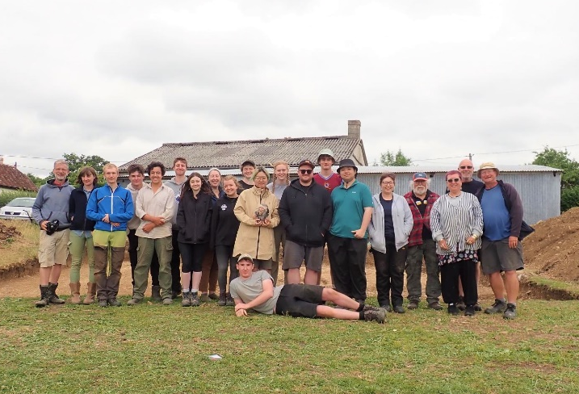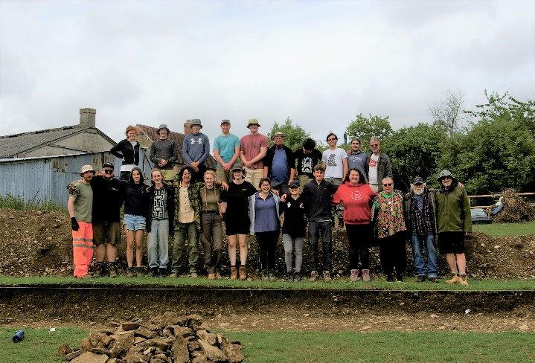
The Hinton St Mary 2022 and 2023 Excavation Teams (© The British Museum)

More information about the Hinton mosaic as well as previous work at the site can be found at www.vianovaarchaeology.com/hinton-st-mary/, which will be updated soon with a summary of this season’s results.
Dr Peter Guest
Vianova Archaeology & Heritage Services

