**THE MOSAIC**

**HINTON ST MARY**

**MAY 2023**

**Captain James Rawe RN**

We in Old School Lane were all very sad to hear about the death of Captain James Rawe RN, who has been our neighbour for close on forty years. We will miss seeing him on his daily walks in the village, without his trademark pipe lately but still wearing the well-known hat.

Aside from wonderful stories from his distinguished Naval Career spanning World War 2, D-Day landings to being in charge of the harbour at Lagos, James and Irene have been the perfect neighbours, kind, thoughtful and tolerant of our girls and various pets.

From the early years when constructing a new staircase for Nicholson’s Farmhouse to gardening and renovations James was always active. We watched in mounting trepidation each year as he climbed the wooden ladder, yet again to repaint his windows, brushing aside offers to help or to hold the thing steady.

Our thoughts are with Irene and the family.

**Gwyn and John James**

James was just 18 when he took part in the D.Day assault

on the Normandy beaches. He attended every anniversary,

laying the Naval wreath on Omaha beach.

KING CHARLES lll CORONATION PARTY/picniC

 SUNDAY 7TH MAY 

2pm – 5pm (Setting up from 1pm)

HINTON ST MARY VILLAGE HALL & CRICKET GROUND

Please come and join us for a fun family picnic and games afternoon to celebrate the King’s Coronation.

* Please bring your own picnic food and drink, chairs, tables or picnic blankets. There will be some seating and a few tables provided.
* We have use of the village hall and gazebos will be provided if wet.

**Thank you to all who attended and helped at the first hub. It was a great success and given us some great ideas for future hubs.  
We had some lovely donations of cake and toys for all to enjoy. So many offers of help to do a village litter pick and what a success that was.**

**21st May 10.30am – 12.30pm**

**Millennium Gardens (Weather dependant)**

The next hub we are hoping to hold it in the millennium gardens so we can incorporate the seed/plant swap. If it is raining, we will move the hub and seed swap over to the village hall.

**What to look forward to on Mays hub -**  
**Tech support** - anyone who would like to volunteer their time to help run a technology session so we can teach those who need it how to use their iPads, computers, laptops and smart phones. Register details with Andy and either a weekend or evening session for this will be held in the village hall.  
**Seed/plant swap** - please bring along any seeds or plants that are surplus to requirement to swap, any donations for plants or seeds would be well received for support to the millennium gardens and the work they do.  
**Food swap**- we will continue with the food swap. Any home-grown fruit and veg or stable cupboard items can be swapped between us and any surplus will be donated to the vale pantry.

**Children -** this session the children will have the opportunity to plant a sunflower seed to take home and grow. In August the tallest sunflower will win a prize. Gwyn will also have sheets for children to take part in a treasure hunt on the day or at a later date and all those who take part will win a prize.

Teas coffee biscuits and cakes will be provided and refreshments for the younger residents.

We look forward to seeing you all on 21st May  
If you have any questions or ideas of what you would like from the hub please contact Gemma or Andy via Facebook, email - [hintonhubdt10@gmail.com](mailto:hintonhubdt10@gmail.com) or phone 07469208904

We would like to say a massive thank you to everyone who supported the litter pick. Such an amazing effort by all involved and an incredible amount of litter was collected. The bus shelter has had a wonderful makeover and a new bin bag has been placed inside which Andy will change as and when needed. We can have use of the council’s litter pick equipment as and when needed, The hub has plans to arrange another litter pick when the vegetation dies back but if anyone notices that we may need to do one sooner don’t hesitate to mention it to us and we can arrange another litter pick session.

Once again thank you all for the amazing effort in making our village sparkle.

**Hinton St Mary Millennium Garden Volunteers - May 2023**

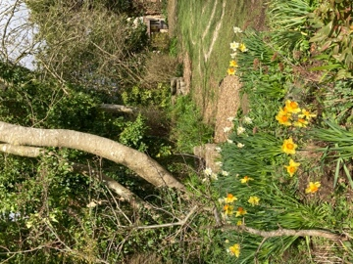We are planning our Plant Day differently this year by joining up with the Hinton Hub. We are pleased to announce that this joint event will be held in the Millennium Garden on Sunday 21st May, from 10:20 a:m - 12:30 p:m, weather permitting.

Please bring along any plants, seedlings or seeds which you wish to exchange, on the day. Alternatively, plants can be bought for a small donation which will go towards the upkeep of the garden.

In the meantime, we continue to meet each Tuesday afternoon to work in the garden. All are welcome.

Contact: Gwyn James: [gmjames28@icloud.com](mailto:gmjames28@icloud.com).

*Village Garden*

*Anyone who has visited the Village Garden recently will have seen the many improvements and changes. From a sad, neglected space, it is now an attractive and interesting place to visit.*

*Our thanks are due to Liz and Richard Collins and Gwyn and John James. The village is grateful for all their hard work and for their vision.*

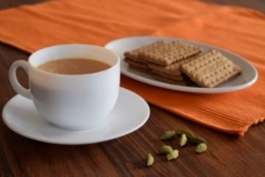

**THE MONTHLY VILLAGE COFFEE MORNING**

**Tuesday 2nd May 10.30 – 12.00.**

The cost is £1.50– for as much coffee or tea as you can drink and as many biscuits

as you can eat.

**BLANDFORD HOSPITAL SHOP**.

As the King’s Coronation is on the 6th May, the Blandford Hospital Shop Warehouse will not be open on the 6th May. **It will be open on Saturday, 13th May. Old Poisdale building. Hinton St. Mary 10 -12 midday.**

**NIKKI GUY & TOM FLETCHER’S WEDDING – 22ND APRIL 2023**

Thank you more than I can say to everyone in the village who contributed to making Nikki and Tom’s Wedding Day last Saturday so special – it was a very happy day, albeit freezing but we managed to forget about that quite quickly!

Nikki has always considered Hinton to be her home in England, and I know her family and friends who came over from South Africa now really understand why.   I am so grateful for all the warmth and friendship shown to both Nikki and Tom, so thank you again – it means a huge amount to us all.

**Susie Burbidge**

To all the people of Hinton St Mary

I would like to extend my sincere thanks to you all for the love and friendship you have shown to Nikki and Tom over the past few years.   Your support has made them feel that the village is truly their second home.

Thank you also for your help over their wedding – your generosity helped make it a truly magical day.

Bless you all. With much love,

**Carol Guy**



Firstly we must thank you for your support with the Easter Egg raffle, over £150 raised for Home Start, we were totally blown away with the generosity.

**Bank Holiday Mondays** So this month seems to be full of Bank Holiday Mondays, for which we will open 12pm for lunch.

**Coronation Saturday**

Open from 11am, the tv will be on so why not watch with us, enjoy some limited-edition Coronation Ales & Coronation Specials on the menu.

**Sunday 7th May**

Quiz night from 7pm with quiz master Mark Steggs , look out for some royal questions !!

Pizza man Dan in the garden with his usual tasty pizzas.

**Sunday 21st May**

Open mic night -a fun night, with a real selection of local artists, starting from 6pm. Pizza man Dan in the garden.

**Monday 29th**

Bank holiday (again)…open 12pm for lunch.

**No cribbage this month, look out for June’s date in the next Mosaic.**

Once again thank you for your continued support, and we look forward to welcoming you to the pub soon.

The White Horse Team

01258915001

thewhitehorsehinton.co.uk

*Pub Quiz*

*We have been asked by several people to thank Mark and Jane for all their efforts in preparing and running the monthly pub quiz.*

*It is a very happy village evening (****first Sunday of every month. 7.p.m.)***

*It is thoroughly enjoyed by all who take part and they do appreciate all the work that goes into making it such a success.*



**St Peter’s Services**

**May 2023**

|  |  |
| --- | --- |
| **Date** | **Service** |
| Sunday 7th May at 9.30 am | Holy Communion |
| **Saturday 13th May 11:00**  Sunday 14th May at **11.00 am** | **Funeral Service - James Rawe**  Morning Prayer |
| **Thursday 18th May at 7.00 pm** | **Ascension Day - Holy Communion at St Mary’s, Sturminster Newton** |
| Sunday 21st May at 9.30 am | Holy Communion |
| Sunday 28th May at 9.30 am | Morning Prayer (Lay Led) |

The Church is open for sanctuary and prayer each day and, in accord with common practice within Salisbury (and other) Diocese, at Eucharist the common cup is reintroduced for those wishing to receive the full sacrament. Communicants unwilling to receive wine are welcome to receive the bread.

All queries relating to Church-related support and services should be directed in the first instance to the Church Wardens:

|  |  |
| --- | --- |
| Robin Gibbs Tele: 01258 471493  Email: [robin@aviaconsult.uk](mailto:robin@aviaconsult.uk) | Kevin Peto-Bostick Tele: 01258 475469  Email: [kevin.peto.bostick@gmail.com](mailto:kevin.peto.bostick@gmail.com) |
| The Revd Mary Gubbins  The Vicarage, Sturminster Newton | Tel: 01258 721704  Email: revd.mary.gubbins@gmail.com |

**Lynne Fish has been investigating her family tree and in the process has discovered this photograph of school children in Hinton St Mary circa 1913**

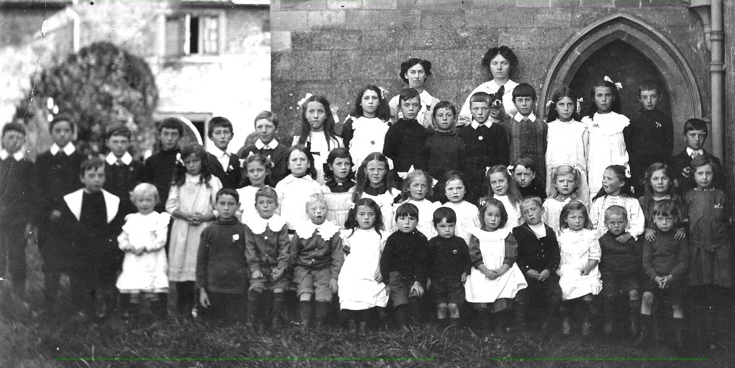

Hinton St Mary schoolchildren circa 1913. The teachers are, from left, Miss Ida Rose and Miss Rachel Kiddle. Miss Kiddle arrived in Hinton by bicycle on 1st April 1911. She asked directions from the local blacksmith Walter White and the rest, as they say, is history, as she later married him.

**The Blackmore Vale Partnership *Spring Covid Booster***

The Spring Covid Booster campaign started on 17th April 2023 for adults aged 75 years and over and individuals aged 5 years and over who are immunosuppressed. However, they are only available until June 30th .

The Blackmore Vale Partnership are not providing these vaccines this Spring, therefore please do not ring the Practice.

The NHS will write to people to remind those eligible that they can get the vaccine, but bookings can be made at any time via the National Booking Service or calling 119 – most sites are appointment only.

There are some local clinics being held in the following venues:

- **Blandford Community Hospital** (Outpatient Clinic), Blandford Forum, DT11 7DD

Clinics will be held on Saturdays between 09:00-17:30

- **Westminster Memorial Hospital**, Abbey Walk, Shaftesbury, SP7 8BD

Clinics will be held in the Outpatients Department on Thursdays between 09:30-16:30 and Fridays between 13:30-16:30

The residents in care homes for older adults has already begun. Patients who are registered as housebound will be contacted by Dorset Health Care when their COVID booster is due, to arrange a visit from a vaccination team. For any queries from patients, please contact Dorset Health Care directly in the first instance.

You can find out all you need to know about COVID-19 vaccinations, including who is eligible for a seasonal booster by searching ‘Dorset vaccination service’ online or click on the following link:

https://www.dorsethealthcare.nhs.uk/covid-19-vaccination....

**MAY QUICK QUIZ**

Ditloid 2 B T in S Riddle: What has 88 keys

ANSWERS TO APRIL QUIZ

Ditloid 40 days in lent Riddle: A carrot

IF YOU LIVE IN HINTON ST MARY AND DO NOT RECEIVE A COPY OF THE MOSAIC **EVERY MONTH** – PLEASE LET NIGEL KNOW ON 07710 088322 OR EMAIL DJNMARTIN@BTINTERNET.COM

To enquire about or to book the village hall please call Chris Andrews on 01258 473107.

***Please let us have any articles, notices, celebrations,, information, items for sale, trusted traders etc you would like to have included in next month’s Mosaic.*** *Deadline 24th of the Month. Thank you. Janet, Jo & Nigel.*

*janetbolton25@hotmail.co.uk jo.martin99@btinternet.com*

*Keep abreast of all things ‘HSM’ on the village facebook page: Hinton St Mary Village Group and the Hinton St Mary Website:*

[*http://www.hintonstmary.com*](http://www.hintonstmary.com) *where all previous copies of The Mosaic are also available.*

Thank you to our Sponsors and Advertisers:

Mr & Mrs Pitt Rivers, Hinton St Mary Parish Council, St Peter’s Church, HSM Village Hall Committee.

**Trusted Traders**

These are tradesman/workers who have been personally recommended by villagers. Please let us have details of anybody who has done a great job for you. Thank you.

|  |  |  |
| --- | --- | --- |
| COMPUTER HELP | TIM WEST | 01258 817537 sturcomputers@hotmail.co.uk |
| CURTAINS, BLINDS, TRACKS, FABRICS &  FITTING (Marnull) | THE CURTAIN MAN  (Anna & Tony) | 01258 821117 thecurtainmanshop@gmail.com |
| CARPENTRY/JOINERY | NIGEL BASTABLE | 01258 860459 [www.nigelbastable.co.uk](http://www.nigelbastable.co.uk) |
| CARPENTRY (& WOODEN FLOORS) | GARY CORCORAN | 07920557651 [gccarpentry@hotmail.co.uk](mailto:gccarpentry@hotmail.co.uk) |
| **ADVICE ONLY** WITH WASPS & BEES | TED EYRES | 472154 |
| PEST CONTROL | MARK GOULD  (Rats, Wasps, Moles & Fleas) | 07999 957694 [mark_gould2@btconnect.com](mailto:mark_gould2@btconnect.com) |
| BUILDERS | ANDREW TRIM | 07939 541128 |
| FENCING & REPAIRS | DAVID WHITEHAND | 07549 151 799 |
| BOILER MAINTENANCE | BOB JONES & SON | 01963 362 502 |
| CARPET & UPHOLSTERY CLEANING | CASTLE GUARD CLEANING | 01202 715 115 |
| GROUNDWORK & HARD LANDSCAPING | KEIRAN HARVEY | 07792 250 347 |
| BUILDING & RENOVATION | MARK GORDGE | 07941 443 306 |
| ROOFING | BEN GIBBS ROOFING | 07912 655095 [Bengibbs.roof@gmail.com](mailto:Bengibbs.roof@gmail.com) |
| SCAFFOLDING | EDW SCAFFOLDING | 07474 552259 [elwin1965@icloud.com](mailto:elwin1965@icloud.com) |
| PRINTING | PROPRINT STALBRIDGE | 01747 851417 sales@proprint2k.co.uk |

**NIGEL BASTABLE LTD**

**CARPENTRY & JOINERY**

**The Building Yard – Hinton St Mary**

**Doors, Windows, Wardrobes, Stairs, Kitchens, Cupboards, Bookcases Etc.**

**Renovations and Repairs**

**01258 860459**

[**nigelbastable@btinternet.com**](mailto:nigelbastable@btinternet.com)[**www.nigelbastable.co.uk**](http://www.nigelbastable.co.uk)



**Turk’s Garage**

MOT’s, servicing and repairs

All makes and models

**Mr. S.J. Chatfield**

**01258 472 686**

Marnhull Road, Hinton St Mary

DT10 1NG



**BB**

**BIGGER BITES**

Nicholson’s Yard, Hinton St Mary

www.biggerbites.co.uk

**Event catering covering the Southwest & beyond**

Breakfast - Burgers - Pulled Pork – Hot & Cold Drinks

Jonathan Murray

0990 703 573

Jossmurray001@gmail.com



**Rose’s Yard, *Hinton St Mary– Air B and B***

*Self-Contained first floor annex*, sleeping 4 in the centre of the village.

Contact:

[jo.martin99@btinternet.com](mailto:jo.martin99@btinternet.com)

Jo 07860 612412

Or book through Air B and B

