** THE MOSAIC**

**HINTON ST MARY**

**JANUARY 2023**

**VILLAGE CHRISTMAS PARTY**

I would like to thank the organising team for a great Christmas party this year. It is great we live in such a wonderful village where people are prepared to step up and organise events for the village to come together. Thanks team 2022 & thanks Anthea for previous Christmas parties.

Thank you Warren for such great music. You are a star.

**Celia Wright**

*The Christmas Party Committee would like to thank everybody who helped make the event such a success. Special thanks go to Father Christmas, DJ Warren, Harts for donating a lovely Christmas tree, Robin and Gina for Frostie the Snowman and to everybody who helped to set up before the party and/or who helped to clear away everything the following morning.*

*Of course the party could not take place without the generosity of Mr and Mrs Pitt Rivers who allow us to use the beautiful Tithe Barn and provide the heating and the logs for the fire so a very big thank you to them.*

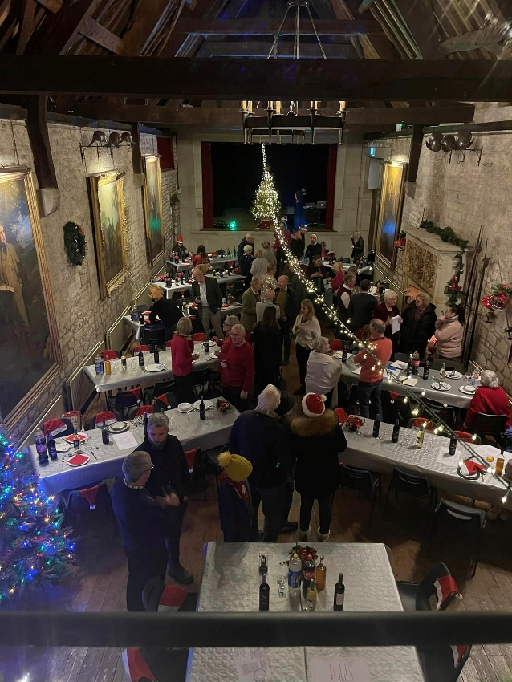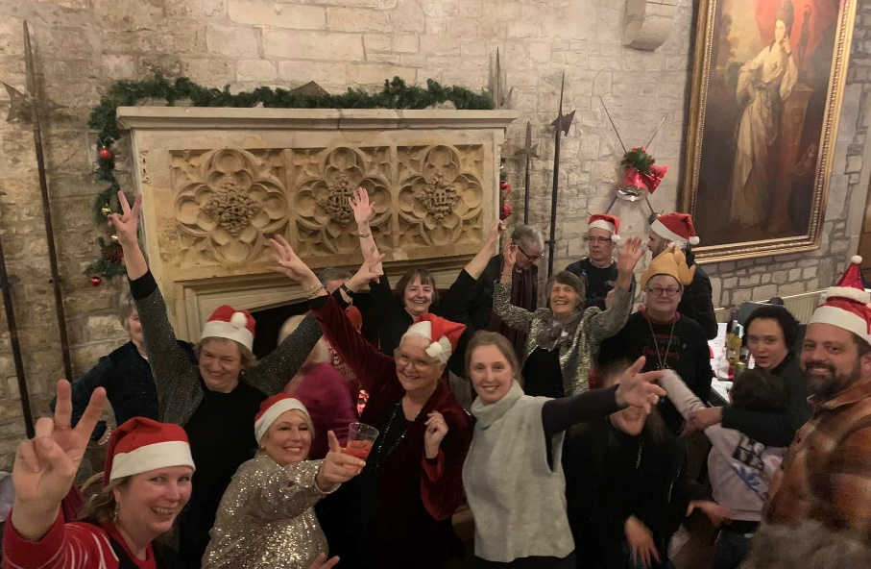

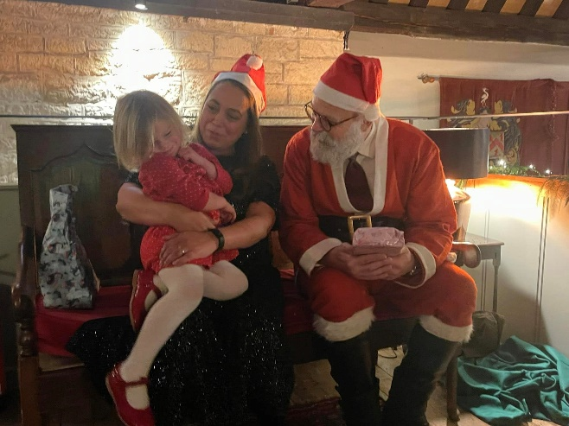

**Hinton St Mary Millennium Garden 2022**

A small group of volunteers meets every Tuesday afternoon for routine maintenance and restoration of the garden, providing a community space and wildlife area for the village.

We have recently concentrated on working on the thicker foliage to let light in for the under planting and to create a sense of space. More ambient light should make the sundial more usable, encourage insects to use the bug hotel and make the garden feel more welcoming. Many thanks to Bartlett’s for providing the means to remove all the debris! Chipped smaller branches have been used for the upkeep of the woodland walk. Thanks also to Robin Gibbs who keeps the orchard grass manageable for us.

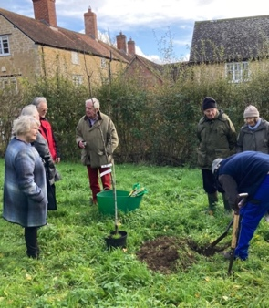On a cold, windy Wednesday in November an addition was made to the orchard of a Red Bartlett Pear sapling, a gift for the Queen’s Platinum Jubilee from the Sturminster Town Twinning group. A welcome inclusion in the orchard for blossom, pollinators and eventually fruit.

The new flower area in the orchard has been a great success. The wildlife friendly planting has created a colourful area, bringing more insects and even frogs into the garden. Sue and John East have been the prime movers for this.

Apple Day produced over 300 litres of juice from apples from the orchard and other trees in the village and we were able to supply juice for the Harvest Lunch, Children’s Halloween party and the Christmas party as well as for distribution between helpers and contributors. However, it was not so successful in raising money for the garden, and we will be looking at possible alternative plans for next Autumn. Thanks are due to Liz and Richard Collins for the huge amount of work and planning which goes into this event.

Clearing the ground of weeds and leaves, takes time but we hope it will help our spring bulbs and flowers make a bright start to the year. Thanks to Jo and Philip Curtis we have been able to clear an area behind the stocks and will plant this in the Spring to make a more inviting entrance. They have done great work in reducing the laurel hedge between the orchard area and the Old Stone House so we can re-site the water butt, which needs a means of water catchment to make it productive, and have room for a herb garden.

An amount of £388.80, has been raised from plant and seed exchanges, Bring and Buy Sale and Apple pressing with £11 to add from sale of juice pouches.

Our current priorities for 2023 are:

* Re-siting the water butt and providing a canopy to capture rainwater.
* Two quotes received for the renovation of the maze, one of £1166.75 and another of £2602.97 are out of our scope at present. Meanwhile we plan to use environmentally friendly lime paint to temporarily maintain the outline.
* New planting to enhance the garden entrance and creation of a herb area.

**Future events:**

* Seedling/plant exchange in Spring
* An Autumn plant sale in addition to the Spring seedling swap gives an opportunity to increase our stock of appropriate low maintenance plants and to raise funds.
* Dates for occasional Saturday Work parties and Family Activities to be decided.

Contacts: Liz Collins ([lizcollins50@gmail.com](mailto:lizcollins50@gmail.com)) & Gwyn James ([gmjames28@icloud.com](mailto:gmjames28@icloud.com))

**GOOD NEWS**

**Steve Chatfield has now recovered and**

**TURKS GARAGE**

**Will be re-open for business from 16th January**

**FULLY OPERATING BATTERY POWERED CARBON MONOXIDE MONITORS**

**FREE OF CHARGE**

As many of us are reliant on coal, wood, oil and gas for our heating, winter is a particularly important time to have a fully operating Carbon Monoxide Detector. Part of what I do at work is manage gas detection products, in particular domestic battery powered Carbon Monoxide monitors used in housing. We recently stopped manufacturing a range of these which has left us some remaining stock which has now been written off and would have been destined to be disposed of. Rather than let this happen which would be a real waste, I was hoping to find homes for them within the village, obviously completely free of charge with no strings attached, I’d simply hate to think somebody was without one whilst we were throwing perfectly good ones away!

The device in question is the XC70 which is a 7 year CO detector (pictured below).

If people want to provide their name and address to my personal email address, I’m more than willing to hand deliver them to wherever is needed within the village, alternately you’re more than welcome to knock on the door and collect one (or more if needed) in person.

Chris Townsend

8 Old School Lane

[cp.townsend@btinternet.com](mailto:cp.townsend@btinternet.com)

**SUPERB CHRISTMAS DAY LUNCH AT THE WHITE HORSE Jo Woodcock**

The white horse was open for business over the festive season and provided a gourmet Christmas lunch to remember for a lucky few couples, in a cosy intimate and unrushed single sitting.

The seafood platter and lobster bisque starter was a meal in itself, accompanied by a complimentary festive sparkling aperitif, followed by luxuriant goose with all the trimmings and a delicious moist and very alcoholic plum pudding. To finish, a giant cheese board , washed down with port. A good time was had by all and the chef received a well- deserved standing ovation!

Book your place early for next Christmas as news is spreading ....

**NEW YEARS EVE AT THE WHITE HORSE**

A massive thank you to Sarah, Cecily, Charlotte and to DJ Warren Chalke for a fantastic New Years Eve at The White Horse!

**Quite a Special (Musical) Weekend!**

It is not often (if at all?) that one can enjoy three musical

events with singing in the space of 18 hours and all within

walking distance!

Of course, this was kicked-off with the very successful

Village Christmas Party in the Tithe Barn with singing, music and

dancing in front of a roaring fire.

If even this weren’t enough the evening could be rounded off with a live band in the “White Horse”. (With even more slightly-out-of-tune singing by the audience?).

The following morning we held our Christmas Concert at “The Exchange” where we had a packed house with standing room only and the opportunity to stand and sing carols accompanied by a full orchestra, replete with sleigh bells.

We would like to express our sincere appreciation for all those from HSM who attended and supported our chosen good cause. With your amazing generosity we raised £600 for “The Vale Pantry”.

You might also be pleased to know that, in 2022, we also have raised over £1500 for the people of the Ukraine at our other short concerts.

***All in all, a fitting way to celebrate Christmas!***

**John Harding On behalf of the Sturminster Newton Orchestra**

|  |
| --- |
| “**The perfect Covid Christmas**: we want to thank all the friends and neighbours who called, sent greetings and offered help during Christmas when all our plans and family visits had to be cancelled at the very last minute when both Gina and I tested positive with Covid.  Needless to say, Christmas was strangely quiet but at least we had the comfort of knowing you were all out there.  We wish you hope for 2023,  **Robin & Gina** |

**Appeal for North Dorset Refuge**

A huge thank you once again to parishioners and villagers for once again supporting this appeal. Before Christmas, I delivered two car loads of much needed bedding, maternity and children’s clothes, toys, toiletries and food. Your generosity, during these very difficult economic times is very appreciated.

**Shane Johnstone**

**St Peter’s Services**

**January 2023**



|  |  |
| --- | --- |
| **Date** | **Service** |
| Sunday 1st January at 11.00 am | **There is no service at St Peter’s on this day, but a Holy Communion service at St Mary’s, Sturminster Newton** |
| Sunday 8th January at 9.30 am | Morning Prayer - Lay Led - BCP |
| Sunday 15th January at 9.30 am | Morning Prayer - Lay Led |
| Sunday 22nd January at 9.30 am | Holy Communion |
| Sunday 29th January at 11.00 am | **There is no service at St Peter’s on this day, but a Benefice (with Holy Communion) service at St Mary’s, Sturminster Newton** |

The Church continues to be open for prayer each day and all Covid 19 measures have been waved. In accord with practice now adopted within Salisbury (and other) Diocese, the common cup has been reintroduced for those wishing to receive the full sacrament. It remains entirely acceptable, however, for any communicant not wishing to receive wine to simply receive the bread. A presiding priest may, at their discretion, choose to offer the wine through a pipette as a continued precaution while a Covid threat exists.

The Patron and the Bishop of Sherborne are delighted to announce that the next Vicar of Sturminster Newton, Lydlinch and Hinton St Mary will be the Revd Mary Gubbins. Mary and her husband Andrew will be moving to the vicarage in Sturminster Newton before Easter 2023 and her Installation by the Bishop of Sherborne will take place on Tuesday 28th March. Details of this service will be announced in due course. Until further notice, all queries relating to Church-related support and services should be directed to the Church wardens:

|  |  |
| --- | --- |
| Robin Gibbs Tele: 01258 471493  [robin@aviaconsult.uk](mailto:robin@aviaconsult.uk) | Kevin Peto-Bostick Tele: 01258 475469  [kevin.peto.bostick@gmail.com](mailto:kevin.peto.bostick@gmail.com) |

HINTON ST MARY PARISH COUNCIL

Minutes of the Parish Council Meeting

held at Hinton St Mary Village Hall on Tuesday December 6th 2022 at 7pm

*Present:-*

*Chairman* – Kevin Jones (KJ)

*Councillors* – Steve Johnson (SJ) Jo Curtis (JC)

*Clerk* – Vivian Hitchmough (VH)

2022.43 *Apologies*

Cllr Susie Burbidge (SB) Rob Bartlett (RB) County Cllr Carole Jones

2022.44 Minutes of the meeting of Tuesday October 4th 2022 were agreed as a true record and duly signed.

2022.45 *Matters Arising*

JC pointed out that the drains by the public house are still not working despite being jettisoned. The Chairman suggested it was probably caused by a collapsed pipe underground as the drain had been a problem for some while.

The Chairman said that due to the cold spell he will look to see if the grit bins are full.

2022.46 *Declarations of Interest*

None

2022.47 *Updates from Officers*

*Planning* JC had nothing to report

*Roads, drains and potholes*

SJ said the split in the raised footpath at Nicolson’s Cottages had been repaired and in her absence thanked Cllr Carole Jones for her swift action.

*Village Liaison/Garden*

JC said she was organising a work party to get the village garden under control with a clear up and hedge cutting.

*Speed Indicator Device*

The Chairman repeated that there was an issue with the solar panel on the S.I.D. There is no longer any warranty on the S.I.D but he is confident that a panel can be replaced for a modest sum and he will deal with this matter.

*Defibrillator* SJ attended the Train the Trainer Course but felt it would be more appropriate if a First Aid Trainer could offer the guidance. To this end the Chairman will liaise with RB to possibly join a yard training session with his company. Parish Council will be prepared to pay for this training.

*Telephone Box*

No report

2022.48 *Finance*

A cheque for the clerk’s salary was signed.

2022.49 Cllrs held a discussion regarding the application for Precept for 2022/23. Application deadline is January 2023. With possible future funding required for spares for the defibrillator and solar panel for the S.I.D and telephone box repairs it was decided to keep the application at £2000, as 2021/22.

The Clerk will scan and post the documentation to Dorset Council applying for the Precept.

2022.50 *Reports*

None

2022.51 *Questions from members of the public*

There were no members of the public present.

2022.52 *Correspondence*

No outstanding correspondence

2022.53 *Any Other Business*

JC had concerns that the fire hydrant by the crossroads appears to be out of commission. The Chairman said this was Dorset Fire Service responsibility and they would have carried out a risk assessment before decommissioning.

2022.11 *Date of next meeting Tuesday March 21st 2023* The Chairman closed the meeting at 7.35pm

*………………………………………………………………………………………………………………………………………………………………………………………………………..*

**THE MONTHLY JANUARY TUESDAY VILLAGE COFFEE MORNING**

**Tuesday January 3rd 10.30 – 12.00.**

The cost is £1.50– for as much coffee or tea as you can drink and as many biscuits as you can eat !!

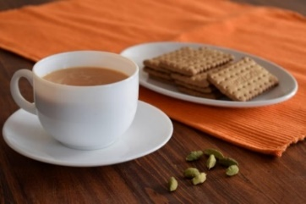

……………………………………………………………………………………………………………………………………………………………………………………..

**A Call for Citizens Advice Volunteers in North Dorset**

The service provided by Citizens Advice is in great demand due to the increasing number of people in the community who are facing real hardship, as a recession looms. The cost of living crisis, rising food and fuel prices, redundancy, debt and so on, creates huge pressure and anxiety, but Citizens Advice with over eighty years’ experience, is perfectly placed to help.

However, they need more Volunteer Advisers in North Dorset, to cope with the increasing workload. So, do you have what it takes to volunteer? Advisers come from different backgrounds, ages and varied life experiences, but all have one thing in common – they want to help their community.

In terms of qualifications, you need to be a good listener, IT literate and have a passion for wanting to help others. Full training and support are provided and there is flexibility about how much you do and when and where you offer advice.

Telephone 01747 834900 for more information and don’t delay – call today and make a difference!

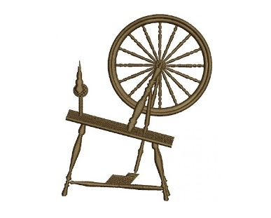 **BMV SPINNERS**

Hinton St. Mary Village Hall

Spin fleece to yarn, weave, knit, crochet etc

We meet 1st and 3rd Wednesday in the month, 11am – 3pm

Like to join us?

Tel: 01747 838035 / 838589

 **JANUARY QUICK QUIZ**

Ditloid: W 9 T F B D P (Clue music) Anagram: Repay Yap When

ANSWERS TO DECEMBER QUIZ

Ditloid: 7 Dwarfs in Snow White Anagram: Carol Singers

IF YOU LIVE IN HINTON ST MARY AND DO NOT RECEIVE A COPY OF THE MOSAIC **EVERY MONTH** – PLEASE LET NIGEL KNOW ON 07710 088322 OR EMAIL DJNMARTIN@BTINTERNET.COM

To enquire about or to book the village hall please call Chris Andrews on 01258 473107.

***Please let us have any articles, notices, celebrations,, information, items for sale, trusted traders etc you would like to have included in next month’s Mosaic.*** *Deadline 24th of the Month. Thank you. Janet, Jo & Nigel.*

*janetbolton25@hotmail.co.uk jo.martin99@btinternet.com*

*Keep abreast of all things ‘HSM’ on the village facebook page: Hinton St Mary Village Group and the Hinton St Mary Website:*

[*http://www.hintonstmary.com*](http://www.hintonstmary.com) *where all previous copies of The Mosaic are also available.*

Thank you to our Sponsors and Advertisers:

Mr & Mrs Pitt Rivers, Hinton St Mary Parish Council, St Peter’s Church, HSM Village Hall Committee.

**Trusted Traders**

These are tradesman/workers who have been personally recommended by villagers. Please let us have details of anybody who has done a great job for you. Thank you.

|  |  |  |
| --- | --- | --- |
| COMPUTER HELP | TIM WEST | 01258 817537 sturcomputers@hotmail.co.uk |
| JOINERY/CARPENTRY | ANTHONY GILBERT  AGJ JOINERY | 01258 268134 [ant_gilbert1@hotmail.co.uk](mailto:ant_gilbert1@hotmail.co.uk)  [www.ajg-joinery.co.uk](http://www.ajg-joinery.co.uk) |
| CARPENTRY/JOINERY | NIGEL BASTABLE | 01258 860459 [www.nigelbastable.co.uk](http://www.nigelbastable.co.uk) |
| CARPENTRY (& WOODEN FLOORS) | GARY CORCORAN | 07920557651 [gccarpentry@hotmail.co.uk](mailto:gccarpentry@hotmail.co.uk) |
| **ADVICE ONLY** WITH WASPS & BEES | TED EYRES | 472154 |
| PEST CONTROL | MARK GOULD  (Rats, Wasps, Moles & Fleas) | 07999 957694 [mark_gould2@btconnect.com](mailto:mark_gould2@btconnect.com) |
| BUILDERS | ANDREW TRIM | 07939 541128 |
| FENCING & REPAIRS | DAVID WHITEHAND | 07549 151 799 |
| BOILER MAINTENANCE | BOB JONES & SON | 01963 362 502 |
| CARPET & UPHOLSTERY CLEANING | CASTLE GUARD CLEANING | 01202 715 115 |
| GROUNDWORK & HARD LANDSCAPING | KEIRAN HARVEY | 07792 250 347 |
| BUILDING & RENOVATION | MARK GORDGE | 07941 443 306 |
| ROOFING | BEN GIBBS ROOFING | 07912 655095 [Bengibbs.roof@gmail.com](mailto:Bengibbs.roof@gmail.com) |
| SCAFFOLDING | EDW SCAFFOLDING | 07474 552259 [elwin1965@icloud.com](mailto:elwin1965@icloud.com) |
| PRINTING | PROPRINT STALBRIDGE | 01747 851417 sales@proprint2k.co.uk |

**NIGEL BASTABLE LTD**

**CARPENTRY & JOINERY**

**The Building Yard – Hinton St Mary**

**Doors, Windows, Wardrobes, Stairs, Kitchens, Cupboards, Bookcases Etc.**

**Renovations and Repairs**

**01258 860459**

[**nigelbastable@btinternet.com**](mailto:nigelbastable@btinternet.com)[**www.nigelbastable.co.uk**](http://www.nigelbastable.co.uk)



**Turk’s Garage**

MOT’s, servicing and repairs

All makes and models

**Mr. S.J. Chatfield**

**01258 472 686**

Marnhull Road, Hinton St Mary

DT10 1NG



**BB**

**BIGGER BITES**

Nicholson’s Yard, Hinton St Mary

www.biggerbites.co.uk

**Event catering covering the Southwest & beyond**

Breakfast - Burgers - Pulled Pork – Hot & Cold Drinks

Jonathan Murray

0990 703 573

Jossmurray001@gmail.com



**Rose’s Yard, *Hinton St Mary– Air B and B***

*Self-Contained first floor annex*, sleeping 4 in the centre of the village.

Contact:

[jo.martin99@btinternet.com](mailto:jo.martin99@btinternet.com)

Jo 07860 612412

Or book through Air B and B

