** THE MOSAIC**

**HINTON ST MARY**

**JUNE 2022**



**Don’t forget – The Big Lunch is on Sunday 5th June at The Tithe Barn, Hinton St Mary, starting at 1.00pm**

We have access to the Tithe Barn from 4.00 p.m. on Saturday 4th June – please could I ask for some help in moving tables and chairs into the Barn so that we can arrange and lay-up for the lunch the next day – and also to put up Bunting, etc.

For the children entering the Crown-making competition, please deliver your Crowns to the Tithe Barn by 11.00 a.m. on Sunday morning – Mr and Mrs Pitt-Rivers have kindly agreed to judge the Crowns before the Lunch starts at 1.00 p.m. A template is attached to the back of the Mosaic for those who wish to use it - but all designs are welcome!

Just to remind you, we will be providing crockery and cutlery, and there will also be wine, beer, soft drinks and Fizz to raise a glass to the Queen.

All you need to bring are yourselves and a plate of food for the communal table so that everyone can join in and help themselves – but if you would prefer to bring your own food, particularly if you have allergies, etc., or your own picnic, then please do so.   Please make sure your dishes are named so that we can return them to their rightful owners !

If you have not already done so, **please can you let me know as soon as possible whether or not you will be coming to the Lunch** so that we can make sure we have enough plates, etc.

Really looking forward to seeing as many people as possible at the Big Lunch !!

Susie Burbidge

Laurel House, 3 Veals Lane, Hinton St Mary, Tel: 01258 472 264 Mob 07831 741 419 Email [susieburbidge@gmail.com](mailto:susieburbidge@gmail.com)

**GARDENS OPEN**

**Saturday 18th and Sunday 19th June 2022**

**2.00 p.m. - 6.00 p.m.**

With only just over 3 weeks to go before the weekend, I would just like to thank all the team leaders who have been hard at work finalising the plans and their team members.

If you are still wanting to offer to help or wishing to donate, please advise the person responsible or deliver to the Tithe Barn on Friday 17th at 6pm, or the morning of Saturday 18th before 10.30 am or before that day by agreement. All of the stall holders are still needing donations and if you have them hiding in your cupboards, any strong plastic bags, small cardboard boxes, bubble wrap or any wrapping materials.

I will need to finalise the map to include details of the gardens being open, so unless you have confirmed to me previously, please let me know by Monday 6th June.

Subject to the weather conditions, we will start putting up the tents and tables on Friday 17th from 6 pm and will hope to take everything down from 6 pm on Sunday 19th. We will particularly need some strong young people to assist in this task.

Finally, all we need now is warm weather, not too warm like in 2019 when it reached 30 degrees and hopefully no rain. Any queries or questions – just contact me. Shane Johnstone

**Gardens Open - Collectables.**

‘Collectables’ covers a multitude of possibilities. In previous years we have had success with:

CURTAINS, SOFT FURNISHINGS, CUSHIONS, DECORATIVE FABRICS and other home related fabrics

SMALL PIECES OF FURNITURE

PICTURES

CHINA

GLASS

JEWELLERY

And ANYTHING interesting or attractive and vaguely Home related.

We also need cardboard boxes, bubble wrap, other wrapping paper and plastic bags.

**The Tithe Barn will be open for delivery from 9 a.m. on Friday, 17th June and Saturday, 18th June 9 a.m. – 12 midday.**

**Anything can be collected – just ring Janet on 472300**

**Gardens Open – Plant stall**

A final call for donations of plants, pots, tools etc, but particularly plants! If you have any surplus plants you would like removed, I would be happy to come and assist. Even if you plan to bring them along on the Friday evening/ Saturday morning, it would be helpful to have a rough idea of what we might be getting, so we can plan the space accordingly.

Any used carrier bags and trays/boxes for transporting plants would useful.

Also, if anyone would be able to assist with manning the stall on either of the two days, even for a short time, it would be a great help.

If you have any queries or suggestions, you can contact me on either:

[lizcollins50@gmail.com](mailto:lizcollins50@gmail.com) or on my mobile: 07377389453

**COMMUNITY GARDEN SEED AND SEEDLINGS SHARE**

Many thanks to everyone who took part in the community seed and plant share held on Saturday April 30th in the Millennium Garden, Hinton St Mary.

The sum of £75.19 was raised on the day from donations for plants and for the cake and coffee, provided by the garden volunteers. This will be put back into the costs of maintaining the garden.

A 200 Litre water butt has been bought with some of the money raised. We hope that, although the garden planting will be as drought resistant as possible, we will be able to use this additional resource for new planting.

It gave an opportunity to see the ongoing work of maintaining the Millennium Community Garden as a wildlife friendly garden and to share ideas for the future. If you are interested in helping with the garden, we can be found there on Tuesday afternoons, weather permitting.

**The Estate Alice Fox-Pitt**

What a couple of months for the estate, with the dry weather all the drilling was done on time. The rain got the grass going and with a window in the weather the first silage cut is just about complete.

The first bits of the stewardship scheme are being implemented, cut and laying hedges and the planting of wildflower and bee mix margins.

It was great to be able to welcome Barney into the pub at last and thank you to so many of you who popped by.

Last weekend saw the first wedding that used every part of the projects. The family had dinner in the pub on Friday night and stayed all together in the houses. The boys had drinks on Saturday morning while the bridesmaids and bride got ready. The ceremony was beautiful under the lime arch followed by drinks in the sunken garden and dinner and dancing in the barn. The weekend was rounded off with Sunday lunch back in the pub.

The team of Mark, Gail, Rupert, James, Michelle, Barney, Sara, Craig, Danielle, Michelle and Carl were outstanding in meeting all the deadlines, smiling all the way through the preparations and delivering a happy, happy time. Hopefully we can build on a great start.

We are looking forward to everyone coming for Jubilee celebrations in the tithe barn and the weekend of open gardens.

Work is now about to start in the old carpenter’s workshop in the builder’s yard to get it stable and secure without any scaffolding, exciting times.

**Wedding Celebration at the Tithe Barn**

**The White Horse – Open Again**

**The Yard Alice Fox-Pitt**

April and May have been flat out for the team at Wood Lane Stables.

William didn’t have the best preparation for Badminton with a fall that ruled him out of competition for 21 days.

In spite of that he had two horses ready and it was absolutely fantastic to be back at this iconic event after three years away. The crowds were extraordinary with a sell out on Saturday of nearly 200,000. It was wonderful to watch the amazing reception the horses and riders got as they travelled round the extremely demanding course, it brought back memories of the London Olympics. Both Oratorio and Little Fire were outstanding, particularly across country.

Annoyingly a couple of show jumps down dropped them just outside the top ten, but William and the team were really proud of the horses and they have come out of the event in great shape.

As a very major side line Chloe also competed at Badminton aged 9 with her Shetland James in the Shetland pony grand National. It was an extraordinary experience for her to be in the main arena on Saturday morning as the entertainment before the start of the cross country! She was so brave and had the best fun. No wins but what an opportunity.

Kazu has been working hard and got the last qualifying result he needed for the World Championships, his autumn target. Jackie travelled with him to Ireland for their major international and he performed fantastically to finish second.

Megs travelled with William to Chatsworth for another successful weekend and the young horses are really starting to step up.

Toots, who is juggling her growing string of horses with working in the pub, has headed to Norfolk this weekend for Houghton so best of luck to her.

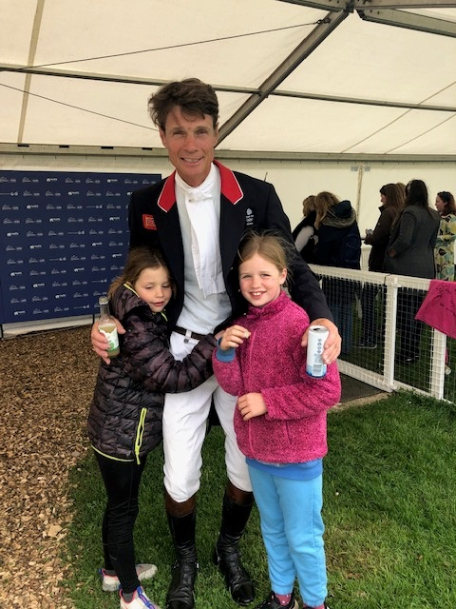

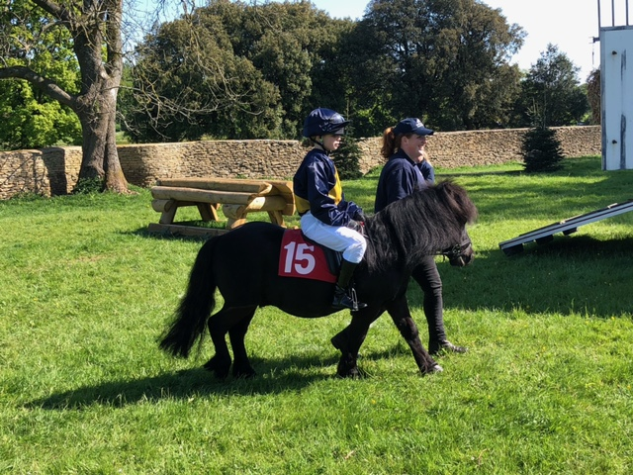

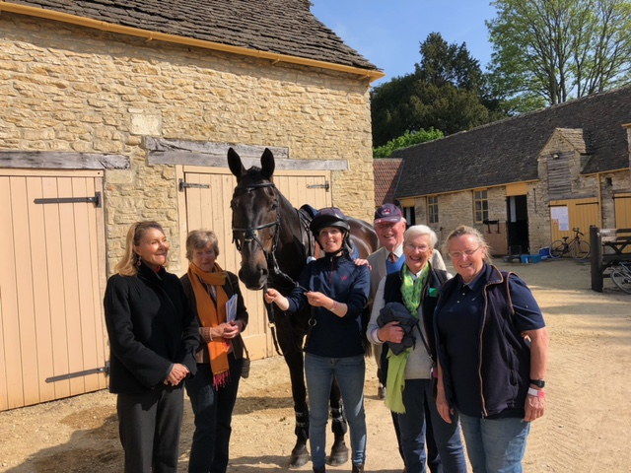



A big thank you to everyone who contributed to our grandson’s run for Ukraine on the bank holiday

weekend. He completed the 5k run in around 30 minutes and raised £462 for Ukrainian schoolchildren in Sturminster, to be distributed via Carole Jones and The Pantry.

**Liz Collins**



**The White Horse**

The White Horse is now open! We really appreciated everyone coming in last week and saying hello, the pub had a great buzz about it all week.

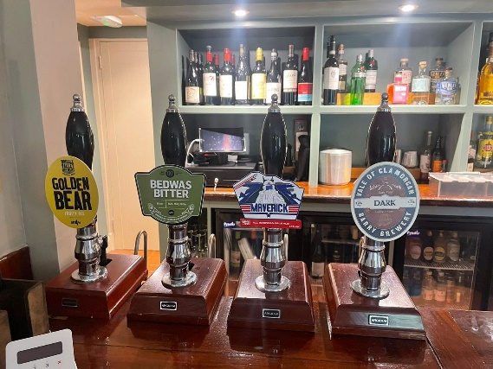 We're opening shorter hours over the next few weeks whilst we build up the team, but as soon as we can we'll be open 7 days a week. We'll keep you updated. Current Hours 4-11 Wednesday & Thursday, 12-11 Friday & Saturday, 12-10.30 Sunday.

We want to share our love of wine with everyone so we’ve organised an informal wine circle, a place where people can come, enjoy a few tastings of interesting & noteworthy wines, and understand more about the world of wine. **Our first event, an introduction to wine tasting, is on Tuesday June 14th.** These events will be very sociable, inclusive and are open to all, regardless of your wine experience to date. Tickets are available now online, via Facebook or pop into the pub.

|  |
| --- |
| **A cup of coffee  Description automatically generated with medium confidence VILLAGE COFFEE MORNING**  **Tuesday, 7th June**  **10.30 a.m. – 12 noon**  **VILLAGE HALL** |

What’s Happening in Stur

The first electronic edition of a new Sturminster Newton Newsletter covering Events, News Headlines, Business and Community Organisations is now available online.

If you would like to receive further monthly editions please email [whatshappeninginstur@btconnect.com](mailto:whatshappeninginstur@btconnect.com)

with the subject line “Please email me the Stur Newletter”

 **St Peter’s Services**

**June 2022**

All services are being held at 9.30 am this month

|  |  |
| --- | --- |
| **Date** | **Service** |
| Sunday 5th | Morning Prayer - BCP - Lay Led |
| Sunday 12th | Morning Prayer - Lay Led |
| Sunday 19th | Morning Prayer - Lay Led |
| Sunday 26th | Holy Communion |

The Church continues to be open for prayer each day and all Covid 19 measures have been waved.

Having for some time now been receiving bread and wine at Holy Communion, in accord with renewed practice in Salisbury cathedral, with effect from the 1st of July 2022 we propose a return to the Chalice (the common cup). However, if anyone feels this is a step too far, please feel able to continue to receive in one kind only but please also make your views known.

Until further notice, all queries relating to Church-related support and services should be directed to the Church wardens in the first instance:

|  |  |
| --- | --- |
| Robin Gibbs Tele: 01258 471493  [robin@aviaconsult.uk](mailto:robin@aviaconsult.uk) | Kevin Peto-Bostick Tele: 01258 475469  [kevin.peto.bostick@gmail.com](mailto:kevin.peto.bostick@gmail.com) |

**ST PETER’S, HINTON ST MARY**

**Parochial Church Council with effect from 11th May 2022**

The Revd Philippa Sargent

Mr Robin Gibbs - Vice-Chairman, Churchwarden and Electoral Roll Officer

Mr Kevin Peto-Bostick - Churchwarden

Mrs Janet Bolton

Mrs Jill de Bretton-Gordon

Mr David Johnstone – Treasurer (Officer)

Mrs Shane Johnstone – Secretary (Officer)

Mr Roy Davey – Parish Safeguarding representative

|  |
| --- |
| **BOULES**  The boules pitches are ready for use.  All necessary equipment in the big box.  Chris has oiled the benches.  If a group want to book the pitches  (anytime except 4 p.m. – 6 p.m. Thursdays)  Ring Janet 01258 472300 |

|  |
| --- |
| **BLANDFORD HOSPITAL SHOP WAREHOUSE.**  Saturday, 4th June  10   - 12 midday  Old Poisedale Building,  Hinton St. Mary |

C**hild Okeford Open Gardens Day, Sunday, 19 June, from 11:00 am to 5:00 pm**:

There will be around 20 gardens open to visit in the village, which nestles under picturesque Hambledon Hill (NT). Tickets will be available, £5 per person, children free, no dogs, on the day from both the Community Centre in Station Road (DT11 8EW), and the Village Hall in The Hollow (DT11 8EX). Teas and cakes will be available at the Community Centre, where there will also be plants for sale. For further information contact Jack Shonfield at [*j.shonfield@gmail.com*](mailto:j.shonfield@gmail.com)

***THE BLACKMORE VALE PARTNERSHIP – NEWSLETTER MAY 2022***

**Practice News**

The Practice receives between 500 and 600 telephone calls a day. With 24 lines incoming, this led to patients having to hold on for a long time until their call was answered.

As there are not enough staff available to cover all 24 lines, to avoid patients holding for a long time, the Practice has decided to reduce the number of available lines, which means that at certain times in the day, for example between 8.00 and 10.00, some patients may receive an engaged tone.

If this happens, please try a little later and when you get through, you will be dealt with faster than before.

**Telephone Call Back**

Patients have commented about the uncertainty of the timing surrounding a call back from the Practice.

If you have a non-urgent pre-booked appointment, you can check the timing in your personal section of the Practice Website (If you don’t have access to this, ask for a password from reception.)

Go to ‘Your Appointments’; ‘Future Appointments’ and it will show the detail of your telephone appointment and the approximate time of the call. You should receive the call well within 2 hours - of that time.

If your call-back is as a result of a same-day Urgent Care request, it is very difficult to predict when you will be called back. Calls are prioritised by clinical urgency, so whilst you may be first to ring in, subsequent patients whose need is greater, may well be ‘phoned before you. The Practice understands this can be difficult, but as you will see later in the Newsletter, there are many factors which can affect this.

Cont.

***The GP Practice in 2022***

Gone are the days when the GP would be working out of their front room, seeing a handful of patients throughout the day, his/her spouse answering the phone to deal with out of hours enquiries. There might also be one practice nurse assisting during clinics.

Patient demand and need is continually growing along with the range of services commissioned and the complexity of disease that general practice now looks after. The capacity to do all that, is a significant challenge with limited resources.

The practice now needs multiple professionals – GPs with specialist knowledge or interest (minor surgery, sexual health and contraception, diabetes, palliative care and so on), Pharmacists, nurses (long term conditions management, advanced wound care), social prescribers (experts in joining up/signposting patients to the services working alongside healthcare, benefits, etc.)

Specialist admin is needed, data specialists making sure patients aren’t missed from recalls and monitoring performance.

Vaccination campaigns such as covid and flu need to be organized and run, receptionists do so much more than just booking appointments – they are knowledgeable in signposting to the correct professional, managing patient problems, then we have medical secretaries and admin dealing with the hospitals and other external organisations.

Everyone working to ensure the patient experience is as seamless and supportive as possible.

**Practice Staff**

At present there are 100 staff at the Blackmore Vale Partnership, with a patient list of 26,500.

14 GPs (6 Partner GPs), 1 GP Registrar, Advanced Practitioners, 17 Nursing team, 1 pharmacist and 2 medicine technicians, 20 patient services staff, 10 administrators, 6 management team and 9 cleaning staff.

There are staff who work across the Blackmore Vale Practice in what is known as the Vale Primary Care Network.

This includes 6 social prescribers, 1 clinical pharmacist, 1 operational manager, 1 Mental Health peer support worker, MSK physio (plus various practice staff also have time allocated on a regular or ad hoc basis to supporting this work)

In addition, other staff are attached to the Practice including Midwives from Salisbury & Dorchester Hospitals, Health Visitors and the Community Team (district nurses, occupational therapists, speech and language), links with school nursing and social services (Safeguarding)

**A Day in the Life of a GP**

This is a snapshot of one GPs working day.

**07:30** – deal with incoming results, letters,

prescription requests, queries from patients and staff, start on task list.

**08:00** – Start patient consultations

A mix of telephone calls, face to face, video and online 10-minute consultations.

A mix of prebooked and same day appointments – upwards of 20 booked patient contacts in a morning plus extras.

In between patients, deal with urgent issues, more incoming results, letters, medication requests, do referrals to hospital or other services, check up on very unwell patients etc. A Huddle meeting with Frailty team to discuss patient cases.

**10:30** – multi-disciplinary team meeting

look at home visit requests, discuss clinical cases, catch up with staff re queries.

**11:00** – more patient consultations, more

incoming results, more referrals, more queries.

**13:00** – Clinical or non-clinical meetings (usually

while eating lunch) or home visit or dealing with more administration.

**14:00** – Consultations with a further 15 patients

With still the administration for those 15+ patients plus other admin for those not seen/spoken to

**18:30** – either continue with extended hours consultation with another 3-5 patients or catch up on the days admin.

Safeguarding reports, Insurance reports, Solicitor’s requests etc.

Power of attorney forms, support letters for DWP, universal credit, shot gun licenses etc.

**c.20:00** – go home, eat, sleep – possibly an

evening meeting.

The average working day for a GP is 12 hours. Most GPs do the equivalent of a full-time job in 3 days. Nowadays, it is very rare and not sustainable for a GP to work 5 days a week.

The BMA say that a GP should work 8.5 hours per day.

The Practice, in common with the rest of England, continues to have extreme difficulties in recruiting more GPs.

Last month, the BMA said "In the year between March 2021 and March 2022, the NHS lost 330 GP partners and 356 salaried and locum GPs. This means that the number of fully qualified GPs by headcount decreased by 686 net in just over one year.”

**PPG Secretary**

We are looking for someone who could take minutes and email newsletters. If you think you would like to be involved, please get in touch by email - bvpppg@gmail.com. Thank you!

 **JUNE QUICK QUIZ**

Dingbat: tre eeeeee Riddle: The most common way people know me is through my link to royalty . I can also make your mouth right, although painfully!

ANSWERS TO MAY QUICK QUIZ

Dingbat: Back Seat Driver Riddle: A Cloud

IF YOU LIVE IN HINTON ST MARY AND DO NOT RECEIVE A COPY OF THE MOSAIC **EVERY MONTH** – PLEASE LET NIGEL KNOW ON 07710 088322 OR EMAIL DJNMARTIN@BTINTERNET.COM

**Trusted Traders**

These are tradesman/workers who have been personally recommended by villagers. Please let us have details of anybody who has done a great job for you. Thank you.

|  |  |  |
| --- | --- | --- |
| COMPUTER HELP | TIM WEST | 01258 817537 sturcomputers@hotmail.co.uk |
| JOINERY/CARPENTRY | ANTHONY GILBERT  AGJ JOINERY | 01258 268134 [ant_gilbert1@hotmail.co.uk](mailto:ant_gilbert1@hotmail.co.uk)  [www.ajg-joinery.co.uk](http://www.ajg-joinery.co.uk) |
| CARPENTRY/JOINERY | NIGEL BASTABLE | 01258 860459 [www.nigelbastable.co.uk](http://www.nigelbastable.co.uk) |
| CARPENTRY (& WOODEN FLOORS) | GARY CORCORAN | 07920557651 [gccarpentry@hotmail.co.uk](mailto:gccarpentry@hotmail.co.uk) |
| **ADVICE ONLY** WITH WASPS & BEES | TED EYRES | 472154 |
| PEST CONTROL | MARK GOULD  (Rats, Wasps, Moles & Fleas) | 07999 957694 [mark_gould2@btconnect.com](mailto:mark_gould2@btconnect.com) |
| BUILDERS | ANDREW TRIM | 07939 541128 |
| FENCING & REPAIRS | DAVID WHITEHAND | 07549 151 799 |
| BOILER MAINTENANCE | BOB JONES & SON | 01963 362 502 |
| CARPET & UPHOLSTERY CLEANING | CASTLE GUARD CLEANING | 01202 715 115 |
| GROUNDWORK & HARD LANDSCAPING | KEIRAN HARVEY | 07792 250 347 |
| BUILDING & RENOVATION | MARK GORDGE | 07941 443 306 |
| ROOFING | BEN GIBBS ROOFING | 07912 655095 [Bengibbs.roof@gmail.com](mailto:Bengibbs.roof@gmail.com) |
| SCAFFOLDING | EDW SCAFFOLDING | 07474 552259 [elwin1965@icloud.com](mailto:elwin1965@icloud.com) |



|  |
| --- |
| ✓ A type of hand plane that serves as a carpentry tool for paring, smoothing,  trunig, and finishing woodwork, using muscle power , vintage line drawing  or engraving illustration. premium vector in  **NIGEL BASTABLE LTD**  **CARPENTRY & JOINERY**  **The Building Yard – Hinton St Mary**  **Doors, Windows, Wardrobes, Stairs, Kitchens, Cupboards, Bookcases Etc.**  **Renovations and Repairs**  **01258 860459**  [**nigelbastable@btinternet.com**](mailto:nigelbastable@btinternet.com)[**www.nigelbastable.co.uk**](http://www.nigelbastable.co.uk) |



|  |
| --- |
| ***Rose’s Yard, Hinton St Mary– Air B and B***  *******Self-Contained first floor annex, sleeping 4 in the centre of the village.*  *.Contact :* [*jo.martin99@btinternet.com*](mailto:jo.martin99@btinternet.com)  *Jo 07860 612412*  *Or book through Air B and B* |

IF YOU LIVE IN HINTON ST MARY AND DO NOT RECEIVE A COPY OF THE MOSAIC **EVERY MONTH** – PLEASE LET NIGEL KNOW ON 07710 088322 OR EMAIL DJNMARTIN@BTINTERNET.COM

*Please let us have any articles, notices, celebrations,, information, items for sale, trusted traders etc you would like to have included in next month’s Mosaic. Deadline 24th of the Month. Thank you. Janet, Jo & Nigel.*

*janetbolton24@hotmail.co.uk jo.martin99@btinternet.com*

*Keep abreast of all things ‘HSM’ on the village facebook page: Hinton St Mary Village Group and the Hinton St Mary Website:*

[*http://www.hintonstmary.com*](http://www.hintonstmary.com) *where all previous copies of The Mosaic are also available.*

Thank you to our Sponsors and Advertisers:

Mr & Mrs Pitt Rivers, Hinton St Mary Parish Council, St Peter’s Church, HSM Village Hall Committee.

|  |
| --- |
| Print, decorate and cut out.  Attach to a headband to make  your coronation crown |