**THE MOSAIC**

**HINTON ST MARY**

**FEBRUARY 2023**

**Watch this space! Val Pitt-Rivers**

You may have noticed that the Horse Chestnut tree opposite The White Horse has disappeared. Anthony & I planted it about 50 years ago but, as it had been dying for some time, sadly it had to be felled.

We thought of planting another Horse Chestnut in its place but were advised that, in case of any lasting disease in the soil, it would be better to choose a different tree, so it will be replaced by a Hornbeam (carpinus betulus) `Rockhampton Red` which grows to be a fine specimen tree with wonderful coloured leaves in the autumn.



**THE WHITE HORSE**

January is nearly over, hopefully the people that have been doing dry January are looking forward to their 1st tipple!

* Our ever-popular quiz night is on the first Sunday of every month, with Pizza Man Dan with his lovely pizzas, eat in or take home.
* We have started an open mic night, next one is 19th February, hosted in connection with the Beagles, all individual acts - great fun, Pizza man is in the garden too.
* Valentines night, we are opening on this special Tuesday for all you lovers❤️
* We are showing all 6 Nations games, in the bar.

* Moving forward, we are organising a race preview evening, local trainer Joe Tizzard to be in attendance. It should be a fun, informal chat about Cheltenham races (hopefully he might give us some race tips!)

**Tuesday 7thMarch - save the date!**

Our Sunday roasts are still very popular, booking definitely recommend, Thank you for your continued support.

The White Horse Team 01258915001 thewhitehorsehinton.co.uk

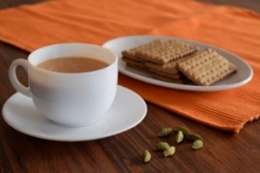 **THE MONTHLY VILLAGE COFFEE MORNING**

**Tuesday February 7th 10.30 – 12.00.**

The cost is £1.50– for as much coffee or tea as you can drink and as many biscuits

as you can eat.

**The Yard Alice Fox-Pitt**

A big thank you has to go to the team at Woodlane Stables for amazing commitment and smiles in the rain and the cold we have all been experiencing for the last couple of months!

Burst pipes, frozen water buckets, frozen roads and facilities, mud, floods they have had it all thrown at them and have been the epitome of keep smiling and carry on!

Things are really ramping up. All the horses are back in from their holidays and in full work. They have a gradual build up to their first competition which is in March. It is a bit like couch to 5k. They just walk for an hour for the first two weeks, gradually working in some trot work before cantering and jumping about 5 weeks in.

The team for the season is Jackie, Sara from Denmark, Stefan, Megs, Seito from Japan, Thierry with us from Holland and the wonderful Dan who is now in his 5th year supporting the management of the barn. James Lewis splits his time between the estate, the yard and the Sturminster fire station. Michelle is the boss at the heart of the operation running the office.

We had a major milestone this month as we celebrated the amazing super groom Jackie having managed William’s horses for 30 years!

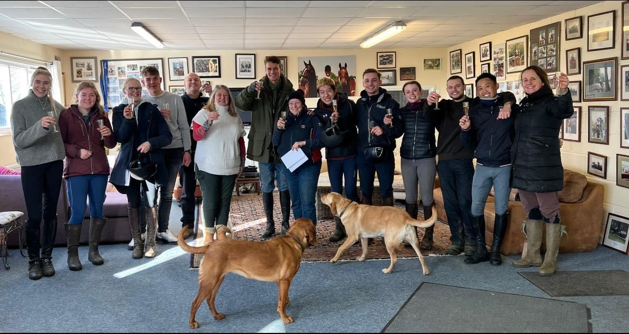

You can’t put into words the part she has played in the successes over the years. Her intuition and feel with the horses. Her calm and professional approach to every part of the management of them as athletes. Her focus and preparation at big competitions leaving William able to do his job.

Their professional partnership has been unique in the sport and William and everyone who has learned from her over the years is so lucky.

It was very special that just before Christmas the British Equestrian Federation recognised Jackie’s phenomenal contribution to British sport with a medal of honour presented to her in the main ring at the London International Horse Show. The team all went up to support, unfortunately William, the kids and I broke down on the M3 and didn’t get there. We were beyond gutted!

Kazu arrived back from Japan. He was in great form despite being welcomed to England with train delays and freezing fog!

He has now headed straight to Belgium to meet the Japanese show jumping team squad to plan his show jumping schedule, meanwhile the team at Woodlane have been getting his horses back into work so they are ready to get going on his return. His big spring aim is Badminton, Olympic qualification for the Japanese team and personal qualification as a show jumper for Paris. Exciting times!

**Village Hall AGM Thursday 23rd Feb 2023 at 7 pm.**

All Villagers are welcome to attend our AGM. We require a Secretary, Boules Club /Pitch organizer and a General Maintenance / cleaner helper.

 2023 is our 20th Year since re-opening the Old Cricket Pavilion, refurbishing it as a Village Hall and joining up with the Cricket Club. We need more Village support. Myself and my wife Christine with Chris Andrews are still the original Trustees since 2003 so we are very keen for more new members. (20 Years with no breaks is a long time looking after the Village Hall every day, over 7,300 days.)

 We are very keen for more Villagers to join our Village Hall Committee to help run the facilities that we provide for the Village and surrounding Area.

The Cricket Club are going well, more news on fixtures for 2023 to follow in March.

**We are pleased to report that we do now have additional heaters in the hall, including one in the ladies toilets. We would like to thank Marsh’s in Sturminster for supporting the village hall and giving us a substantial discount on the heaters.**

**St Peter’s Church**

**Parochial Church Council (PCC)**

We are a small, friendly village group responsible for maintaining our Grade 2* Listed Parish Church building and supporting routine parish affairs.

While we meet formally 2 or 3 times a year, essential work continues quietly in the background without imposing any significant burden on individual members.

The PCC always welcomes new members but would now specifically welcome volunteers, who need not be church goers, interested in working with our current Treasurer and Secretary with a view to ultimately taking over those vital responsibilities with effect from our Annual Meeting, due to be held in late April 2023

The respective roles can be undertaken by PCC members, but membership is not essential for these two appointments. Being a qualified accountant or secretary experienced in producing accounts or organising and recording meetings is not necessary.

If you are at all interested in joining the PCC and in particular the roles of Secretary or Treasurer, please contact us for a chat.

Robin Gibbs Kevin Peto-Bostick

Churchwarden Churchwarden

Tele: 471493 475469

Email: robin@ aviaconsult.uk [kevin.peto.bostick@gmail.com](mailto:kevin.peto.bostick@gmail.com)

**The Estate**  **Alice Fox Pitt**

The last couple of months have been quite quiet on the farm. Dave has been getting the hedge cutting finished but it is too wet on the land to do much else.

Mark has been very active in the local farmers cluster group promoting best practices of farming along the river Stour. He has hosted a meeting with talks on muck spreading and management. We also attended a really interesting meeting about hedge management, trying to understand the best ways of dealing with the amazing miles of hedgerows on the farm. The challenge is keeping the bases dense to hold as much wildlife as possible and maintain the widths and heights at the right times to maximise the opportunity for birds to feed on the berries and not be disturbed whilst nesting. The big project of cut and laying on the Sturminster side of the farm is all working towards those aims.

We had a momentous and quite emotional moment when the scaffolding that had been supporting the carpenter’s workshop for nearly 30 years came down to reveal a beautiful Victorian industrial building. The windows are now in and it is weather proof. Phase one completed and it is now an amazing space and opportunity to bring life and industry into the village. Watch this space!

The pub has been ticking over well. Barney, Sarah and the team are doing a wonderful job. Please support where you can, we are so lucky to have them here and it is a tough business. If there are things you would like or ideas you have please filter them through, they are there for you and would love your support.

The weddings kick off again in March but we have an incredible international star coming to do a one man show on 25th February in the Tithe barn to raise money for Stour Connect the wonderful charity doing such good work in Sturminster. It should be a really special night for a great cause. Pre show supper in the pub from 5. Doors open at 7 and there will be drinks and light refreshments after the show.

Should be a fun night!

 **St Peter’s Services**

**February 2023**

All Services this month will start at 9.30 am

|  |  |
| --- | --- |
| **Date** | **Service** |
| Sunday 5th February | Morning Prayer - Lay Led - BCP |
| Sunday 12th February | Morning Prayer - Lay Led |
| Sunday 19th February | Morning Prayer - Lay Led |
| Sunday 26th February | Holy Communion |

The Church continues to be open for prayer each day and all Covid 19 measures have been waved. In accord with practice now adopted within Salisbury (and other) Diocese, the common cup has been reintroduced for those wishing to receive the full sacrament. It remains entirely acceptable, however, for any communicant not wishing to receive wine to simply receive the bread. A presiding priest may, at their discretion, choose to offer the wine through a pipette as a continued precaution while a Covid threat exists.

The Patron and the Bishop of Sherborne are delighted to announce that the next Vicar of Sturminster Newton, Lydlinch and Hinton St Mary will be the Revd Mary Gubbins. Mary and her husband Andrew will be moving to the vicarage in Sturminster Newton before Easter 2023 and her Installation by the Bishop of Sherborne will take place on Tuesday 28th March. Details of this service will be announced in due course. Until further notice, all queries relating to Church-related support and services should be directed to the Church wardens:

|  |  |
| --- | --- |
| Robin Gibbs Tele: 01258 471493  [robin@aviaconsult.uk](mailto:robin@aviaconsult.uk) | Kevin Peto-Bostick Tele: 01258 475469  [kevin.peto.bostick@gmail.com](mailto:kevin.peto.bostick@gmail.com) |

**The North Dorset Refuge Appeal**.

Thanks to the wonderful response from villagers our Christmas Appeal was a great success, however, tragically the work must go on.

In response to a significant offer of on-going support we have decided to set up a ‘permanent’ collection point in St Peter’s church. The church is open daily and so any donations can be placed there and accumulated materiel will be moved on periodically (monthly?) to the Refuge.

If anyone needed reminding, the items most needed include (single) bedding, sheets, duvets and pillows plus towels. Toiletry items and other small gifts for children are also always welcome.

**Time to get walking again!**

With Spring on its way we start to think about getting out to walk in the beautiful English countryside again, but where to find new and interesting walks?

 Walking in Dorset <https://www.walkinginengland.co.uk/dorset> has loads of walks to download and print, free, it also has books of walks, details of all the walking groups in the county and much more. Whether you want to walk on your own or with a group all the information is there in one place.

John Harris (who maintains the website) said ‘There is so much walking information on the web but it is difficult to find. Walking in Dorset (part of the Walking in England website) has brought it together in one place so whether you are walking from home, or away on holiday, you will be able to find a walk suitable for you’.

With walks from half a mile to twelve miles plus long, and a note of suitability for pushchairs and wheelchairs, everyone can find a walk to enjoy.

So home or away, check out the websites and get walking!

John Harris [www.walkinginengland.co.uk](http://www.walkinginengland.co.uk) [john@walkinginengland.co.uk](mailto:john@walkinginengland.co.uk)

**USED POSTAGE STAMPS**

If anybody in the village collects used postage stamps for charity please could you let us know so that we can include your details in the March Mosaic. Several people have asked if we know of anybody. Thankyou

**FULLY OPERATING BATTERY POWERED CARBON MONOXIDE MONITORS**

**FREE OF CHARGE – STILL AVAILABLE**

**Contact Chris Townsend, 8 Old School Lane,**

**cp.townsend@btinternet.com**

There are still a few mixed plates and bowls, left over from the Christmas party, in the Church porch.

If they are still there in a couple of weeks, we will donate them to the Tithe Barn.

**DOG MESS EXCUSES Richard Collins**

Walking down the avenue this morning I spotted a dog walker failing to pick up dog mess from one of his two dogs. When I asked him why he was not picking up the mess he replied that he used to live in the village.

Two lady dog walkers had listened to the exchange. One chipped in that she had recently accosted a dog walker who was also failing to pick up dog mess. His excuse to her was that villagers In Hinton did not want their bins being filled up.

Have readers heard of any other excuses?

 **FEBRUARY QUICK QUIZ**

Ditloid: 6 = B in an O in C Anagram: Any Valid Teens

ANSWERS TO JANUARY QUIZ

Ditloid: Working 9 to 5 by Dolly Parton Anagram: Happy New Year

IF YOU LIVE IN HINTON ST MARY AND DO NOT RECEIVE A COPY OF THE MOSAIC **EVERY MONTH** – PLEASE LET NIGEL KNOW ON 07710 088322 OR EMAIL DJNMARTIN@BTINTERNET.COM

To enquire about or to book the village hall please call Chris Andrews on 01258 473107.

***Please let us have any articles, notices, celebrations,, information, items for sale, trusted traders etc you would like to have included in next month’s Mosaic.*** *Deadline 24th of the Month. Thank you. Janet, Jo & Nigel.*

*janetbolton25@hotmail.co.uk jo.martin99@btinternet.com*

*Keep abreast of all things ‘HSM’ on the village facebook page: Hinton St Mary Village Group and the Hinton St Mary Website:*

[*http://www.hintonstmary.com*](http://www.hintonstmary.com) *where all previous copies of The Mosaic are also available.*

Thank you to our Sponsors and Advertisers:

Mr & Mrs Pitt Rivers, Hinton St Mary Parish Council, St Peter’s Church, HSM Village Hall Committee.

**Trusted Traders**

These are tradesman/workers who have been personally recommended by villagers. Please let us have details of anybody who has done a great job for you. Thank you.

|  |  |  |
| --- | --- | --- |
| COMPUTER HELP | TIM WEST | 01258 817537 sturcomputers@hotmail.co.uk |
| CURTAINS, BLINDS, TRACKS, FABRICS &  FITTING (Marnull) | THE CURTAIN MAN  (Anna & Tony) | 01258 821117 thecurtainmanshop@gmail.com |
| CARPENTRY/JOINERY | NIGEL BASTABLE | 01258 860459 [www.nigelbastable.co.uk](http://www.nigelbastable.co.uk) |
| CARPENTRY (& WOODEN FLOORS) | GARY CORCORAN | 07920557651 [gccarpentry@hotmail.co.uk](mailto:gccarpentry@hotmail.co.uk) |
| **ADVICE ONLY** WITH WASPS & BEES | TED EYRES | 472154 |
| PEST CONTROL | MARK GOULD  (Rats, Wasps, Moles & Fleas) | 07999 957694 [mark_gould2@btconnect.com](mailto:mark_gould2@btconnect.com) |
| BUILDERS | ANDREW TRIM | 07939 541128 |
| FENCING & REPAIRS | DAVID WHITEHAND | 07549 151 799 |
| BOILER MAINTENANCE | BOB JONES & SON | 01963 362 502 |
| CARPET & UPHOLSTERY CLEANING | CASTLE GUARD CLEANING | 01202 715 115 |
| GROUNDWORK & HARD LANDSCAPING | KEIRAN HARVEY | 07792 250 347 |
| BUILDING & RENOVATION | MARK GORDGE | 07941 443 306 |
| ROOFING | BEN GIBBS ROOFING | 07912 655095 [Bengibbs.roof@gmail.com](mailto:Bengibbs.roof@gmail.com) |
| SCAFFOLDING | EDW SCAFFOLDING | 07474 552259 [elwin1965@icloud.com](mailto:elwin1965@icloud.com) |
| PRINTING | PROPRINT STALBRIDGE | 01747 851417 sales@proprint2k.co.uk |

**NIGEL BASTABLE LTD**

**CARPENTRY & JOINERY**

**The Building Yard – Hinton St Mary**

**Doors, Windows, Wardrobes, Stairs, Kitchens, Cupboards, Bookcases Etc.**

**Renovations and Repairs**

**01258 860459**

[**nigelbastable@btinternet.com**](mailto:nigelbastable@btinternet.com)[**www.nigelbastable.co.uk**](http://www.nigelbastable.co.uk)



**Turk’s Garage**

MOT’s, servicing and repairs

All makes and models

**Mr. S.J. Chatfield**

**01258 472 686**

Marnhull Road, Hinton St Mary

DT10 1NG



**BB**

**BIGGER BITES**

Nicholson’s Yard, Hinton St Mary

www.biggerbites.co.uk

**Event catering covering the Southwest & beyond**

Breakfast - Burgers - Pulled Pork – Hot & Cold Drinks

Jonathan Murray

0990 703 573

Jossmurray001@gmail.com



**Rose’s Yard, *Hinton St Mary– Air B and B***

*Self-Contained first floor annex*, sleeping 4 in the centre of the village.

Contact:

[jo.martin99@btinternet.com](mailto:jo.martin99@btinternet.com)

Jo 07860 612412

Or book through Air B and B

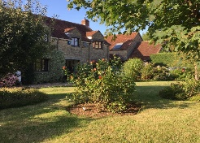

**SNADS’ PANTO**

**RED RIDING HOOD** & **THE 3 LITTLE PIGS**

**16th – 19th February @ The Exchange Sturminster Newton**

7**.30pm Friday 17th & Saturday 18th Feb**

**IN ADDITION Please Note the following Special Performance Dates & Times:**

**6pm 16th Feb – Relaxed Performance**

Specifically aimed at people with additional needs. Low house-lighting will be on throughout and an inclusive environment guaranteed,   
with **free entry for accompanying carer/parent.**

**2.30pm Saturday 18th & Sunday 19th Feb**

Full performances but Matinées (for those who like to get home early)

**Tickets available from The Exchange Box Office – 01258 475137**

**or** [**www.stur-exchange.co.uk**](http://www.stur-exchange.co.uk)