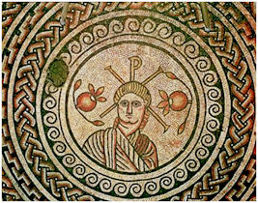
THE MOSAIC
HINTON ST MARY
SEPTEMBER 2022

NEW LIGHT ON ROMAN HINTON ST MARY
By Lead Archaeologist, Dr. Peter Guest

Archaeologists returned to Hinton St Mary for 4 weeks in June and July, to find out more about the immediate setting of the famous mosaic discovered in the village in 1963 (currently in the British Museum). After last year’s evaluation season, when we dug 6 long, narrow trenches in the field behind The Forge (see the October 2021 issue of The Mosaic), this time we excavated 3 larger trenches close to where the mosaic was found 59 years ago. We were looking to answer questions about the layout of the Roman buildings to which the mosaic belonged, as well as when they had been in use. After 2021’s covid-affected season, this year we also wanted to involve local children in the dig and to offer more opportunities for people from Hinton St Mary and the local area to come and see the trenches being excavated.

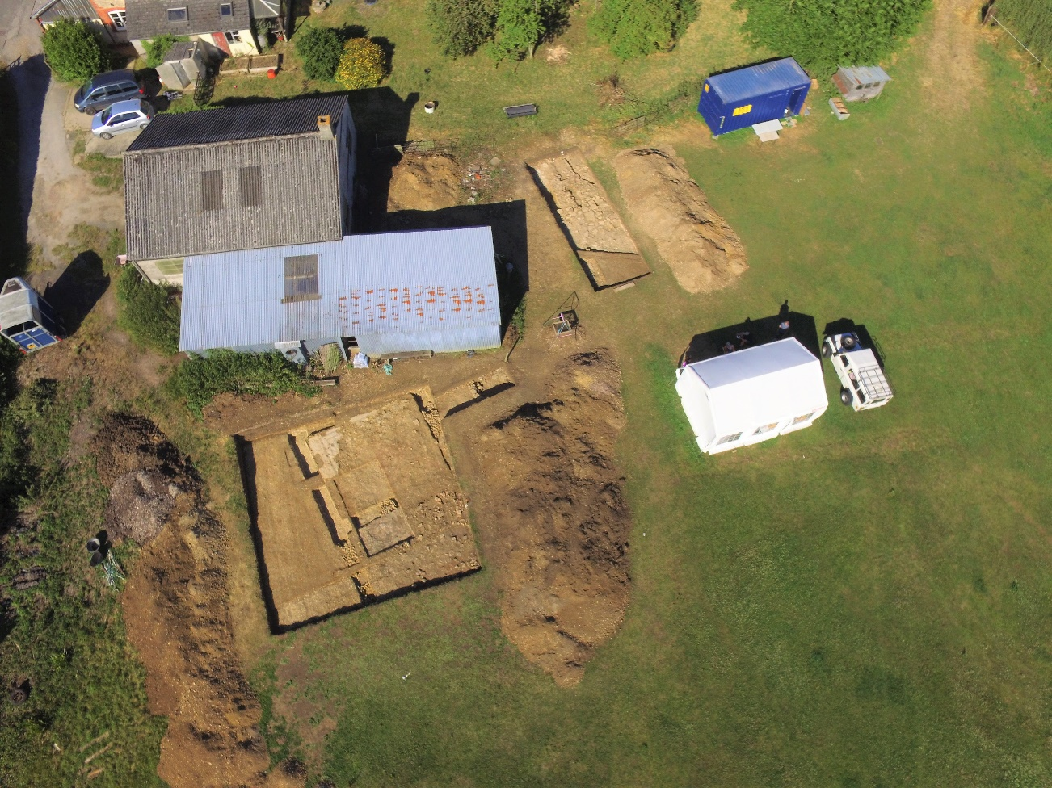

Fig. 1 Aerial view of the 2022 excavations - the 3rd trench was inside the corrugated building (photo courtesy of Tom, Poppy and Archie Blake).

It will take a while before we fully understand what we found (the work to clean, identify and catalogue the many finds we recovered has already started), but it’s very clear that much of what we thought we knew about Roman Hinton St Mary is wrong and will need to be rewritten.
For almost 60 years now, it has been believed that the mosaic decorated the floor of a room in the centre of a large ‘villa’ building, consisting of an imposing main range (the domestic quarters), and 2 ‘wings’ enclosing a large courtyard (not dissimilar in many ways to The Manor in Hinton St Mary today). There were many impressive villas like this in southern Roman Britain, thought to have been the homes of wealthy landowners and farmers, and the mosaic suggested that the occupants of the Hinton St Mary example were members of the earliest Christian community in Britain, who were able to express their faith openly and without fear of persecution after the Emperor Constantine’s decision in 313 to decriminalise the Christian religion.
We now know that the room with the famous mosaic was not in the centre of a long building, nor were there any ‘wings’ around a courtyard. Instead, the mosaic ‘room’ seems to have stood alone, perhaps with an open paved area in front and around it (we found the remains of what looks like a boundary wall in Trench 3). Elsewhere we discovered the end of a separate rectangular building running downslope at almost 90° from the mosaic. This building was probably 35-40m long and was divided into up to 8 square rooms, with a corridor or portico along its front. Trench 2 revealed the 2 northernmost rooms, the 1st of which had a mosaic floor while the adjacent room was provided with a more modest mortar surface. A small area of this 2nd mosaic from Hinton St Mary was revealed in a narrow trench dug in 1964 and, although it had been badly damaged by medieval ploughing, we can now see that originally it had an ornate black-and-white border around a central panel that was probably decorated with figurative scenes and fine scrollwork. What this building was for is a mystery for the time being, though it seems to have faced onto another large open paved area. From the finds we recovered, it’s clear that this building was contemporary with the famous mosaic. Both were built at some point in the middle decades of the 4th century – 330-350 or thereabouts – and people used them right up to the end of the Roman occupation of Britain in 400-410 (if not even later).
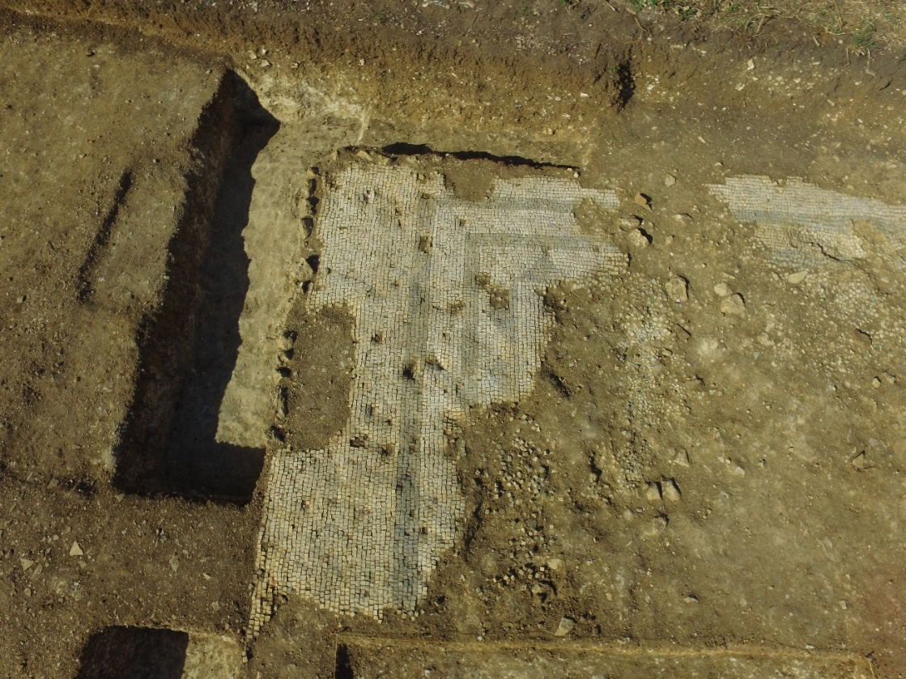
Fig. 2 Surviving parts of the damaged mosaic in Trench 2 (© The British Museum).

Although we know the evidence does not support the existence of a courtyard-type ‘villa’ at Hinton St Mary, the very unusual layout of the Roman buildings means it’s difficult at the moment to say with any certainty what the mosaic’s immediate setting might have looked like. For instance, we still don’t know how many buildings stood there, or how far the complex might have extended. Nor do we know what the buildings were for or how people might have used them. While almost certainly not a villa – i.e., the home of a wealthy landowner and his family – are we instead looking at a religious complex, such as a church, chapel or martyrium perhaps, or possibly a monastic community of some kind?
Prof. Keith Wilkinson from the University of Winchester carried out a Ground Penetrating Radar survey while we were digging that hopefully will locate any other buildings beneath the ground behind The Forge. Keith was assisted by the student archaeologists from Cardiff University (for whom this was their first excavation experience) and other volunteers who worked on the dig and whose hard work has revealed so much new and exciting evidence about Roman Hinton St Mary. We were also joined by 4 classes from Yewstock School in Sturminster Newton (Yewstock is a day community school for children from North Dorset with a range of learning difficulties and special educational needs), who came along for afternoons of trowelling, sieving, metal detecting and pot washing. Opportunities to take part in archaeological excavations are all too rare, especially for children such as those going to Yewstock School, and it was very special to see their faces as they relaxed and began to enjoy their first tastes of being Real Archaeologists!
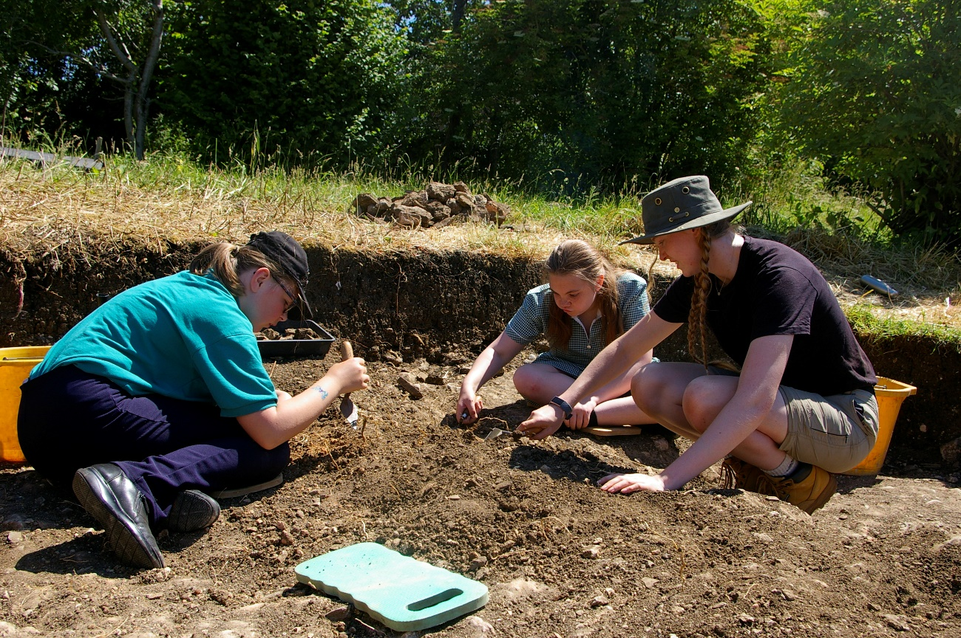
Fig. 3 Children from Yewstock School digging in Trench 3 with archaeologist Tierney Tudor (© The British Museum).

This is a British Museum project and I feel very fortunate to have been asked to organise and run an archaeological excavation at such an important and prestigious site on their behalf. I am also delighted that the 2022 excavation season was such a resounding success – so much so that we are now thinking about organising a 3rd season next year to find answers to those questions that still remain about Roman Hinton St Mary and to tie up any final loose ends!

None of this would have been possible without the help and support of a lot of people and organisations. Many thanks to Katie Scorgie for allowing us to dig up her garden (again), to Mr and Mrs Pitt Rivers and the Hinton St Mary Estate for allowing us to camp and use the facilities in Billy’s Shed, to Chris Hardiman and the Village Hall Committee for letting us use the village hall as our base (we are now dedicated fans of the Sturminster and Hinton cricket team!), to Alice and William Fox-Pitt for their support and advice, and to Emma Wellman for somehow managing to keep 25 hungry archaeologists going with her hearty meals! Special mention too to all of the 2022 team for making this such a rewarding and enjoyable season, particularly the inspirational staff from our commercial partners Albion Archaeology who did such an excellent job in the trenches, as well as the fantastic students and volunteers.
Finally, and on behalf of the entire team, I’d like to thank all of the residents of Hinton St Mary and Sturminster Newton for making us so welcome during our time with you. 300 people visited the excavation during our open Sunday events – we look forward to seeing you all again and showing you what new secrets we’ve uncovered!
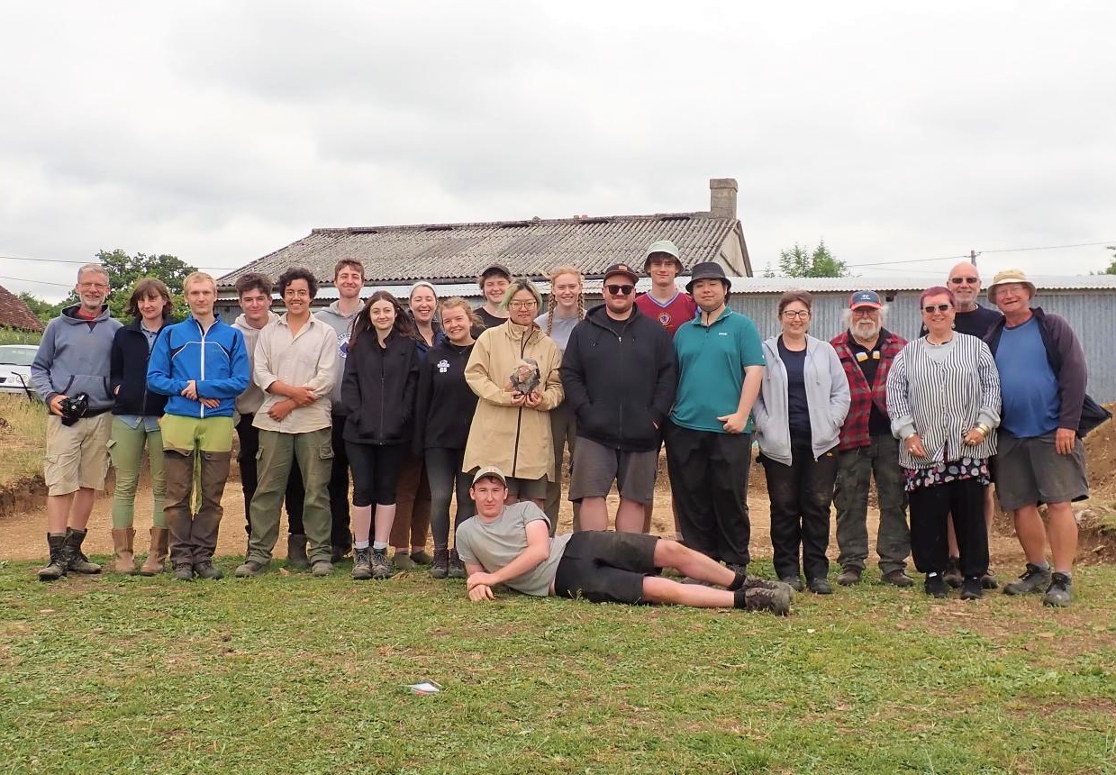
Fig. 4 The Hinton St Mary 2022 excavation team (© The British Museum).
More information about the Hinton mosaic as well as previous work at the site can be found at www.vianovaarchaeology.com/hinton-st-mary/, which will be updated soon with a summary of this season’s results.
Dr Peter Guest
Vianova Archaeology & Heritage Services

Millennium Garden News

Very many thanks to all who so generously supported the Coffee Morning and Bring and Buy in aid of the Millennium Garden at the end of July, and especial thanks to Anthea and John Harding for hosting the event in their lovely garden and providing coffee and cakes.
We raised £255, which will cover the cost of materials for the refurbishment of the maze, but we still need to cover the cost of the labour. We hope also to raise money this year from the Community Apple Juicing Day in October (see below), but what we really need to know is whether there is sufficient interest in the maze to make the project worthwhile. There have been quite a few children making use of the garden recently and it would be good to hear from their parents. The aim is to make the maze more easy to maintain, but as those of us who are currently maintaining it are not getting any younger, it would be helpful to know whether there is sufficient interest from the next generation. The alternative would be to continue marking it out in spray paint as we have done at intervals during this year.
Let us know what you think!

Apple Day 2022 – October 15/16th

Our community apple juicing started in 2020 during Covid and we were still affected by restrictions last year, so plans for a larger celebration of Apple Day had to be curtailed, but both years we managed to produce around 250 litres of juice. This year the harvest is uncertain – there are plenty of apples but many are falling prematurely so we cannot be certain how many will be available. However, we plan to provide bottles for the Harvest Lunch, share juice roughly according to the guidelines below and hope to have some left to offer in exchange for a donation towards the restoration of the maze.
- Bring apples and help juice them – a share based on fruit contribution.
- Bring apples but don’t stay to help – a share of juice
- Pick apples and have them collected – a share of juice
- Help on the pressing day or beforehand – a share of juice
We have a core team of helpers but it is a labour-intensive process to get everything achieved on time, and offers of help either on the day or with picking and collecting apples or washing and de-labelling bottles in the preceding week would be gratefully received, as well of course as apples! Also – if the weather is better than last year - would anyone be able to organise some apple related children’s activities in the Millennium Garden on either the Saturday or Sunday for a short period?
If you are able to help in any way, or have any suggestions, please contact either Liz Collins: lizcollins50@gmail.com; Gwyn James: gmjames28@icloud.com or Sue East: sue-east@hotmail.co
More details to follow in the October Mosaic and on the Village FaceBook page.

Hinon St Mary Estate - Down on the Farm Mark Harvey Farm Manager

Harvest was complete in good time this year with no drying of Grain required, a first for me. Yields were reasonable and straw quickly baled and moved to the Barns. Let’s hope for a dry time when the Maize is fit which should be from Mid-September.
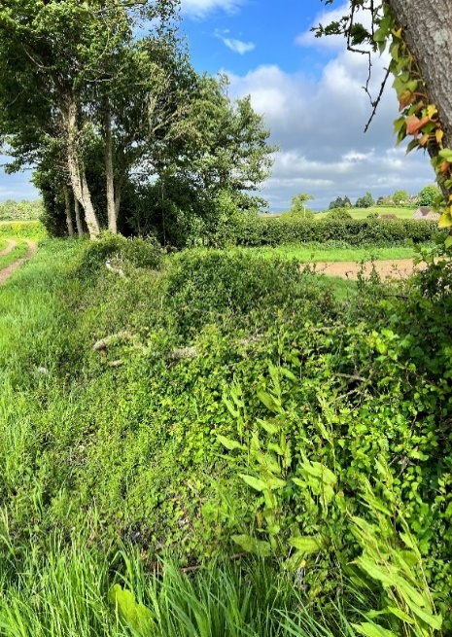
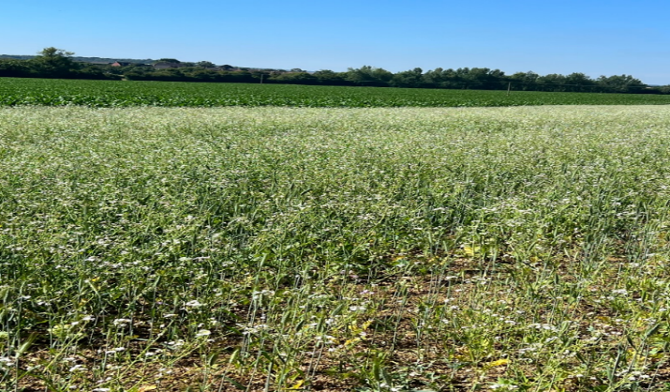
We now have a Country Countryside Stewardship agreement which you can see around the Estate. Some of these options include hedge laying, fencing along the water coarse, along with some wildlife plots, winter bird food, pollinator mixes and flower rich margins. These are across the Estate at Shillingstone, Fiddleford, Marnhull and Hinton. We are currently drilling winter cover crops to protect the soils over winter. Hedges will be managed in a different way with a lot of hedge laying being carried out through the winter months.

Winter Bird Food

Hedge Laying Hinton

The September Village Coffee Morning will be on
Tuesday, 6th September. 10.30 -12 noon. Village Hall.
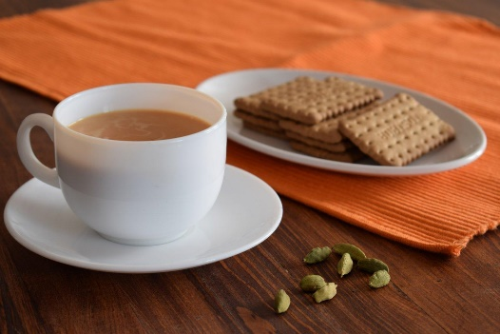
We get a lovely mix of villagers, so do come along and have a chat with people you do not see very often.

The cost is £1.50– for as much coffee or tea as you can drink and as many biscuits as you can eat !!

The Yard Alice Fox Pitt

The Stables have been in full swing throughout August.

The drought has caused a few problems with firm ground and very little grass. The events have limited resources to water the ground, so the horses have just had quiet runs with William and Kazu going steady to protect the horses.

Kazu had a very uncharacteristic bad day on his last big run before the World Championships and had a fall off both his horses. Luckily, he was ok as were Vince and Vinny. He has been working hard to get the confidence back on track.

William has had the news that he is reserve for the British team for the Worlds which was about where he expected to be. Team GB is unbelievably strong at the moment with the Gold medal winning team from the Olympics all back and a wonderful young rising star Jaz Ingham getting her first call up. The Championship is in Italy the second week of September.

I mentioned last month that super star racehorse Santini arrived with us to be assessed for a second career.
What a star he is having finished second in the Cheltenham Gold Cup and 4th in the Grand National. The team are loving working with him. He is so talented and has the most amazing attitude to learning. He is having to change the way he canters as he is used to galloping and now he has to canter with a shorter stride to help him jump in a different way. Racing he must get from A to B as fast as he can, eventing you want him to be careful and get up into the air more. He is picking it all up fast and his muscle shape is changing all the time.

We are now packing the lorry for one of the biggest events in the calendar, the Land Rover Burghley Horse Trials in Lincolnshire. William is riding Oratorio who was bred on Bulbarrow by Cosmo Jenks. He is 13 now and is in incredible form ahead of one of the biggest tests. William loves Burghley having won it a record 6 times in his career.
We are excited to be going back to this iconic venue for the first time in 3 years and have the whole family coming up in a camper van. Hopefully there will be good news to report in the October issue!

Thank you again for all your patience with the horses around the village, we are so grateful.

Re: Hinton St Mary Gardens Open Weekend – letter to Wendy King
Dear Wendy,
I don’t know how involved you are with the The Open Garden weekend but I would be grateful if you could pass on my thanks and congratulations to any of the organising team and others involved – a super event.
When I have driven through the village, I had often thought of stopping at Turk’s Garage to see if there was anyone with contacts of long ago. I remember my father’s cars being repaired there. It was a delight to meet you – what a coincidence both being in the Church at that time – my head is still reeling. Me clutching my photos of the King/Coffin wedding of 1952 with me looking a slightly wayward 4-year-old bridesmaid and my friend Clive Pakenham – also from the village as pageboy. Clive, who now lives in Sherborne, was due to meet me at the Church but he contracted the dreaded virus on Saturday! We have met at the open garden weekend many times. I lived in Home Farm House and my father was Agent for the Estate until he moved here in a similar role in about 1956. I went to the village school in Hinton and have a couple of photos of dancing displays during Mrs Tate’s headship of the school. I can remember the names of most of the younger children.
On Sunday I met other people with connections to people I knew who lived out of the village. All rather strange. I also met a lady whose husband is going to start a new teaching post at Sandroyd School based in Rushmore House, the former P-R family seat a couple of miles out of our village. I taught there for 40 years.
All very best wishes
Marcelle Mitchell
Tollard Royal

St Peter’s Services

September 2022
This month all services will start at 9.30 am

Date | Service
Sunday 4th | Morning Prayer - BCP - Lay Led
Sunday 11th | Morning Prayer - Lay Led
Sunday 18th | Morning Prayer - Lay Led
Sunday 25th | Holy Communion
The Church continues to be open for prayer each day and all Covid 19 measures have been waved.
In accord with the practice adopted within Salisbury (and other) Diocese, the common cup at Eucharist services in St Peter's has been reintroduced for those who wish to receive the full sacrament. It remains entirely acceptable for any communicant not wishing to receive the wine to continue to receive just the bread.
Until further notice, all queries relating to Church-related support and services should be directed to the Church wardens:

Robin Gibbs Tele: 01258 471493  robin@aviaconsult.uk | Kevin Peto-Bostick Tele: 01258 475469  kevin.peto.bostick@gmail.com

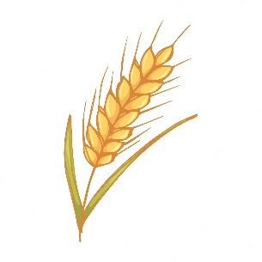
Harvest Festival 23rd October.
Village Harvest lunch in Tithe Barn.
All details next month.

“It’s a dogs life”
By Carol Fishenden

We never really intended to have four dogs, but then again, we had never intended to have four horses and three cats! The horses began when our two daughters had the same obsessive love of horses and ponies as I had had all my life. It just took over our lives, the ponies then horses, gymkhanas and then eventing. It was the most exciting twenty years of our lives. When it suddenly came to a terrible abrupt ending, with me damaging my back, and us realising that we would never be able to care for them as they needed to be cared for, a dreadful hole opened up in our lives. We had always had collies, one or two at a time and as it became evident that we desperately needed another way of life to fill the cavernous hole, Agility for dogs was introduced to us. We were lucky enough to find a fabulous trainer and had already got a young clever Collie who immediately took to her new life like a duck to water. We were also lucky to find another young Collie who had found herself in the dogs trust who became John’s first Agility dog. It quickly went from hobby to obsession and a wonderful way of life as we travelled all over the country competing with enormous success.

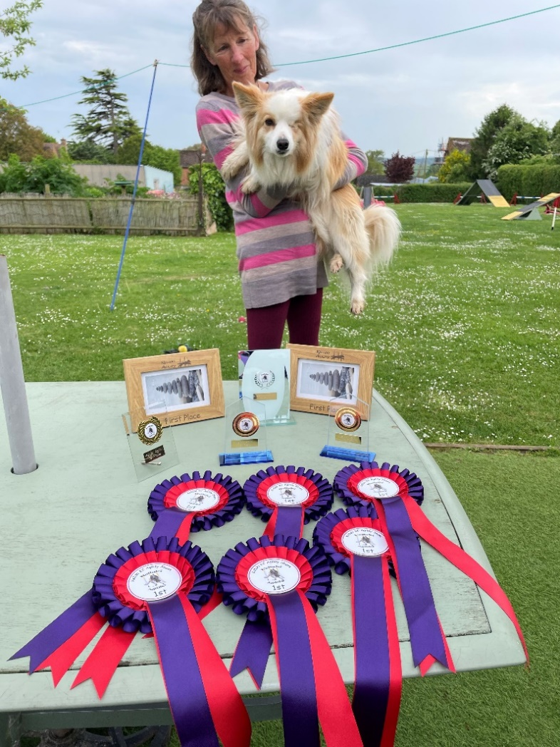
Roll on14 years and having won between us over 200 trophies, and both getting to championship level, and my beautiful Lolly being entered into the hall of fame, it was time for Lolly and Pippi to retire and hand over to two younger dogs. We found an amazing lady who bred Agility line collies, very intense and super intelligent with an incredible love for learning. Covid rather got in the way of socialising our youngest who is sadly rather nervous of men and children but showing encouraging signs of improvement. Since covid our Agility life has been amazing. John took his exams and is now a judge, and our two youngsters are totally amazing. With many wins for Hattie, blond girl with only one eye, taking her from grade two to grade six, (7 being the highest), in under two years, it is such an incredible achievement for her after losing her eye and for me to learn different skills to assist her on very difficult courses as she goes higher up the grades. Peggy is coming along nicely and at just three years old, has reached grade four. She is super-fast and poor John is struggling to both run fast enough and speak instructions quickly enough but is having a wonderful time learning. They are both very entertaining to watch!!
The Agility season comes to an end in October and in the winter we train them once a week and they return to being muddy pet dogs who just love their long walks.
BLANDFORD HOSPITAL SHOP WAREHOUSE.
Saturday 3rd September
10 - 12 midday

Old Poisedale Building, Hinton St. Mary

St. Peter’s Church, Hinton St. Mary and its importance in our village
A (very) short history of the Church.
The mediaeval Church was established on the site of the present Church in the 12th century. At that time, it was a settlement belonging to the Abbey of St. Mary in Shaftesbury. The dissolution of the monasteries around 1535 marked the end of Shaftesbury Abbey.

In 1846, the Church was rebuilt in the Perpendicular style and this incorporated the tower which had been constructed in the 15th century. 2 bells were hung, and these are still in good working order.

In earlier times the Church was of great importance to the village and we have records of births, marriages and deaths going back to 1521.

Nowadays congregations are much smaller and people from Sturminster and neighbouring villages boost our numbers. Hinton people still use the Church for the important occasions in their lives – christenings, weddings and funerals. We are seeing an increase in the numbers of non-resident couples who want to be married in an attractive village Church. These days the importance of the Church, to quite a lot of people, is the part it plays in making Hinton an attractive and desirable village.

Our problem now is keeping the Church and the area around it clean and tidy. The people who have cared for it in recent years are getting older and frailer. It would be really wonderful if we could have some offers of

1) Grass cutting and path weeding
2) A monthly get-together to give the Church interior a good clean and polish.
3) Joining the rota for ‘doing’ the flowers. We work in pairs, 3 or 4 times a year.
Everyone helps at Christmas, Easter and Harvest

If you think you could help in any way, or have any suggestions, please contact
or Janet Bolton 01258 472300. janetbolton24@hotmail.co.uk
or Robin Gibbs 01258 471493 robin@aviaconsult.uk
Shane Johnstone 01258 474670 johnstone.ytc@btinternet.com
…………………………………………………………………………………………………………………………………………………………………..

The Rev. David Dunning will be doing his marathon cycle ride for our Church on the 10th September. Any sponsorship will be greatly appreciated. Details of on-line sponsorship are shown and there will be a form for sponsorship in the Church.

50% of the sponsorship money comes to our Church and the other 50% to Dorset Historic Churches. We have been able to call on the Historic Churches several times recently for financial help with restoration and maintenance in our Church.

UPDATE FROM THE BLACKMORE VALE PRACTICE

Flu Campaign

Supplies of flu vaccines are due to arrive at the end of September. Every year the Joint Committee for Vaccination and Immunisation (JCVI) recommend the type of vaccine to be offered to individuals and which age and at risk groups should receive it.
This year, the JCVI have recommended the following groups receive the vaccine:-
Anybody aged 65 years and over (including those becoming 65 years by 31st March 2023)
At risk patients aged 2-65 years
• Chronic (long-term) respiratory disease, such as asthma (requires continuous or repeated use of inhaled or systemic steroids or with previous exacerbations requiring hospital admission), chronic obstructive pulmonary disease (COPD) or bronchitis
• chronic heart disease, such as heart failure
• chronic kidney disease at stage 3, 4 or 5
• chronic liver disease
• chronic neurological disease, such as Parkinson’s disease or motor neurone disease
• learning disability
• diabetes
• splenic dysfunction or asplenia
• a weakened immune system due to disease (such as HIV/AIDS) or treatment (such as cancer treatment)
• morbidly obese (defined as BMI of 40 and above)

Pregnant women (including those who become pregnant during the flu season).
Household contacts of immunocompromised individuals where sharing accommodation and close contact is unavoidable.
Those in receipt of carer’s allowance, or who are the main carer of an older or disabled person.
Children aged 2 or 3 years on 31 Aug 2022.

Secondary school-aged children focusing on Years 7, 8 and 9 and any remaining vaccine will be offered to years 10 and 11, subject to vaccine availability and provided through the school age immunisation service.
Healthy adults 50-64 years and those who turn 50 from 31st March 2023 from 15th October 2022.
Front line healthcare and social care workers (to be offered by employers).

The Practice is unable to start these clinics until October as they are dependent on the delivery dates of the vaccines, which is out of their control. Smaller clinics may be offered later in the Autumn programme at different sites, depending on the uptake.

Covid Vaccinations – Autumn Programme

JCVI advice as at 15/7/22 confirms that the COVID-19 Autumn booster should be offered to the following groups:
• Residents in a care home for older adults and staff working in care homes for older adults
• Frontline health and social care workers
• All adults aged 50 years and over
• Persons aged 5 to 49 years in a clinical risk group, as set out in the Green Book (https://www.gov.uk/government/publications/covid-19-the-green-book-chapter-14a)
• Persons aged 5 to 49 years who are household contacts of people with immunosuppression
• Persons aged 16 to 49 years who are carers, as set out in the Green Book (https://www.gov.uk/government/publications/covid-19-the-green-book-chapter-14a)

The Practice is working with NHS Dorset to agree the programme and intends to offer Covid vaccines to those over the age of 18 years. They plan to run a combined Flu and Covid vaccine programme at The Exchange at Sturminster Newton.
Most clinics will be on a Saturday and approximately 2500 patients will be vaccinated in a day. These clinics will be on an appointment only basis and times will be given to patients to aid throughflow and reduce waiting time.

KLINIK HEALTH SOLUTION

From the middle of September the Practice will be implementing a new clinical triage system called Klinik. Patients will able to access this system via the BVP partnership website. It can be accessed on your phone, or at home on your laptop or PC, it is very simple to use and is user friendly.
The system is designed to help get your request / issue to the right person to be able to deal with it effectively and in a timely manner. The systems also helps to determine the urgency of the patients need. It will be replacing the current e-Consult. Other surgeries currently using this system have seen vast improvements in their on the day/routine appointments and a reduction in telephone waiting time.


SEPTEMBER QUICK QUIZ

Dingbat: LEFAVAELLS Anagram: Normal Dance (clue 5TH November)
ANSWERS TO AUGUST QUICK QUIZ
Dingbat: In the middle of nowhere Riddle: Your right elbow

IF YOU LIVE IN HINTON ST MARY AND DO NOT RECEIVE A COPY OF THE MOSAIC EVERY MONTH – PLEASE LET NIGEL KNOW ON 07710 088322 OR EMAIL DJNMARTIN@BTINTERNET.COM

Trusted Traders

These are tradesman/workers who have been personally recommended by villagers. Please let us have details of anybody who has done a great job for you. Thank you.

COMPUTER HELP | TIM WEST | 01258 817537 sturcomputers@hotmail.co.uk
JOINERY/CARPENTRY | ANTHONY GILBERT  AGJ JOINERY | 01258 268134 ant_gilbert1@hotmail.co.uk  www.ajg-joinery.co.uk
CARPENTRY/JOINERY | NIGEL BASTABLE | 01258 860459 www.nigelbastable.co.uk
CARPENTRY (& WOODEN FLOORS) | GARY CORCORAN | 07920557651 gccarpentry@hotmail.co.uk
ADVICE ONLY WITH WASPS & BEES | TED EYRES | 472154
PEST CONTROL | MARK GOULD  (Rats, Wasps, Moles & Fleas) | 07999 957694 mark_gould2@btconnect.com
BUILDERS | ANDREW TRIM | 07939 541128
FENCING & REPAIRS | DAVID WHITEHAND | 07549 151 799
BOILER MAINTENANCE | BOB JONES & SON | 01963 362 502
CARPET & UPHOLSTERY CLEANING | CASTLE GUARD CLEANING | 01202 715 115
GROUNDWORK & HARD LANDSCAPING | KEIRAN HARVEY | 07792 250 347
BUILDING & RENOVATION | MARK GORDGE | 07941 443 306
ROOFING | BEN GIBBS ROOFING | 07912 655095 Bengibbs.roof@gmail.com
SCAFFOLDING | EDW SCAFFOLDING | 07474 552259 elwin1965@icloud.com
PRINTING | PROPRINT STALBRIDGE | 01747 851417 sales@proprint2k.co.uk


NIGEL BASTABLE LTD
CARPENTRY & JOINERY
The Building Yard – Hinton St Mary
Doors, Windows, Wardrobes, Stairs, Kitchens, Cupboards, Bookcases Etc.
Renovations and Repairs
01258 860459
nigelbastable@btinternet.com www.nigelbastable.co.uk

Turk’s Garage
MOT’s, servicing and repairs
All makes and models

Mr. S.J. Chatfield
01258 472 686
Marnhull Road, Hinton St Mary
DT10 1NG

Rose’s Yard, Hinton St Mary– Air B and B

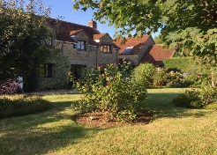
Self-Contained first floor annex, sleeping 4 in the centre of the village.

Contact :

jo.martin99@btinternet.com
Jo 07860 612412
Or book through Air B and B

Please let us have any articles, notices, celebrations,, information, items for sale, trusted traders etc you would like to have included in next month’s Mosaic. Deadline 24th of the Month. Thank you. Janet, Jo & Nigel.
janetbolton24@hotmail.co.uk jo.martin99@btinternet.com

Keep abreast of all things ‘HSM’ on the village facebook page: Hinton St Mary Village Group and the Hinton St Mary Website:
http://www.hintonstmary.com where all previous copies of The Mosaic are also available.

Thank you to our Sponsors and Advertisers:
Mr & Mrs Pitt Rivers, Hinton St Mary Parish Council, St Peter’s Church, HSM Village Hall Committee.

